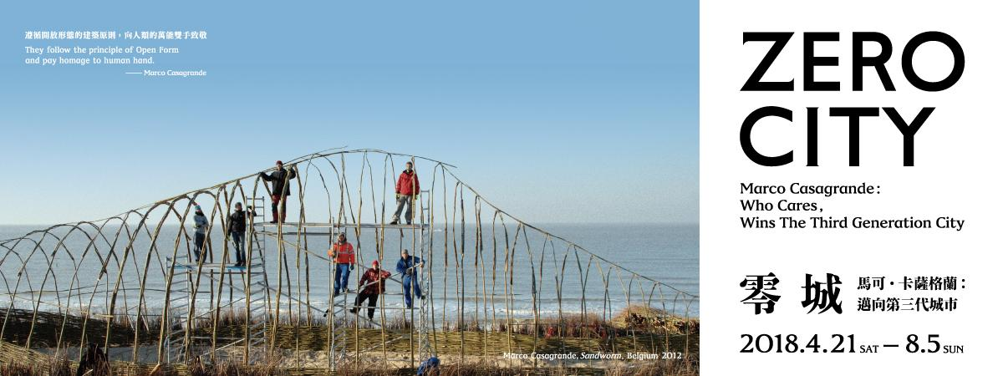

Solo Exhibition of Architect Marco Casagrande, a Lab for Organic Architecture
ZERO CITY – Marco Casagrande: Who Cares, Wins the Third Generation City

They Follow the principle of Open Form and pay homage to human hands. -Marco Casagrande

Human being lives in cities, in harmony with the nature. It is the future, the Third Generation City, the Zero City. Proposed by Marco Casagrande, the recipient of the 2013 European Prize and the 2015 Global Award of Sustainable Architecture, “Zero City – Marco Casagrande: Who Cares, Wins the Third Generation City” is inclusively presented in the Jut Art Museum since April 21st.

From Finland to Taipei, Witnessing the Third Generation City
Finnish architect Marco Casagrande is also an art creator. His intimacy with the nature in childhood was where his originality and unique style are found for his creation. As early as 16-year-old, Casagrande worked as a reporter of a local newspaper. Later he became a scholar of bio-urbanism, among many of his other identities. Coming to Taiwan, Casagrande changed our view of our cities that we thought we had known so well. In 2003, his actions in the Treasure Hill led him to the Third Generation City, most likely existing in between formal and informal spaces. The urban vegetable farms, self-made shacks and irrigation systems in Treasure Hill impregnated abundant lively local knowledge for the formation a true Third Generation City.

Casagrande’s great passion for cities connected him to the Jut Foundation for Arts and Architecture, which is also driven by great passion to interpret cities and nature. Beginning from an evacuated 5-floor building in - Ximending in 2010, Casagrande headed a group of enthusiastic Anarchy Gardeners to open up the decrepitude for wind, rain and sunlight. They also started urban farming from it, transforming the building into an experimental platform— “Ruin Academy.” Theories and models of The Third Generation City and Urban Acupuncture were burgeoning here.

The Best Communication Is To Do It in Person— Handmade Studio
Marco Casagrande strongly believes that a designer should be at the site in person to feel the movements of wind and sunlight. Being present is the best channel for understanding. The architect office in the exhibition venue is crafted by Casagrande with his own hands and sweat. Hand drawings in this office demonstrate how the architect conducts his design, like the “Phimenes sp.” inspired by insect nests. In this exhibition, the audience are able to see how Casagrande thinks and develops his work.

Waking Up Your Five Senses and Exploring Inside the Brain
This exhibition breaks off the boundary between arts and architecture and presents models and photographs of 17 architectural projects. At the lobby is “Paracity,” an organic body growing from the Open Form theory. Stacked cubes are expanding upward through the atrium of the second floor, an imaginable edifice is erected in The Third Generation City. “Tikku,” a project attracting hot debates in 2017, is to provide dwellers a sitting quarter, a bedroom, an office and a garden at the site as small as a parking space in cities dominated by cars. “Sandworm” in Belgian is an example of “weak architecture” that Casagrande built with several young architects with willow branches. And his projects in Taiwan, the “Oystermen,” “Chen House,” “Ultra-Ruin” and “Ruin Academy Taitung” are also represented.

The arrangement of the exhibition galleries has completely overthrown the orderly space and white walls of the museum. Setting out from the Open Form for natural elements, Casagrande makes the building into a lab of organic architecture. A variety of recycled building materials are installed around; paths paved by glistening glass gravel or white pebbles are walled by red bricks, concrete slabs or rusted iron panels. Visitors are, imaginatively, brought into the wonderful world of the architect’s mind, adventuring with him through his brilliant projects. The museum also breaks up with the conventional framework of exhibition and provides the audience open spaces and free circulation. Each route leads to the starting point of architecture, the Zero City, the Third Generation City where people and nature live peacefully together.

The Coming Publication – a Salon on Papers
Jut Art Museum is also publishing “Marco Casagrande: Who Cares, Wins the Third Generation City.” The book will include many interviews and conversations from the perspective not only of Casagrande himself, but his partners, researchers and fellow architects. In this paper salon, readers get to know this Finnish architect from different angles, and his career will be crucial reference for architectural profession. This publication is scheduled to be released in this summer.

From Home to City, Thinking about the Future with Jut
Inaugurated in 2016, Jut Art Museum presents exhibitions and events of three categories: contemporary art, urban architecture, and issues of the future. The first exhibition was HOME 2025, it engaged Taiwanese architects to propose homes for ten years later. “Zero City – Marco Casagrande: Who Cares, Wins the Third Generation City” is an extension from individual homes to the gigantic body containing human settlements. We invite all the people concerning urban living to observe cities and their future through the Finnish architect’s eyes. This exhibition concludes Marco’s important works since 1999, and his ideas of the Third Generation City and the Open Form. “Zero City – Marco Casagrande: Who Cares, Wins the Third Generation City” is exhibiting from April 21st to August 5th, 2018.

Marco Casagrande
Marco Casagrande was born in 1971, Finland. He started teaching since 2000, and completed his master degree of architecture and urban planning from the Aalto University in 2001. Marco Casagrande emphasizes interdisciplinary education, his curriculum covers architectural design, eco-urban planning and environment art. From 2004 to 2008, he taught in the Department of Architecture, Tamkang University in Taiwan. And in 2000, 2004 and 2006 he exhibited at the Danish Pavilion and Taiwan Pavilion in the La Biennale di Venezia. In 2009, Casagrande, Hsieh Ying-Chun and Roan Ching-Yueh teamed as WEAK! for the Shenzhen & Hong Kong Bi-City Biennale of Urbanism and Architecture. Marco Casagrande was also the winner of the 2013 European Prize for Architecture and 2015 Global Award for Sustainable Architecture. He holds a professorship of Bergen School of Architecture, Norway.

About Jut Art Museum
Jut Land Development's 30th anniversary, and the Jut Foundation for Arts and Architecture's 10th birthday, culminates in the establishment of the Jut Art Museum in 2016. It is a milestone commemorating the history of Taiwan's architectural aesthetics. We anticipate that the Museum to act as a new form of think tank, catalyst and platform devoted to corporate social responsibility fulfillment and addressing the societal dynamics of the 21st century. We also anticipate it to carry on the legacy of "A Better Tomorrow" that defines much of the Foundation's work, to become the first museum in Taiwan that is focused on the issues of "future" and "city."

The Jut Art Museum, located in the heart of Taipei, is also where the Foundation's debut exhibition of MUSEUM of TOMORROW is held. After ten years of circuit shows across the city, the exhibition is now back to where it all started, becoming “a showpiece in the heartland of the city and urban inhabitation." As an up-and-coming art establishment, the Museum serves to explore what our future might hold, and transdisciplinary issues. The curation process of the Museum is three-pronged: "future," "urban architecture," and "contemporary art."

Japanese architect Jun Aoki is tasked with spacing designs of the museum. The identification system is developed by Atsuki Kikuchi. This is their first museum collaboration project in Taiwan. The Museum－a statement of both sophistication yet cutting-edge conception－is downtown's new architectural and art landmark; and it is poised at remaking and bringing new energy into Taipei's cityscape.
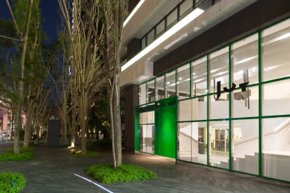

ZERO CITY – Marco Casagrande: Who Cares, Wins the Third Generation City
Dates: 2018/Apr/21(Sat)~2018/Aug/05(Sun)April 21 ~ August 5, 2018
Opening Hours: 10:00~18:00 Tue~Sun 10:00~18:00 Closed on Mondays.
Venue: Jut Art Museum (No.178, Sec. 3, Civic Blvd., Da’an Dist., Taipei City)
Admission: General NTD150
Discounted NTD120 (Students / Seniors 65 and above)
Group NTD100 (Groups of 10 visitors or more)
Free Admission:
People with disabilities and one guardian or companion
Children 12 and under

Organizer: Jut Art Museum
Coordinators: Casagrande Laboratory, Jut Art Museum
Special Thanks: Spring Pool Glass, Department of Architecture TamKang University
Event Partner: MOT CAFÉ
Media Partner: MOT TIMES
Reminder: Due to the floor pavement of unusual materials, please do not wear sandals or high heeled shoes.

Facebook: Jut Art Museum https://www.facebook.com/JUTARTMUSEUM/
#MarcoCasagrande #ZEROCITY #ThirdGenerationCity #JutArtMuseum

For more information, please go to the official website of the Jut Art Museum http://jam.jutfoundation.org.tw/exhibition/1061

