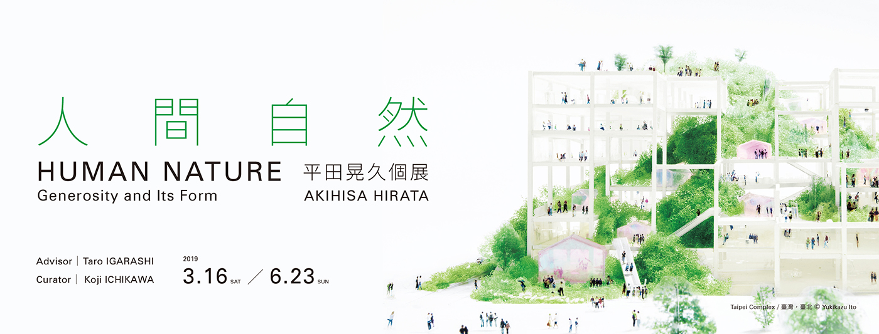

Human Nature – Akihisa Hirata’s Taiwan Debut

HUMAN NATURE: Generosity and Its Form – Solo Exhibition of Akihisa Hirata is staged in the Jut Art Museum from March 16 to June 23 in 2019. Born in 1971, Akihisa Hirata had worked under Toyo Ito and was the recipient of many architectural awards for rising architects. His impressive design and theoretical discourse make him one of the most acclaimed Japanese architects of his generation. This exhibition presents Hirata’s twelve recent projects of unique style that carry out inspiring ideas for the architecture society in Taiwan.

Architecture as A New Ecology Made by Human
Taro Igarashi, well-known architecture scholar, is engaged as the exhibition advisor, and Koji Ichikawa, specialist of modern Asian architecture, the curator. “Human Nature” refers the mundanity or humanity in different languages, suggesting that human exists in nature, manmade nature as well as natural nature. The ambiguity provides different interpretations, which is exactly Hirata’s idealism of openness and compassion in design.

To the public, architecture simply means the spaces for human living, but to Hirata, architecture could be ecology for diversified beings. “Can architecture exist between flowers where butterflies hover around?” Intrigued by biology since his teenage, Hirata has noticed that there is no clearly defined three-dimensional spaces between flowers where butterflies dance. Similarly, there shall not be clearly defined interior and exterior for architecture, but spaces for human and buildings in nature coexisting over or under their entangled interfaces. “karamari-shiro,” or “intricate compatibility,”means human being receding from self-centered viewpoint and connecting their habitats with the surrounding ecology. A new manmade nature therefore emerges.

12 Projects Brilliantly Presenting Philosophy of Karamari-shiro
Hirata’s philosophy of entanglement is brilliantly embodied through the twelve projects exhibited. “Entanglement,” the keyword of his design, is demonstrated by models, films and writings. Art Museum & Library, Ota (2017) had included local people and the administrators in their discussions during the beginning phase of design. The open and inclusive procedure brought out successful integration of the functions for the museum and library.

The audacious design of framework and ramps of Taipei Complex (2015) has changed the stereotypical ideas that manmade is the opposite of nature, but a symbiosis. Although this project is un-built, its ideas are inspiring. The design of Taipei Roofs (2018) breaks away from the conventional boxy buildings, creating undulating hills in the urban context. The patio of each unit gives the building very rich expression. Hirata believes it is the most suitable prototype of high-rise buildings in Asia in the 21st century. Tree-ness House (2017) in Tokyo is a piece which applying the concept of a big tree. The entanglement of the filled or unfilled spaces, upstairs and downstairs, rooms or patios, produces very organic forms. Like tree houses, residents will find the best way of living according to their habits and preferences.

In addition to the exhibiting projects, the galleries are designed by the team of Akihisa Hirata’s architecture office. Setting out from “entanglement,” the venue has been transformed into a white ocean with islands floating over it. Everything is possible here, the audiences are welcomed to sail in it and expect the tides generated by unexpected encounters and mixture.

Jut Art Museum Marches into 2019 with Powerful Exhibition Series of Architecture
Jut Art Museum is an entity of the future. In 2018 we presented Zero City – Marco Casagrande: Who Cares, Wins the Third Generation City, then in 2019 HUMAN NATURE: Generosity and Its Form, followed by Dialogues: Oyler Wu Collaborative in autumn. All these exhibiting architects are in their middle-age, whose solo exhibitions present their established core ideas and the multi-faces of their design, and ultimately the dynamics of architecture. Jut Art Museum provides a platform for creativity and stimulates young creators’ imagination and thinking for the future.

Emerging Architects from Taiwan and Japan Gather for Events and Exchange
Along with the exhibition are events for in-depth discussions. A speech of Akihisa Hirata and a curatorial panel will be held after the opening on March 16. And organized by exhibition advisor Taro Igarashi, “Architecture in Future Tense: Exchange Forums of Rising Taiwanese and Japanesewith Emerging Architects from Taiwan and Japan” will be staged on April, May and June to talk about new faces of architecture in Asia through slices of time.

Multiple Benefits for Exhibition Visits and Free Admission for Hotel Customers
Special Offers:
Student Day on WED | Free admission once upon presentation of valid student ID
eslite Bookstore Members | Buy-one-ticket-get-one-free on WED for visitors with membership ID
eslite Forum Members | Free admission once for visitors with membership ID

Visitors staying in HOTEL PROVERBS Taipei, HOTEL QUOTE Taipei, GLORIA RESIDENCE and GLORIA PRINCE HOTEL Taipei with room card have one-time free admission. It is a package for art lovers and boutique hotel customers.

More benefits can be found on the official site of Jut Art Museum: http://jam.jutfoundation.org.tw/en

EXHIBITION INFORMATION

Title: HUMAN NATURE: Generosity and Its Form Akihisa HIRATA
Date: 2019.3.16 SAT –6.23 SUN
Advisor: Taro IGARASHI
Curator: Koji ICHIKAWA
Venue: Jut Art Museum (No.178, Sec. 3, Civic Blvd., Da'an Dist., Taipei City 106, Taiwan)
Opening Hours: TUE-SUN 10:00-18:00 (Closed on Mondays)
Admission: General TWD 100, Concessions TWD 80 (students, seniors aged 65 and above, and groups of 10 or more); Free Admission for the disabled and a companion, children aged 12 and under (Concessions or Free Admission upon presentation of valid proof).

Organizer : Jut Art Museum​
Coordinators : Akihisa Hirata Architecture Office, Jut Art Museum​
Sponsor : JUT Group, PAUIAN ARCHIKAND
Event Co-organizer : Advanced Developers Association
Official Display Partner : SONY
Supporter : TOTO GALLERY．MA、Yasushi Ichikawa
Cultural Partner : the eslite forum, eslite member, Department of Architecture College of Shih Chien University, Hirata Akihisa Laboratory, Kyoto University
Official Hotel Partner : HOTEL PROVERBS Taipei
Media Partner : La Vie, xin ARCHI, Taiwan Architecture Magazine
Event Partner : MOT Cafe

