**The Jut Art Museum will stage the exhibition titled “*Civilization: The Way We Live Now*” at its satellite venue “Uncanny” from May 18, 2024.**

**For the first time, the museum extends its exhibition to the space “Uncanny” at NOKE, with eight themes fully unfolding in the two exhibition venues.**

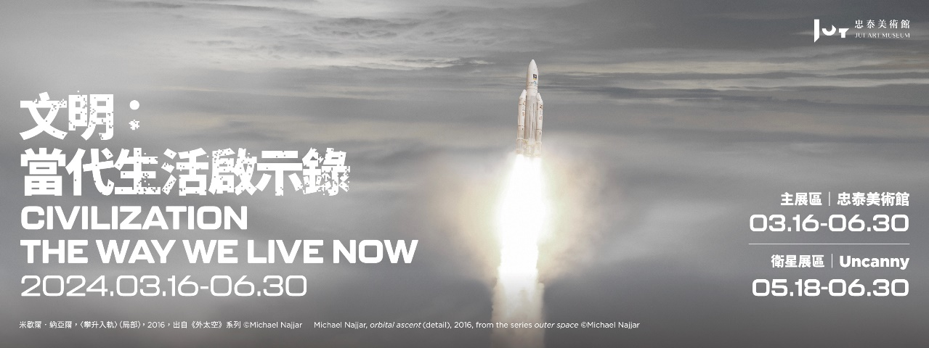

Produced transnationally by the Foundation for the Exhibition of Photography and the National Museum of Modern and Contemporary Art of Korea in collaboration with the Jut Art Museum, the international traveling photography exhibition titled “*Civilization: The Way We Live Now*” is coming to Taiwan this year. Following the opening at the main venue in March, the Jut Art Museum extends part of the exhibition to its satellite venue, the space “Uncanny” at NOKE, for the first time. This part will be on view from May 18, 2024. While the main venue features six themes, namely “HIVE,” “FLOW,” “PERSUASION,” “CONTROL,” “RUPTURE,” and “NEXT ?”, which address explicit phenomena under the impact of globalization, the satellite venue accommodates “ESCAPE” and “ALONE TOGETHER,” two themes that explore the collective state of mind of humankind in the global village. The eight themes fully unfold in the two exhibition venues.

This exhibition shines a spotlight on the modalities of human collective living in the globalized world since the beginning of the 21st century, and its eight themes cover a riotous profusion of subjects, such as dwelling and traveling, production and consumption, work and recreation, thinking and creation, as well as conflict and cooperation. This exhibition documents and interprets the development of contemporary human civilization with photographic art, so that it beckons, inviting visitors to cogitate on the present and the foreseeable future of humankind.

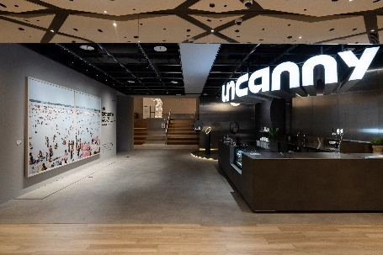 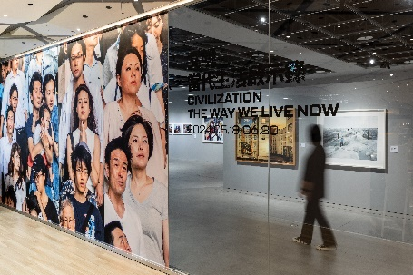 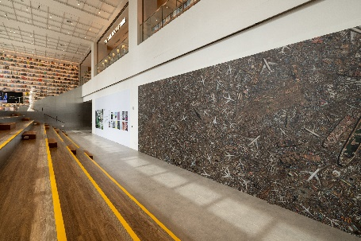

**Theme I at Uncanny: ESCAPE — “bypass, freedom, avoid, evasion, leave”**

“Escape” is often used as a term to describe leaving a place or shaking off physical or spiritual shackles. For people who suffer the calamities of war and conflict, “escape” literally means fleeing any dire situation, which finds expression in the works concerning wars and refugees under the theme “RUPTURE” at the main venue. For those who live in peace and prosperity, “escape” has multiple connotations, such as getting rid of everything and liberating the body, mind, and soul. In the satellite venue, the artists recorded and revealed the truth behind the leisure and entertainment industry through observation and photography.

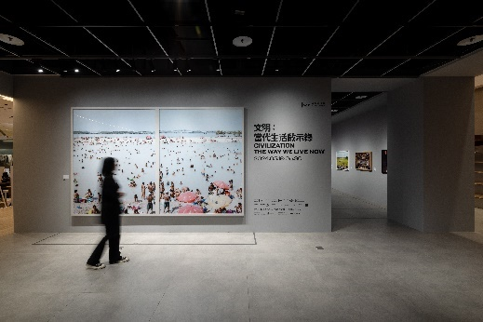 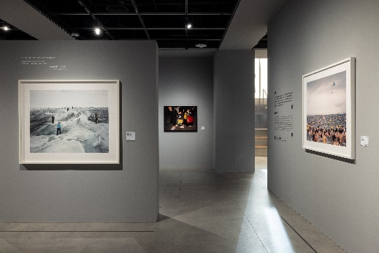

The crowd of bathers in Massimo Vitali’s work *Piscinao de Ramos* seems to perform a global collective ritual in which people arrive at the escape, temporarily getting away from the daily hustle and bustle. Olaf Otto Becker has long been concerned with the environmental disasters in the Arctic. His work *Point 660, 2, 08/2008 67°09’04’’N, 50°01’58’’W, Altitude 360M* shows only several tourists taking souvenir photos on the ice while the natives such as polar bears and seals have been long gone. Roger Eberhard photographed the views and the rooms of different branches of a chain hotel as he traveled around the world, hence the series titled “*Standard.*” *Tokyo* and *Venice* are worlds apart in cultural background and landscape. However, in the photos shot in the two cities, the hotel rooms look so similar as if they were copied and pasted, which suggests that the world appears to be increasingly homogeneous.

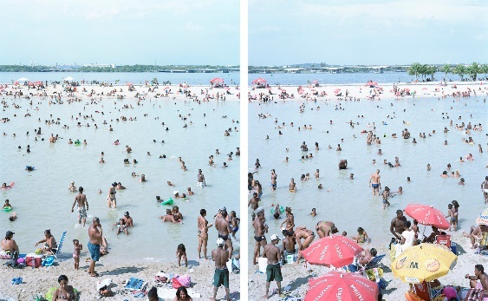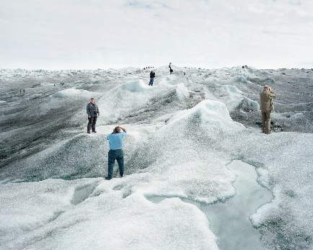

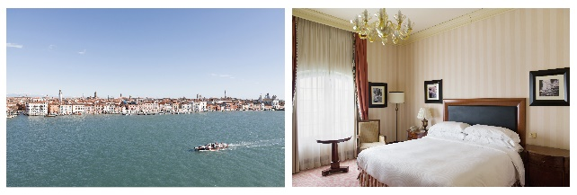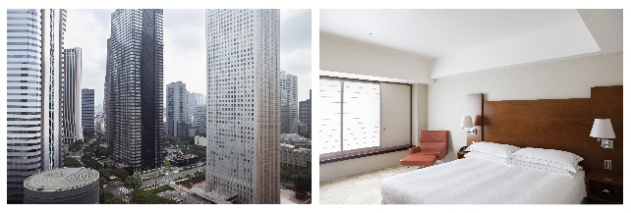

**Theme II at Uncanny: ALONE TOGETHER — “individual, combined, unique, deserted, crowd”**

Human beings are social animals with high social needs. Poet John Donne said, “No man is an island.” People not only seek various kinds of partners in their social lives, but also pursue divergent individualities. Are we blindly following popular crazes or standing out from the crowd? The essential human condition is to be alone — as we come into the world and will depart it. But whilst we are alive, we live collectively. The artists’ works both demonstrate and reinforce our very interdependence.

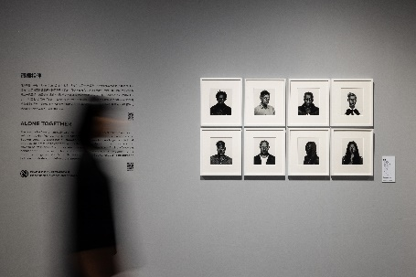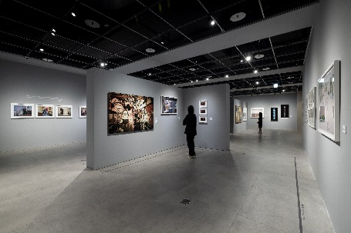

Featuring parents and their children, Dona Schwartz presented two series respectively titled “*Expecting Parents*” and “*Empty Nesters.*” The former captures the states of mind of different types of couples anticipating the arrival of a new baby. The latter displays parents struggling to come to terms with the fact that their adult children flee the nest by showing only the presence of parents. Larry Sultan’s work *Sharon Wild* recorded what a porn actress looks like behind the scenes. As if she were at home, the actress sits alone in front of the camera, conveying a sense of loneliness and alienation in the style of Edward Hopper. It also suggests that these actors are people like us who work hard to earn a living. Vincent Fournier believes that his dream of space travel is shared among the majority of humankind, which has driven him to keep photographing subjects related to aerospace activities. In his work *Ergol #1, S1B clean room, Arianespace, Guiana Space Center [CGS], Kourou, French Guiana*, the astronaut in a spacesuit with a cord seems to be ready for his leap off the earth. However, he is about to face the closeness and loneliness in the extreme environment of outer space, a situation of long-term isolation.

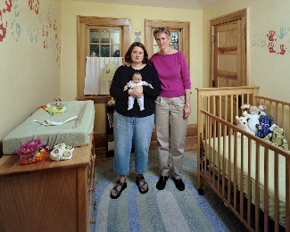 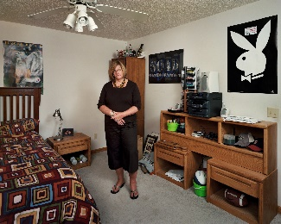  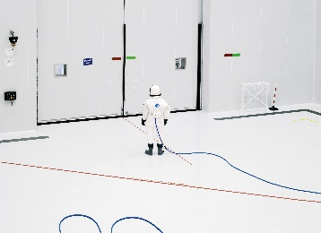

**The Jut Art Museum offers various discounts for visitors in collaboration with several brands at the satellite venue.**

“*Civilization: The Way We Live Now*” will be on view from May 18 at “Uncanny,” a space on the third floor of NOKE. Several brands at NOKE, including MOT X ABOOK, Old Bridge, Uncanny, m̄enom̄eno, and TSUTAYA BOOKSTORE, also offer various discounts during the exhibition period. Visitors will receive these discounts by presenting satellite venue ticket stubs.

The salon “Escape • Loneliness” will take place on 25 May at the satellite venue. The well-known podcaster “Otherwise Library,” accompanied by DJ Elvis Lin’s music performance, will talk about “loneliness” and “escape,” the two most profound issues in human civilization. We cordially invite you to immerse together in the world of art, in which you’ll find escape from loneliness. For details about the exhibition and the discounts, please visit the official website of the Jut Art Museum.

**Information about *“Civilization: The Way We Live Now”***

[**https://jam.jutfoundation.org.tw/en/exhibition/107/4652**](https://jam.jutfoundation.org.tw/en/exhibition/107/4652)

**Satellite Venue｜NOKE 3F Uncanny** (No. 200, Lequn 3rd Rd., Zhongshan Dist., Taipei City 104, Taiwan)

Date｜2024.05.18 SAT- 2024.06.30 SUN

Opening Hours｜SUN-THU 11:00-21:30, FRI-SAT 11:00-22:00

Admission｜General TWD 50 (Free Admission for the disabled and a companion, children aged 12 and under with valid identification)

Organizer｜Jut Art Museum

Curatorial Team｜Jut Art Museum, Foundation for the Exhibition of Photography, National Museum of Modern and Contemporary Art of Korea

**Main Venue｜Jut Art Museum** (No.178, Sec. 3, Civic Blvd., Da'an Dist., Taipei City 106, Taiwan)

Date｜2024.03.16 SAT- 2024.06.30 SUN

Opening Hours｜TUE-SUN 10:00-18:00 (Closed on Mondays)

Student Day｜Free Admission once on WED (With valid student ID)

Admission｜General TWD 150, Concessions TWD 120 (Student, seniors aged 65 and above, and groups of 10 or more)

Free Admission for the disabled and a companion, children aged 12 and under (Concessions or Free Admission upon presentation of valid proof)