The Jut Art Museum and the Mori Art Museum Co-Present Sou Fujimoto’s Largest Solo Exhibition, The Architecture of Sou Fujimoto: Primordial Future Forest with Taipei as the First Stop of Its International Tour
Featuring over 100 architectural projects—from The Grand Ring of Expo 2025 Osaka, Kansai, Japan to visionary concepts for future cities—tracing over three decades of Sou Fujimoto’s creative trajectory.
TAIPEI, Taiwan — In collaboration with Japan’s Mori Art Museum, the Taipei-based Jut Art Museum is proud to present the international debut of Japanese architect Sou Fujimoto’s largest solo exhibition to date, The Architecture of Sou Fujimoto: Primordial Future Forest. Running from 15 August 2026 to 3 January 2027 in Taipei, this exhibition also serves as the inaugural event for the Jut Art Museum’s 10th-anniversary celebration series.
Building on the eponymous exhibition held at the Mori Art Museum in Tokyo in 2025, the Taipei iteration has been specially reorganized for its new context. The exhibition has two venues: the Jut Art Museum (main venue) and the Taipei Brewery Warehouse (satellite venue, a municipal heritage site). Through six major themes ranging from the architect’s biography and creative evolution to his vision for future cities, the exhibition showcases more than 100 architectural projects, including architectural models, sketches, photos, and videos, offering a comprehensive retrospective of his career spanning more than three decades. A captivating highlight at the satellite venue is a massive 1:5 scale partial model of The Grand Ring designed for Expo 2025 Osaka, Kansai, Japan. In line with the Jut Art Museum’s long-term commitment to exploring “city and future,” the exhibition invites the public to envision the future of urban lifestyle through Fujimoto’s continuous exploration of the relationships among architecture, nature, and society.

Open Circle: Bridging Divides, Forging Connections, and Stepping into the Spatial Scale of The Grand Ring
Sou Fujimoto was the Site Design Producer for Expo 2025 Osaka, Kansai, Japan. His tour de force for the event, The Grand Ring, stood approximately 20 meters high, measured 30 meters wide, and boasted a circumference of about 2 kilometers, earning it a Guinness World Records as the world’s largest wooden architectural structure. This monumental ring not only connects pavilions from around the globe but also embodies his concept of the “Open Circle”—re-establishing interpersonal connections while embracing pluralistic coexistence.
The Taipei iteration features a 4.1-meter-tall, 1:5 scale partial model of this structure. Installed at the Taipei Brewery Warehouse, this model allows visitors to roam inside and experience its scale and spatial dynamics up close. Situated in a heritage site steeped in Taipei’s industrial history, the installation demonstrates how traditional timber craftsmanship integrates into contemporary architecture, and therefore sparks a dialogue beyond space and time among historical sites, traditional techniques, and modern architectural thoughts.

The Forest as the Primordial: Tracing Over 30 Years of Sou Fujimoto’s Architectural Praxis and Philosophy
Born in Hokkaido, Japan, in 1971, Sou Fujimoto came of age amidst diversified woodlands, a landscape that became the foundational reference point for his understanding of the relationship between space and nature. After graduating from the Department of Architecture at the University of Tokyo in 1994, he embarked on a six-year independent exploratory expedition, gradually formulating an architectural philosophy that blurs the boundaries between the natural and the artificial, as well as between interior and exterior—a philosophy that led to his three core creative lineages: “open boundaries,” “many many many,” and “amorphous.”
The section “Forest of Thoughts” gathers models, videos, and design prototypes from over 100 architectural projects, spanning from his early career to the present. Showcasing milestones such as the Aomori Museum of Art Design Competition Proposal, the Musashino Art University Museum & Library, the Serpentine Gallery Pavilion 2013 in London, L’Arbre Blanc (The White Tree) in Montpellier, the House of Music Hungary in Budapest, and The Grand Ring of Expo 2025 Osaka, Kansai, Japan, this section maps the interconnections and evolution of his works across his three core creative lineages.
Supervised and compiled by architectural historian Shunsuke Kurakata, the section “Forest of Tracks” juxtaposes Fujimoto’s creative timeline with concurrent global architectural and social events through chronologies, hand-drawn sketches, architectural quotes, and awards. This timeline offers a new perspective on how his architecture has continually responded to shifts in eras, cities, and human lifestyles.
Fujimoto states: “A forest embraces the coexistence of different lives, creating rich diversity; future architecture should also be like a forest, allowing diverse people to gather and coexist, generating unexpected connections out of diversity. This is exactly our vision for the future of architecture and society.”

Forest of the Future: Envisioning a Resonating City Rooted in Pluralistic Coexistence
In response to the social alienation and environmental burdens caused by the over-standardization of modern cities, architect Sou Fujimoto and data scientist Hiroaki Miyata have engaged in interdisciplinary collaboration that returns to the essence of the city. Together, they present a proposal for a future city: “Forest of Future, Forest of Primordial—Resonant City 2025.” Utilizing AI, they co-authored a roughly 40,000-word conceptual framework to design a future city named “Resonatia.” This city comprises interconnected spherical units of various scales, layered together like a forest to accommodate diverse forms of life and activities. Through videos, models, texts, and images, this section presents Fujimoto’s blueprint for a future city—one that restores bodily perception, responds to environmental changes, and fosters a dialogue among pluralistic values.

Viewing the City Through Architecture: The Jut Art Museum’s Decade-long Curatorial Practice and Expanding International Dialogues
Since its opening in 2016, the Jut Art Museum, located in the heart of Taipei, has positioned itself as a “platform, catalyst, and think tank” for society, consistently focusing on urban architecture, contemporary art, and future-oriented issues. From SOS Brutalism—Save the Concrete Monsters!, which explored architectural trends and social change, to exhibitions featuring international masters like Tadao Ando and Alvar Aalto, the museum continues to transform architectural expertise into public dialogue through its curatorial endeavors.
As the Jut Art Museum approaches its 10th anniversary, The Architecture of Sou Fujimoto: Primordial Future Forest raises the curtain on its 10th-anniversary celebration series. Partnering with the Mori Art Museum and Sou Fujimoto Architects to present the first stop of the exhibition’s international tour not only extends the Jut Art Museum’s long-standing focus on “city and future” but also expands international institutional collaboration. Starting from the relationships between the natural and the artificial, as well as between the individual and the collective, this exhibition stimulates profound reflection on future cities and lifestyles.
Aaron Lee, CEO of the Jut Foundation for Arts and Architecture, remarked: “We are pleased that Taipei is the first stop for this major international touring exhibition. It marks a significant milestone in the Jut Art Museum’s ongoing efforts to deepen international collaboration. The museum looks forward to sharing with visitors how we can rethink our connections with architecture, cities, and nature, and thereby collectively envision a future that is more open, inclusive, and capable of embracing diverse lives and lifestyles.”

The Architecture of Sou Fujimoto: Primordial Future Forest
https://jam.jutfoundation.org.tw/en/exhibition/107/5640

Date: 2026.8.15 [SAT] - 2027.1.3 [SUN]
Venue:
- Main Venue: Jut Art Museum (No.178, Sec. 3, Civic Blvd., Da'an Dist., Taipei City 106, Taiwan)
- Satellite Venue: Taipei Brewery Warehouse (No. 40, Ln. 25, Songjiang Rd, Zhongshan District, Taipei City, Taiwan)
Opening Hours: TUE-SUN 10:00-18:00 (Closed on Mondays)
Admission: General TWD 250, Concessions TWD 200 (valid proof required). One ticket grants access to both exhibition venues.

Co-Organizers: Jut Art Museum, Mori Art Museum
Special Support: Sou Fujimoto Architects
Original (Tokyo Exhibition) Curators: Kenichi Kondo(Adjunct Curator, Mori Art Museum, Tokyo), Reiko Tsubaki (Curator, Mori Art Museum, Tokyo)
Original (Tokyo Exhibition) Collaborators: Yoshitaka Haba (Book Director and President of Bach Ltd.), Shunsuke Kurakata (Architectural Historian and Professor at Osaka Metropolitan University), Hiroaki Miyata (Data Scientist and Professor at Keio University)
Grant｜Japan Creator Support Fund, Agency for Cultural Affairs, Government of Japan
Major Sponsor｜JUT Group

Exhibition Team
Exhibition Supervisors｜Aaron Y. L. Lee, Alex Y. H. Lee, Shan-Shan Huang
Exhibition Coordinators｜Yen-Hsiu Chen (Jut Art Museum), Mina Takahashi, Sakura Miyake (Mori Art Museum), Hiyori Mihara, Yukino Fujii (Sou Fujimoto Architects)
Technical Supervisors｜ Norman Chen, Shih-Yi Chen (Jut Group), Daiki Isono (Sou Fujimoto Architects), Masaru Suzuki (Beans Co., Ltd.)
Coordinators｜Ying-Peng Chen, Tsuei-Yi Jang, Ying-Hsuan Liu
Communications and Marketing Coordinator｜Szu-An Chen
Communications and Marketing｜Yen-Shan Li, Tsu-Han Chan, Yu-Chin Liou, Yi-Ning Lin
Public Service Coordinator｜Tsung-Ping Hung
Public Service｜Pei-Chun Tsai, Chia-Chi Lin
Administration Coordinator｜Hsin-Yi Lin
Exhibition Assistants｜Chun-Ming, Huang（Proofreading）, Yin-Yuan Tung, Ya-Hsuan Chang
Visual Design｜60 DEGREE
Exhibition Graphic Design｜Min-Wei Liu
Lighting Design｜LighTemp
Multimedia Design｜UN ART
Satellite Venue Assistant｜Yu-Chen Tsai
Satellite Venue Lighting and Multimedia Design｜Piccolo Perfetto

###

About Jut Art Museum

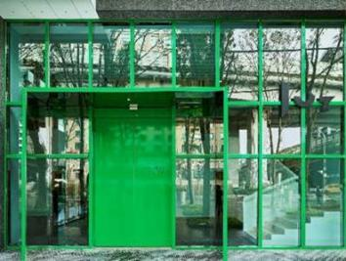 © Jut Art Museum

The Jut Art Museum is a private museum based in Taipei, Taiwan, which collects and presents contemporary international art and architecture. The museum was founded and supported by JUT Group in October, 2016. Jut Art Museum serves to explore what our future might be. The curation process of the museum is three-pronged: “future,” “urban architecture,” and “contemporary art.” We also anticipate it to carry on the legacy of “A Better Tomorrow” that defines much of the Foundation’s work, to become the first museum in Taiwan that is focused on the issues of “future” and “city.”

About Mori Art Museum

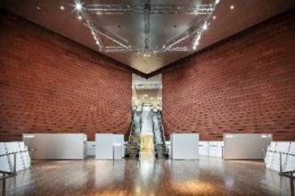 © Mori Art Museum, Tokyo

The Mori Art Museum, Tokyo, opened in 2003 with the aim of becoming a contemporary art museum of international importance, symbolic of the status of Roppongi Hills in Tokyo as “Cultural Heart of the City.” The Museum with a global outlook is committed to presenting cutting-edge visual arts, architecture, design and other modes of creative practice from around the world, from a unique viewpoint informed by its ongoing dedication to the “contemporary” and “international.” Above all, it plays an especially vital role as a center for contemporary art from Japan and the wider Asia-Pacific, by focusing on the art of the region, decoding individual cultural backgrounds and positioning emerging trends within a broader global context. Last but not least, the Mori Art Museum is committed to the principle of “Art + Life,” encouraging to realize an enriched, vibrant and well-rounded society where art relates to all aspects of life.

About Architect, Sou Fujimoto

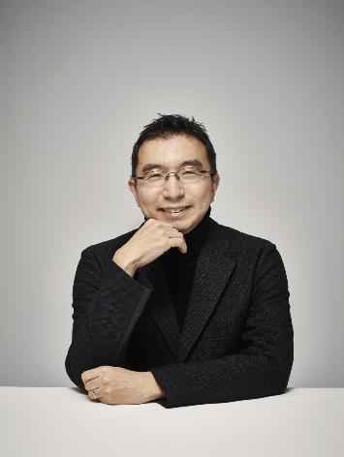 © Jan Buus

Born in Hokkaido, Japan, in 1971, Sou Fujimoto spent his childhood in nature’s embrace. Graduated from the Department of Architecture, Faculty of Engineering at the University of Tokyo, he established Sou Fujimoto Architects in 2000. His major early works include various facilities such as the Children’s Mental Health Center (Hokkaido, 2006) and the Musashino Art University Museum & Library (Tokyo, 2010), as well as private residences like House N (Oita, 2008). His design philosophy seeks to blur the boundary between the interior and the exterior of a building, forging a seamless connection between people and their environment, allowing them to wander freely amidst nature. The Serpentine Gallery Pavilion 2013 and his first-prize victory with L’Arbre Blanc (The White Tree) in the 2014 international design competition successively established Sou Fujimoto's reputation in Europe. In 2024, he was selected for “Subcontract for the Basic Design of the International Center Station Northern Area Complex (Tentative)” in Sendai, Miyagi, which is slated for completion in 2031. Furthermore, in his role as the Site Design Producer for Expo 2025 Osaka, Kansai, Japan, he has realized The Grand Ring, the largest wooden architectural structure in history.

Selected Architectural Works

Project Information | Images and Captions
House of Music Hungary  2021  Budapest  Theater, museum | 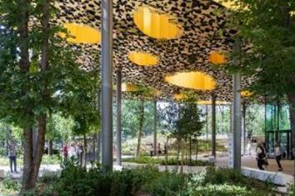  House of Music Hungary © Iwan Baan
The Grand Ring for Expo 2025 Osaka, Kansai, Japan  2025  Osaka  Promenade | 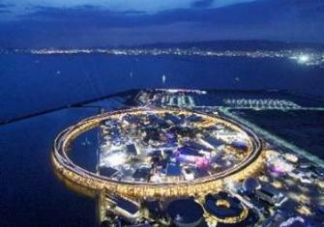  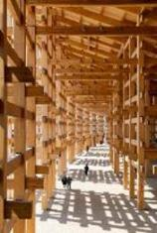  The Grand Ring for Expo 2025 Osaka, Kansai, Japan © Iwan Baan
Musashino Art University Museum & Library  2010  Tokyo  University library | 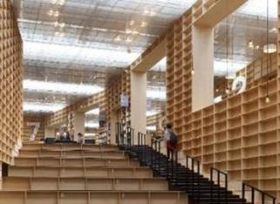  Musashino Art University Museum & Library © DAICI ANO
Children’s Mental Health Center  2006  Hokkaido | 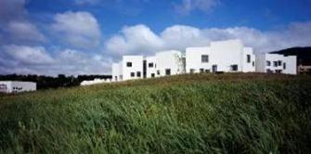  Children’s Mental Health Center © DAICI ANO
Serpentine Gallery Pavilion 2013  2013  London  Pavilion | 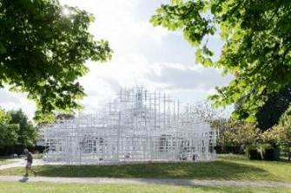  Serpentine Gallery Pavilion 2013 © Iwan Baan
The Aomori Museum of Art Design Competition Proposal  2000 (conception)  Aomori  Art museum | 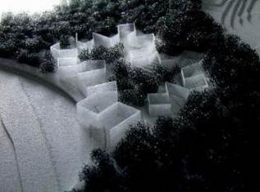  The Aomori Museum of Art Design Competition Proposal © Sou Fujimoto Architects
L’Arbre Blanc (The White Tree)  2019  Montpellier  Collective housing | 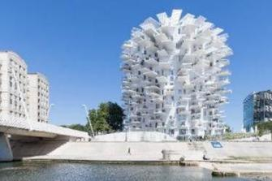  L’Arbre Blanc (The White Tree) © Iwan Baan

Press Images

NOTE
- The press kits and more photos can be downloaded in the link:
https://drive.google.com/drive/folders/1iV9FcObFy9Q5eSrLHHJvpF4wY0yoT78n?usp=sharing
- Standard Usage for Images: Photo credit/by must be given where applicable; and please indicate © Jut Art Museum.

Captions and Credits | Images
The Architecture of Sou Fujimoto: Primordial Future Forest (Vertical Version) Key Visual © Jut Art Museum | 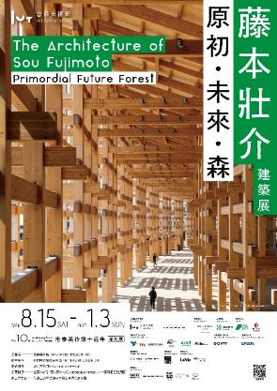
The Architecture of Sou Fujimoto: Primordial Future Forest (Horizontal Version) Key Visual © Jut Art Museum | 
Installation view of the “Forest of the Future” section © Jut Art Museum | 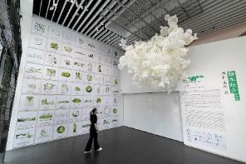  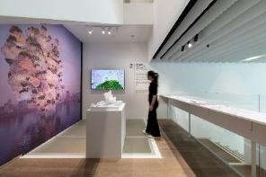
Installation view of the “Open Circle” section © Jut Art Museum | 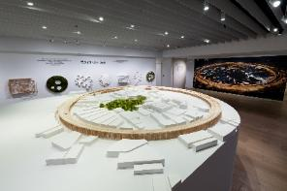  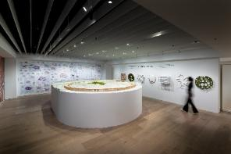  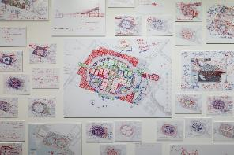
Installation view of the 1:5-scale partial model of “The Grand Ring” from Expo 2025 Osaka, Kansai, Japan, in the satellite venue © Jut Art Museum | 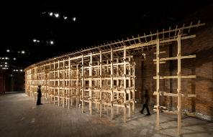  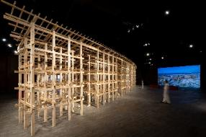  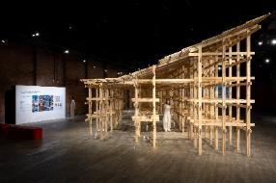  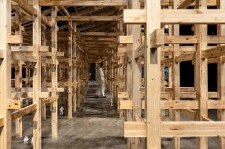
Installation view of the “Forest of Thoughts” section © Jut Art Museum | 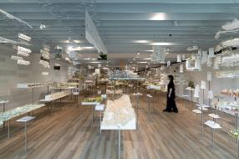  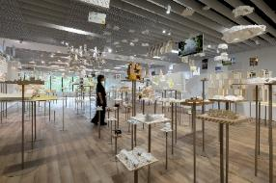  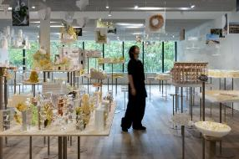
Installation view of the “Forest of Tracks” section © Jut Art Museum | 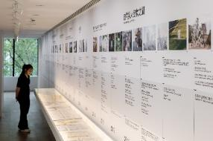  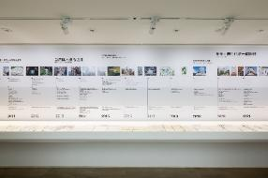  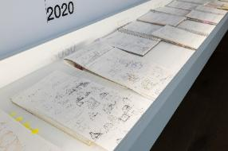
Sou Fujimoto with representatives from Jut Art Museum and Mori Art Museum © Jut Art Museum  From left:  Shan-Shan Huang, Director, Jut Art Museum  Sou Fujimoto, Architect  Mami Kataoka, Director, Mori Art Museum  Aaron Lee, CEO of the Jut Foundation | 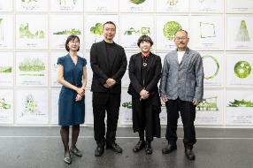
Aaron Lee, CEO of Jut Foundation, delivers remarks © Jut Art Museum | 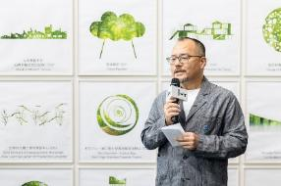
Mami Kataoka, Director of Mori Art Museum, delivers remarks © Jut Art Museum | 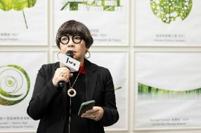
Architect Sou Fujimoto delivers remarks © Jut Art Museum | 