**Contents**

1. **About Jut Art Museum --------------------------------------------P.2**
2. **About Akihisa Hirata --------------------------------------------P.3**
3. **Photos------------------------------------------------------------------P.4~7**

**NOTE**

* The press kits and more photos can be downloaded in the link: <https://drive.google.com/drive/folders/1I_jlDlPtAeInyKb6OxIR4qAd7o1Hxt57?usp=sharing>
* Standard Usage for Images: Photo credit/by must be given where applicable; and please indicate © Jut Art Museum.

**【I - About Jut Art Museum】**

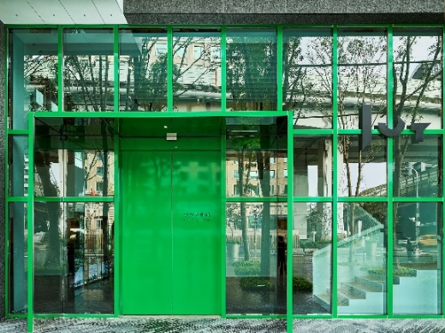 © Jut Art Museum

**Mission**

Jut Land Development’s 30th anniversary, and the Jut Foundation for Arts and Architecture (JFAA)'s 10th birthday, culminates in the establishment of the Jut Art Museum (JAM) in 2016. It is a milestone commemorating the history of Taiwan’s architectural aesthetics.

We anticipate that JAM to act as a new form of platform, catalyst and think tank devoted to corporate social responsibility fulfillment and addressing the societal dynamics of the 21st century. We also anticipate it to carry on the legacy of “A Better Tomorrow” that defines much of JFAA’s work, to become the first museum in Taiwan that is focused on the issues of “future” and “city.”

**Vision**

The Jut Art Museum, located in the heart of Taipei, is also where the Jut Foundation’s debut exhibition of “Museum of Tomorrow” is held. After ten years of circuit shows across the city, the exhibition is now back to where it all started, becoming a “showpiece in the heartland of the city and urban inhabitation.”

As an up-and-coming art establishment, JAM serves to explore what our future might hold, and transdisciplinary issues. The curation process of JAM is three-pronged: “future,” “urban architecture,” and “contemporary art.”

Japanese architect Jun Aoki is tasked with spacing designs of JAM. The identification system is developed by Atsuki Kikuchi. This is their first museum collaboration project in Taiwan. JAM – a statement of both sophistication yet cutting-edge conception – is downtown’s new architectural and art landmark; and it is poised at remaking and bringing new energy into Taipei’s cityscape.

|  |  |
| --- | --- |
|  | Website <https://jam.jutfoundation.org.tw/en>  Facebook <https://www.facebook.com/JUTARTMUSEUM>  Instagram <https://www.instagram.com/jutartmuseum/> |

**【II- About Akihisa Hirata】**

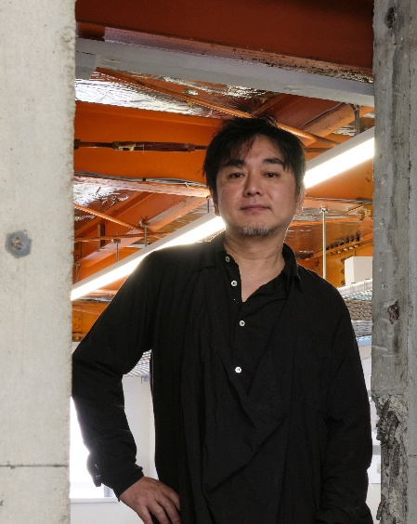 © Marc Goodwin, Archmospheres

Born in 1971, Osaka Prefecture, Akihisa Hirata earned his bachelor degree of architecture and master degree of engineering from Kyoto University. After working for Toyo Ito & Associates, Architects, Akihisa Hirata established his own firm. In addition to leading his Akihisa Hirata Architecture Office, he is also an architecture professor of Kyoto University. Akihisa Hirata is the winner of many architecture awards, including the Asakura Award of SD REVIEW (2004), JIA New Face Award (2008), Golden Lion at the 13th International Architecture Exhibition – La Biennale di Venezia (2012), the ADAN Prize (2015), and the 31st Murano Togo Prize (2018). He has won several architecture design competitions in Taiwan in recent years, such as Hsinchu Municipal Library Design Competition (2019) and NTU Center for the Arts Design Competition (2022). Akihisa Hirata’s solo exhibition HUMAN NATURE: Generosity and Its Form (2019) in Jut Art Museum, Taipei won the Golden Pin Design Award in 2020.

**【III - Photos】**

|  |  |
| --- | --- |
| **Photos** | **Caption** |
|  | Akihisa Hirata - Architecture Arises at the Water’s Edge for Humans (vertical) © Jut Art Museum |
|  | Akihisa Hirata - Architecture Arises at the Water’s Edge for Humans (horizontal) © Jut Art Museum |
|  | Tree-ness House ©Vincent HECHT |
|  | Tree-ness House ©Jut Art Museum |
|  | Taipei Roofs ©Dean Cheng |
|  | Taipei Roofs ©Jut Art Museum |
|  | Art Museum & Library, OTA ©Daici Ano |
|  | Museum and Art Gallery of National Taiwan University ©Akihisa Hirata Architecture Office |
|  | Museum and Art Gallery of National Taiwan University ©Jut Art Museum |
|  | HARAKADO ©KENYA CHIBA |
|  | HARAKADO ©Jut Art Museum |
|  | EXPO National Day Hall “Ray Garden” ©Jut Art Museum |
|  | Jut Art Museum Off-Site Project 2025 “Akihisa Hirata: Architecture Arises at the Water’s Edge for Humans” in Taipei, Taiwan © Jut Art Museum |
|  | Jut Art Museum Director, Shan-Shan Huang © Jut Art Museum |
|  | Architect Akihisa Hirata Introduces the Exhibition via Video © Jut Art Museum |