**The Jut Art Museum’s latest Contemporary Art Exhibition “Intro for the Chaos - Chung-Han Yao” is Now on View.**

**Artist Chung-Han Yao and theater producer Neo Wu make a joint endeavor to mount an interdisciplinary experimental exhibition.**

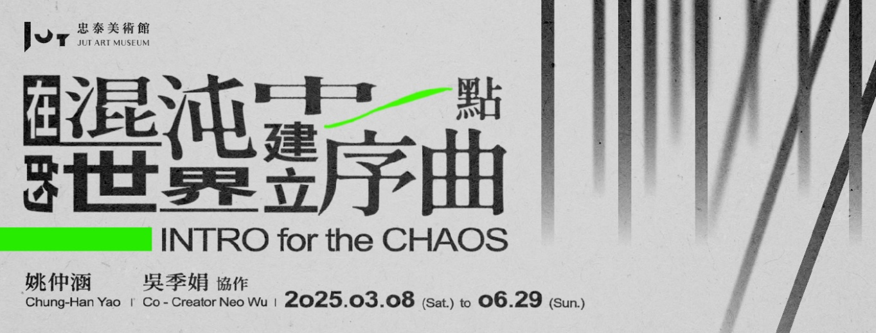

The current contemporary art exhibition ***Intro for the Chaos - Chung-Han Yao*** hosted by the Jut Art Museum is now on view. Jut Art Museum invites new media artist Chung-Han Yao and freelance theater producer Neo Wu to engage in transdisciplinary co-creation through a long-term, close dialogue, insofar as to present a new dimension of Yao’s works interlaced by his secret sensibility and stories. They solicited the participation of image creators and performing artists in these exhibited works. Bearing the signature of Yao’s audiovisual installation, the five works created for this exhibition collectively transform the venue of the Jut Art Museum into a “chaotic world” bristling with installations, sounds, images, as well as light and shadow. Being on view from 8 March to 29 June 2025, this exhibition beckons, inviting you to the venue arranged in a disorderly, random, and open fashion, where you can listen to the prelude that Yao and Wu composed for the chaotic world, in which you may find the rhythmic clues that guide you forward.

**The Jut Art Museum once again presents an interdisciplinary experimental exhibition, with Chung-Han Yao and Neo Wu collaborating for the first time.**

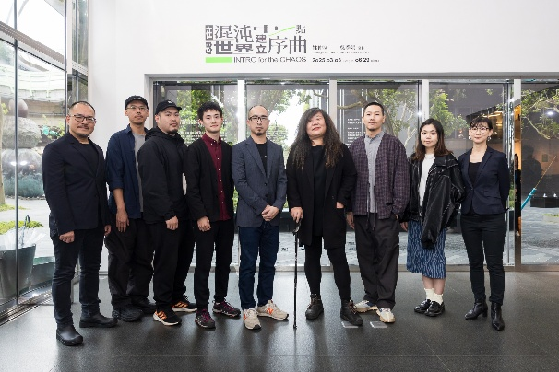 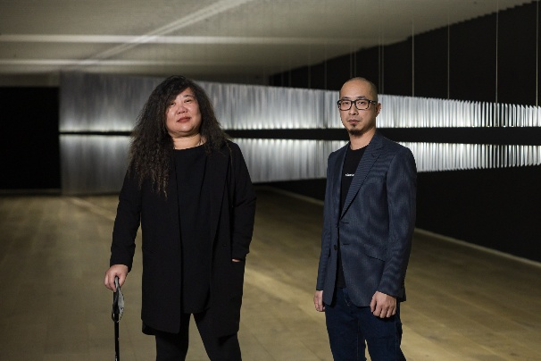

After the ***Sense on Site: Architecture x Art Exhibition*** in 2022 featuring a transdisciplinary collaboration between an artist and an architect, the Jut Art Museum, following the consistent spirit of experimentation, hosts the exhibition ***Intro for the Chaos - Chung-Han Yao*** this year, a collaborative project by two indefinable “creators” — Chung-Han Yao and Neo Wu — working together via a long-term, close dialogue. They went through myriads of questions, assumptions, deconstruction, and reorganization, and eventually shattered common stereotypes about transdisciplinary collaboration by means of co-creation. Although the exhibition does not directly show specific traces of their collaboration, Neo Wu’s role in this project is hidden behind the incubation and development of the exhibited works, driving the collision and evolution of their creative thinking, allowing Yao’s creative process to push the limits and open up new possibilities continuously.

**Five brand-new works — exploring the interplay between chaos and order, and writing another chapter of perceptional creation**

Applying “chaos” and “intro” as the underlying concepts, Yao and Wu delve into how humans survive amid chaos and order. They created five works with the participation of the Loudly Lightning Studio, image artist Wei-Hsuan Huang, and performing artist Kai-Cheng Cho. This exhibition is not only a creative dialogue between Yao and Wu, but also an experiment on collaboration, error, and understanding, jointly conducted by creators from diverse fields, and Yao attempts to respond to the abstract nature of audiovisual creations and contemplate the loss of corporeality through his works.

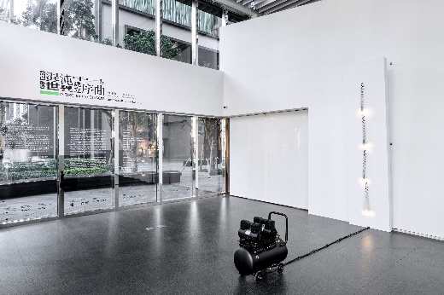 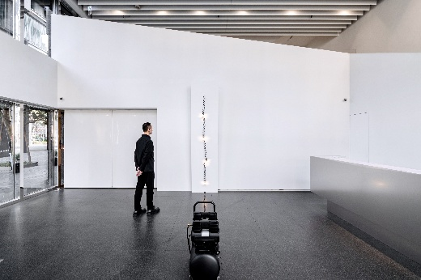

Yao presents an entirely new series of works in this exhibition. For the first time, he experiments with an air blow pipe and an air compressor to create the anthropomorphized work *Stronger, Weaker and Pump* which serves as a visual metaphor for the vicissitudes of life. The springs’ movement symbolizes chaos, whilst the electronic devices hidden behind the work operate regularly and construct a framework of order.

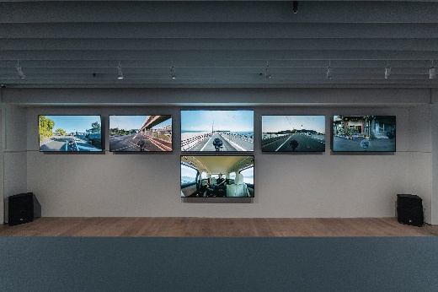 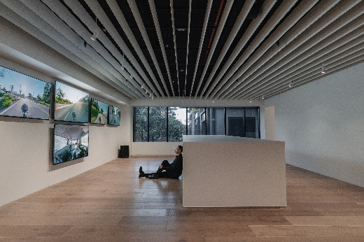

For the first time, Yao experiments with drumming and integrates it into his creative process in the multi-channel video work *Feel the Noise*. He collects environmental noise from external chaos, adds his perception of noise, and transforms it into a sound work with corporeality and order. In the exhibition venue, the sounds that the artist heard when creating the work come from the large loudspeakers, and the television screens on both sides broadcast the ambient noise captured from outside the car. The images are taken from the artist’s quotidian existence, encompassing his living sphere and neighborhoods in Taiwan and Japan, which creates a perceptual field where his personal experiences and urban soundscapes intertwine.

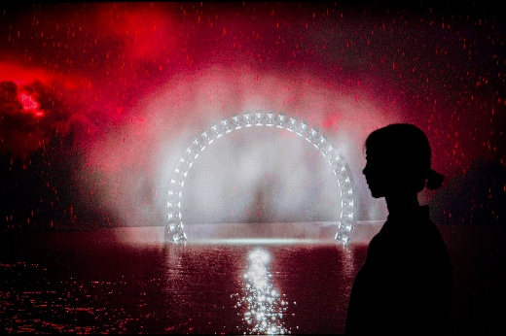 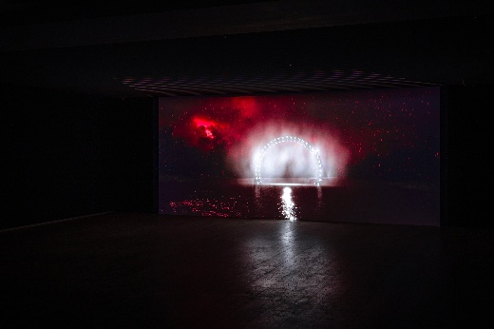

During his discussion with Wu, Yao took on the challenge of writing a script for the first time and completed his first video work *Electronic Monsters Universe – Future*. In collaboration with Wei-Hsuan Huang, this work employs the sci-fi apocalypse as the worldview that threads through the *Electronic Monsters* series. The story is set in 2525 when the sun is dying and people suffer from the “light deficiency syndrome.” In the end, humans are able to fight against the darkness by activating the electronic monsters. This work links Yao’s previous creations with a fresh new narrative perspective, responding to the abstract nature of audiovisual art and meanwhile initiating an experimental exploration of visual languages.

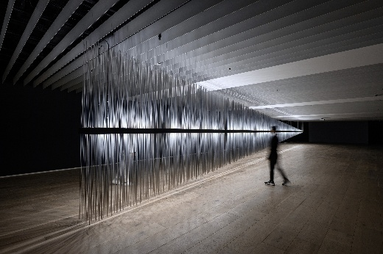 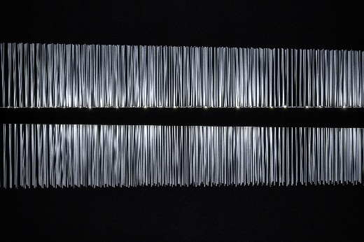

The *Electronic Monsters* series used to be displayed in open spaces, focusing on the flow of light sources. This exhibition features the new large-scale installation, *An Electronic Monster #41 – Chaos* presented in the indoor space. It creates a unique sensory experience through its dialogue with the space of the Jut Art Museum. The sounds become more immersive in such an environment. Revolving around shadows, this work continues the inquiry into the dynamic relationship between light and sound. The work deepens the dialogue and narrative potential between light and shadow through the orderly variation in the length of the aluminum tubes and the interplay of light and shadow. During the exhibition, *An Electronic Monster #41 – Chaos* will also be transmuted into a theatrical stage on which performing artist Kai-Cheng Cho is invited to deliver *Precarious Balance* and interact with this work on 11 April and 17 May 2025. On 16 June, Yao and Cho will present *Chaos / Force / Volume*, the fifth work in the exhibition, which further expands the creative dynamics and performativity through performance art.

**The exhibition’s brilliant side events: The Jut Art Museum** **will launch performances, lectures, and online guided tours by personages.**

Focusing on “future,” “urban architecture,” and “contemporary art” with the museum’s venue as a medium, Jut Art Museum’s exhibitions invite creators with different backgrounds to engage in creative exchanges and cogitation on the relationship between humans and spaces in the spirit of interdisciplinary experimentation. The exhibited works represent the chemical reactions among creators’ thoughts that challenge the visitor’s viewing experience. In the exhibition ***Intro for the Chaos - Chung-Han Yao,*** Yao and Wu, as an artistic duet, showcase the broad horizons and innovative energy generated by interdisciplinary creation.

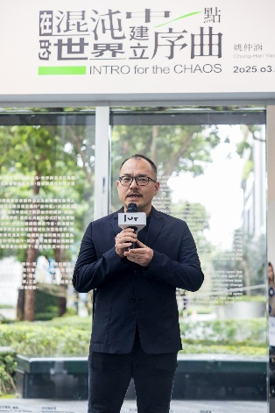

“In recent years, natural and man-made disasters have occurred frequently at home and abroad. It seems that contemporary people must learn to navigate ‘chaos’ and keep moving forward. As a private art museum in Taiwan, we can work together with creators to reflect on our society, try to provide visitors with different perspectives, and offer alternative interpretations of the society,” Aaron Lee, the CEO of the Jut Foundation for Arts and Architecture, stated so.

The exhibition ***Intro for the Chaos - Chung-Han Yao*** is on view from 8 March to 29 June 2025. A concatenation of on-site events like lectures and performances will take place during the exhibition. Creators from various cultural fields, e.g., exhibition, architecture, and new music, will be invited to record guided tours from their perspectives, offering audiences diverse viewpoints on this exhibition. For details of exhibition events and special offers, please visit the official website of the Jut Art Museum.

**Information**

**Exhibition｜*Intro for the Chaos - Chung-Han Yao***

Date｜2025.3.8(Sat.)-2025.6.29(Sun.)

Venue｜Jut Art Museum (No.178, Sec. 3, Civic Blvd., Da'an Dist., Taipei City 106, Taiwan)

Opening Hours｜TUE-SUN 10:00-18:00 (Closed on Mondays)

Admission｜General TWD 150, Concessions TWD 100 (Student, seniors aged 65 and above, and groups of 10 or more)

Free Admission for the disabled and a companion, children aged 12 and under (Concessions or Free Admission upon presentation of valid proof)

Student Day on WED｜Free Admission once on Wednesdays upon presentation of valid student ID

Website｜**<https://jam.jutfoundation.org.tw/en/exhibition/107/5024>**

**Artists**

Artist｜Chung-Han Yao

Co-creator｜Neo Wu

Organizer & Coordinator｜Jut Art Museum

Appointed TV / Screen Sponsor｜SONY

Appointed Projector Sponsor｜BenQ

Cultural Partner｜eslite member

Media Partners｜Art Emperor、ARTouch、Sound of Life

Event Partners｜ONIBUS、NOKE JUT RETAIL

Special Thanks｜Hello World、Live Good Sound

**Exhibition Team**

Exhibition Supervisors｜Aaron Y. L. Lee, Alex Y. H. Lee, Shan-Shan Huang

Exhibition Coordinators｜Tsuei-Yi Jang, Ying-Peng Chen, Yen-Hsiu Chen, Yu-Chen Tsai, Chia-Ching Lin

Exhibition Creation Coordination｜Jui-Pin Tseng, Da-Yan Luo, Wei-Hsuan Huang, Kai-Cheng Cho , Ling-Chieh Cho

Communications and Marketing Coordinator｜Chi-Yun Chang

Communications and Marketing｜Yen-Shan Li, Yu-Chin Liou, Yi-Ning Lin

Public Service｜Tsung-Ping Hung, Pei-Chun Tsai

Administration Coordinator｜Hsin-Yi Lin

Visual Design｜Chen-Huang Chian

Lighting Design｜LighTemp