Paradise Lost- An Atypical Exhibition of Architecture
The Vicissitude of Civilization Built on Human Desires
Five Taiwanese, American, Japanese and Dutch Artists Present Their Own Lost Paradises

“The mind is its own place, and in itself can make a heaven of hell, a hell of heaven.”
― John Milton, Paradise Lost.

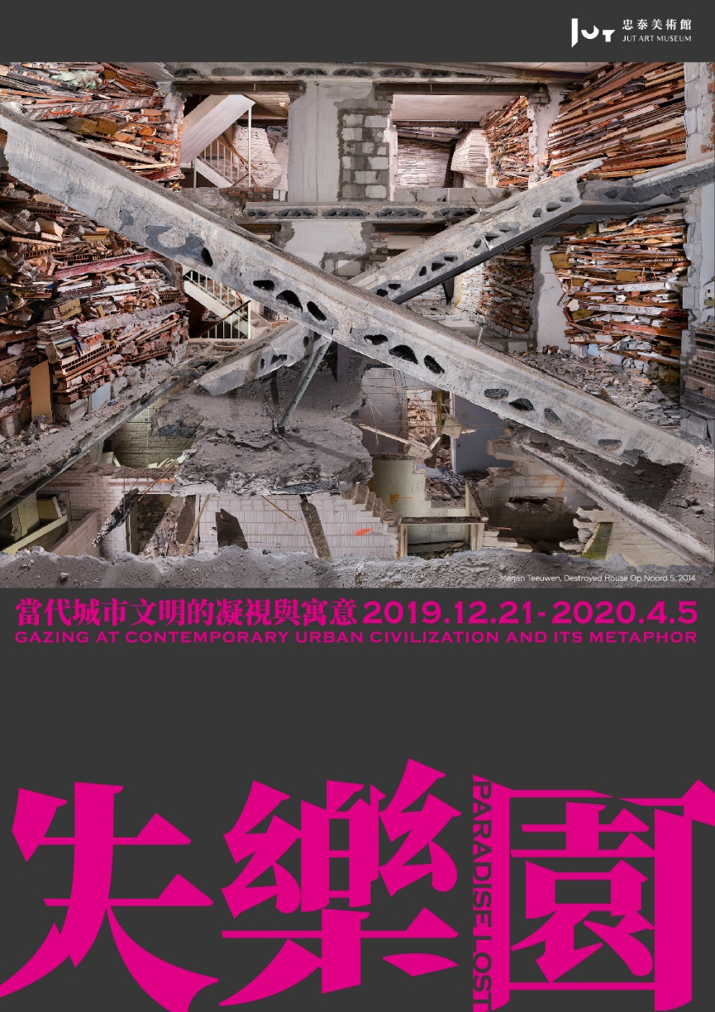

The Jut Art Museum, which is the first museum in Taiwan focusing on urban issues and the future of cities, is launching Paradise Lost – Gazing at Contemporary Urban Civilization and its Metaphor on Dec 21 (Sat). World acclaimed artists including Marjan Teeuwen from the Netherlands, James Casebere from the US, Takahiro Iwasaki from Japan, Yao Jui-Chung and Tu Wei-Cheng from Taiwan are interpreting their ideas about the destruction and rebirth of urban civilization through their vintage or new projects of videos or installations. They reflect upon the changes of cities due to human desires, capitalism or wars and engage the audience to contemplate with them. This exhibition starts on Dec. 21, 2019 and ends on Apr. 5, 2020.

An Alternative “Paradise Lost” Performed by Five Artists

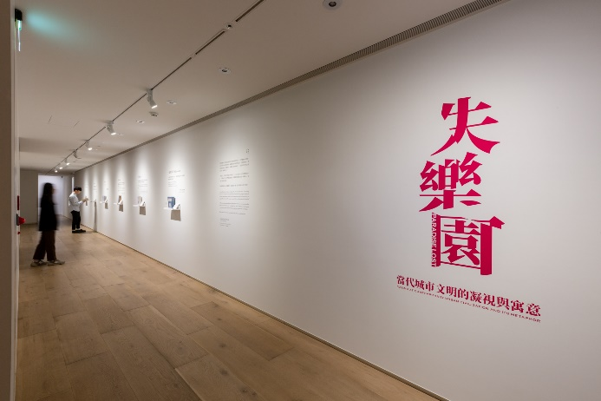
Entering 2020, Paradise Lost – Gazing at Contemporary Urban Civilization and its Metaphor is Jut Art Museum’s representation of John Milton’s epic poem dated back to the 17th century. Five artists from the Netherlands, America, Japan and Taiwan express their ideas of cityscapes with urban relics. Through their art, the audience is led to see the changes in cities by the forces of globalization, capitalism and wars. Meanwhile, the free will and the ever-expanding desires in human nature have driven the construction of a fake garden of wonders, which decided our social conditions. The paradoxes and implications in these spaces are divulged in the interrelation between human and urban civilization. Five zones in this exhibition are made into the lost paradise in the mind of each artist.

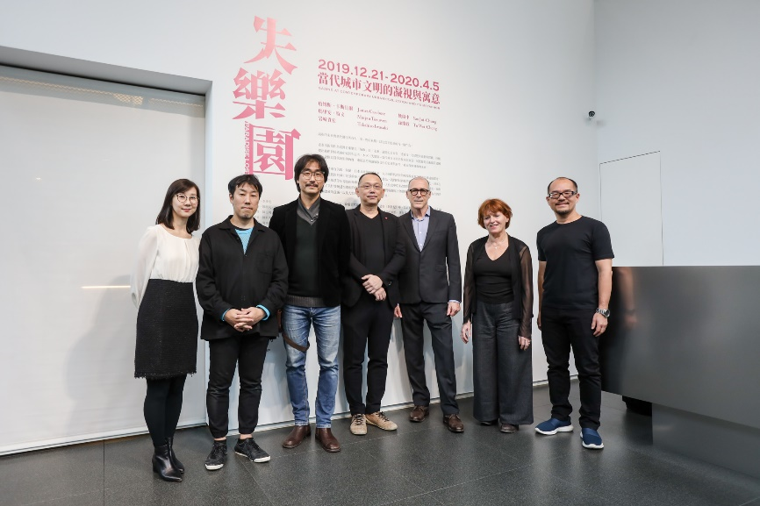
“Presenting Paradise Lost at the end of the year is to break through the stereotype of how people see the cities from the professional frame of architecture. Instead, through the derelict sites and relics, we found a deeper context in the development of human world that allows us to think about the man-made urban civilization before marching into the future.” Stated Aaron Lee, the CEO of the Jut Foundation for Arts and Architecture, in the press release conference for the opening.

The Two Sides of Civilization: Destruction and Rebirth
The rise and fall of a civilization produce residue—ruins of buildings no longer in use. Their properties are lost as their functions fail, becoming the transitional spots between the past, present and future. In this exhibition, Dutch artist Marjan Teewen and Taiwanese artist Yao Jui-Chung create their lost paradises with ruins.
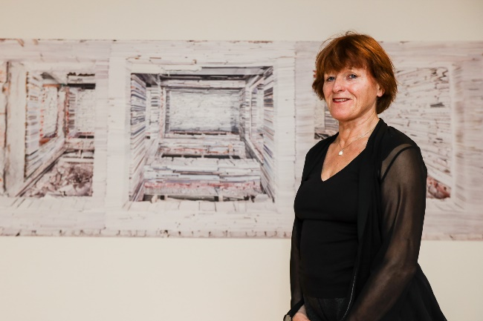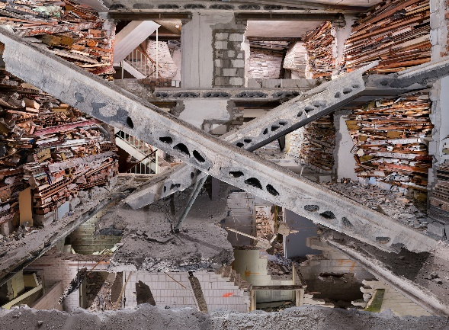
It is Marjan Teeuwen’s first time exhibiting in Taiwan. In her work that “creation not as the opposite of destruction, but as intimately entangled with it” is proposed. Photos and documentary films based on the architectural installations of Marjan Teeuwen, a building as sculpture, had engaged in the Netherlands, France, Russia, South Africa and Gaza Strip are represented. Positioning herself at the sites ruined by urban renewal or wars, she reassembles the relics for the artworks and memories specifically belonging to the sites. She manufactures architectural sculpture of new orders, structures, joints, and relations. It also triggers the reorganization and documentation of memories.

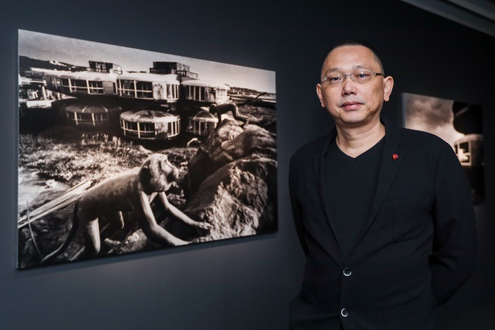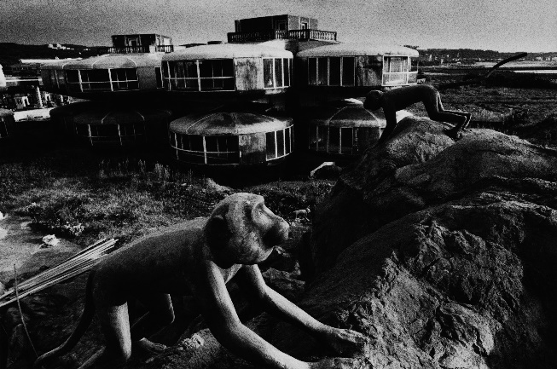
Yao Jui-Chung, an artist representing Taiwan in international art events many times, has investigated abandoned sites throughout Taiwan for years. In this exhibition, he presents the “ideological black holes” tides of globalizing, the development of capitalism and the changing political scenes with black-and-white photography. These images come from his earlier series Roaming Around the Ruins that captured the UFO Houses in Sanzhi, the 13-Storey Mine Selection Plant at the Shuinandong, the Old Haocha Settlement in Pingtung, and Huazhai Village of Wang’an Island in Penghu. The artist attempts to discuss the quick developments of real estate, mining and urbanization during the golden age of Taiwan’s economy, and when the fever of investment has receded, both people and capitals withdrew, leaving the sites into oblivion.

In Between the Virtual and the Real Laid the Metaphor of Urban Civilization
The cityscape constructed according to human wills and desires seems to be peaceful, but how many risks and sacrifices have been implied? How do we understand the world we are living in? What is the truth, what is made up? James Casebere, Takahiro Iwasaki and Tu Wei-Cheng represent cultural milieux with which they concerned through their own styles of surrealism.

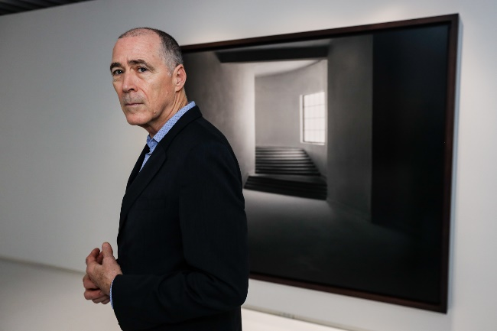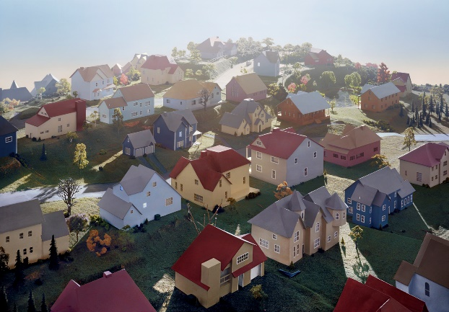
American artist James Casebere is known for his constructed photography—photos of self-made architectural models with dramatic lighting. The rational, calm and distanced images without any human trace are inviting the audience to put themselves into the scenes. Colorful houses are from the wonderful time before the subprime mortgage crisis. Applying water around buildings as a motif, the artist recalls the flooded underground tunnels between the East and West Germany, and the course of slavery in the past. It is his lament to the lost historical memory. In this exhibition, we are seeing James Casebere’s works of different contexts that he has accumulated for years. The models are also presented in Taiwan for the first time.

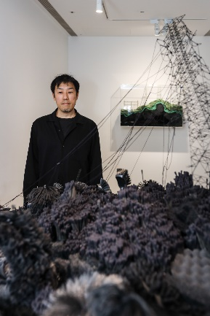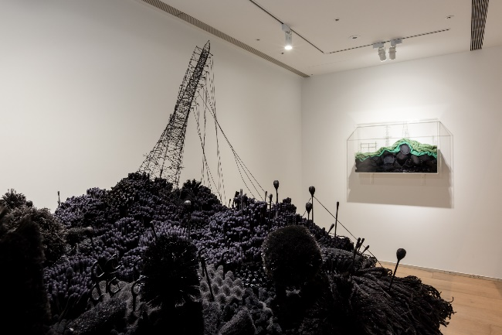
Coming from Hiroshima, Takahiro Iwasaki has an art career evolving around the city once devastated by the atom bomb and its rebirth. He transforms towels, toothbrushes and toothpicks among other commonplace items into a sculpture of miniature landscape. The Out of Disorder (Collapse) is about the nuclear disaster in Fukushima after the earthquake in 2011. The black fallen transmission towers and devastated landscape tell us how vulnerable the energy supply systems are today. The blackness is the symbol of the world over-reliance on coal, fossil, and nuclear power which eventually results in the termination of all living chances.

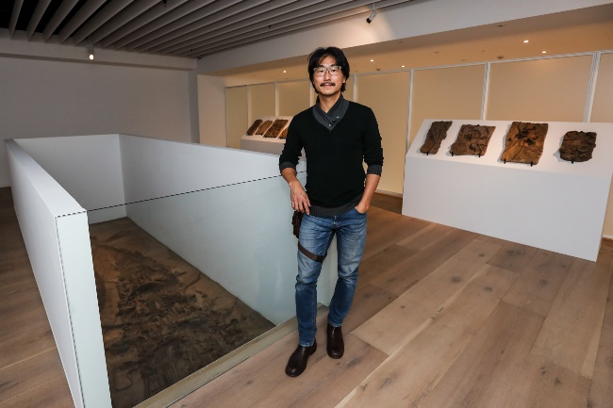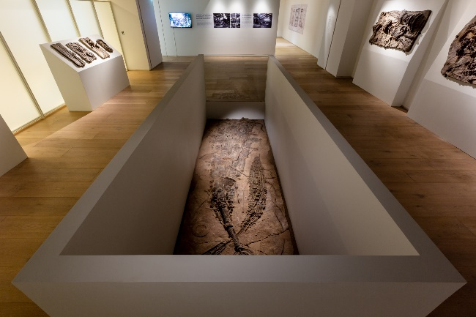
An expert in combining legends, social issues, archaeological and historical knowledge, Tu Wei-Cheng is presenting his new project Museum of Ichnofossils for this exhibition. The political and economic changes over the past have resulted in the closures of many factories and abandoned facilities. The artist collected the components of machines, remnants of the buildings and plants around the sites and made into artificial fossils by pressing and molding clay. The obscure features of these fossils remind us of the past glory, the present decay and the unknown future because of the natural and social selection.

Through Contemporary Art, JUT Art Museum Presents Atypical Architecture Exhibition to Discuss Urban Development from Multiple Perspective
The Jut Art Museum is the first museum in Taiwan focusing on urban issues and the future of cities. Since its inauguration in 2016, it continues exploring and reflecting the future, urban architecture and contemporary art.

A continuation of the earlier exhibition The Flying Land, Paradise Lost – Gazing at Contemporary Urban Civilization and its Metaphor investigates immigrating and the changing urban civilization, and human behaviors in different contexts of space. It attempts to challenge the boundary of architecture and art, which is best practiced by an atypical exhibition of architecture with the perspective of contemporary art.

To inspire the public and students to participate in this exhibition, the Museum has multiple benefits for visitors, including free admission for students with ID on every Wednesday. Also on Wednesdays, the eslite forum attendees with ID are provided free admission, and visitors holding eslite bookstore member card can buy one ticket and get one free. Visitors with room card of Miramar Garden Taipei and four hotels under GLORIA HOTEL GROUP (HOTEL PROVERBS Taipei/ HOTEL QUOTE Taipei/ GLORIA RESIDENCE/ GLORIA PRINCE HOTEL Taipei) can have one-time free admission of their stay. For more info on the ticket benefits, please check out the webpage of the Jut Art Museum.

【Attachment 1-Information】
Paradise Lost – Gazing at Contemporary Urban Civilization and its Metaphor
Artists:
- James Casebere（U.S.A）
- Marjan Teeuwen（The Netherlands）
- Yao Jui-Chung（Taiwan）
- Tu Wei-Cheng（Taiwan）
- Takahiro Iwasaki（Japan）
Venue: Jut Art Museum (No.178, Sec. 3, Civic Blvd., Da'an Dist., Taipei City 106, Taiwan)
Date: 21st December 2019 – 5th April 2020
Opening Hours: TUE-SUN 10:00-18:00 (Closed on Mondays)
Admission: General TWD 120, Concessions TWD 100 (student, seniors aged 65 and above, and groups of 10 or more) *Booklet included.
Free Admission for the disabled and a companion, children aged 12 and under (Concessions or Free Admission upon presentation of valid proof).
Student Day on WED: one-time Free Admission on Wednesdays upon presentation of valid student ID
Organizer & Coordinator: Jut Art Museum
Website: http://jam.jutfoundation.org.tw/en/exhibition/107/2157

International Partner: Netherlands Trade and Investment office
Cultural Partners: the eslite forum, eslite member
Official Hotel Partner: GLORIA RESIDENCE
Official Display Partner: SONY
Media Partner: Art Emperor, xin ARCHI, La Vie
Event Partner: MOT Cafe
Special Thanks: SEAN KELLY、ANOMALY、Het Nieuwe Instituut、TINA KENG GALLERY

【Attachment 2-Artist’s Biography】
Artist |  | Background
James Casebere  （U.S.A） | 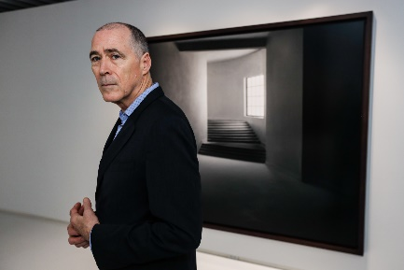  © Jut Art Museum | b. 1953  James Casebere is an American contemporary artist and photographer living in Canaan, New York. As the recipient of the Abigail Cohen Rome Prize 2019-2020, James Casebere resides at the American Academy in Rome. He grew up outside of Detroit, studied with Siah Armajani as an undergraduate student at the Minneapolis College of Art and Design and John Baldessari as a graduate student at Cal Arts. Part of the Pictures Generation of postmodern artists such as Cindy Sherman, Richard Prince, and others, Casebere has been at the forefront of constructed photography.  For over 40 years he has built and photographed architecturally based models, which explore the relationship between sculpture, photography, architecture, and film. His work has often dealt with themes of social control and the history of institutional spaces and his process often involves creating tabletop sized models out of modest materials such as Styrofoam and cardboard and then dramatically lighting the model to set the mood for the subsequent photograph. The photographs are always unpopulated, inviting the viewers to project themselves into the space.  James Casebere’ s work is in the collections of and has been shown at major museums around the world including the Museum of Modern Art, the Solomon R. Guggenheim Museum, and the Whitney Museum (New York); the Tate Gallery (London); the Los Angeles County Museum of Art (Los Angeles); and many others.
Marjan Teeuwen  （The Netherlands） | 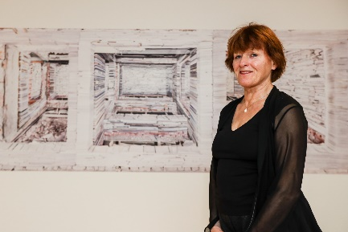  © Jut Art Museum | b. 1953  Marjan Teeuwen is a Dutch artist who lives and works in Amsterdam, Netherlands. She realizes large-scale architectural installations in buildings that are subsequently demolished. A building as sculpture.  Teeuwen’s work expresses a great engagement with the excesses in human history through her life. The excesses of violence and their manifestations in human conditions, as well as the opposite force of construction, are fundamental to her creation. Pointing out the polarity of construction – destruction, falling – standing, order – chaos. A diabolic conflict. In her competently titled body of work, Destroyed House, Teeuwen reclaims the wreckage of abandoned buildings assembling each fragment in painstakingly detailed installations, set within the original structures. Autonomous photos, also a magnificent part of her work, are created on the basis of these installations.  Teeuwen’s work has been exhibited widely in institutions and is held in numerous private and public collections including ARCAM, Amsterdam; Museum De Lakenhal, Leiden; Nederlands Fotomuseum, Rotterdam; Museum Van Bommel Van Dam, Venlo; Ministry of Foreign Affairs, The Hague; Collection AKZO NOBEL; Collection FNAC, Paris; Cisneros Fontanals Art Foundation, Miami; Stedelijk Museum, Amsterdam.
Yao Jui-Chung  （Taiwan） | 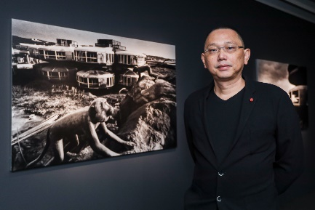  © Jut Art Museum | b.1969  Yao Jui-Chung is a Taiwanese artist who completed his bachelor degree of fine art from the Taipei National University of the Arts in 1994. Currently, he is an adjunct associate professor of the Department of Fine Art, National Taiwan Normal University, and holds a chair of the National Culture and Arts Foundation. Yao Jui-Chung is also the director of Illusion Art Studio.  Over the past years, Yao Jui-Chung follows a double-helix path of creation— issues on the Politics of Bodies and the Politics of Spaces come across one another from time to time. His personal archival studies of the nation-wide land surveys achieved several projects of ruins. In 2010, Yao Jui-Chung founded the Lost Society Document (LSD) and began focusing on the unused public spaces. In his work, images of the dilapidated objects have been transformed in the context of art through his documentary photography that investigates the power behind these buildings and spaces.  Yao Jui-Chung had exhibited in the Venice Biennale, Venice Biennale Architecture, Asia Pacific Triennial of Contemporary Art, Asia Triennial Manchester, Yokohama Triennale, Biennale of Sydney, Shanghai Biennale, among other international events. He is also the recipient of the Asia Pacific Art Prize (Singapore), the Multitude Art Prize (Hong Kong), and the Taishin Arts Award (Taiwan).
Tu Wei-Cheng  （Taiwan） | 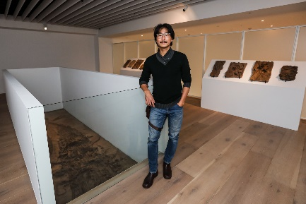  © Jut Art Museum | b.1969  Tu Wei-Cheng is a Taiwanese artist, who has completed his professional training in western art from the Department of Fine Art, Chinese Culture University in 1993 and plastic art from the graduate school of the Tainan National University of Arts in 2005. Currently, he is an assistant professor of the Taipei National University of the Arts. Now he lives and works on his creation in Taoyuan, Taiwan.  Tu Wei-Cheng’s art is his attempt to present the materiality through the labor of his own body and his skills. He demonstrates how an artist self-institutionalized his actions of interpreting “relational aesthetics”. Tu Wei-Cheng’s artworks are his mimicry of the systematic knowledge and operations of archaeology and museology. He constructs a system of modern myths by collaging history, anecdotes, objects and phenomena that had happened in different ages and civilizations. A sense of incongruity is to refer to the current status of our civilization, as well as the dissension and anxiety over cultural identity in the divergent Taiwanese society.  Recently Tu Wei-Cheng has been exhibiting in major events throughout the world, including the 2019 The Future of Now: Bu Num Civilization in the Rijksmuseum in Amsterdam, 2018 Voyage in Time—the 1st Thailand Biennale, where his project is permanently installed in Krabi, and 2017 Collecting Europe—4017 Enfolded World: Mysteries of Lost Civilizations in London V&A. He also had been in the 2012 Guangzhou Triennial, 2012 Gwangju Biennale, 2010 Taipei Biennale, 2006 Shanghai Biennale. Tu Wei-Cheng was the winner of the 28th Taipei Art Award in 2001 and the Jury’s Special Award of Taishin Art Awards in 2004.
Takahiro Iwasaki  （Japan） | © Jut Art Museum | b.1975  Takahiro Iwasaki is a Japanese artist who was born in Hiroshima and now lives and works in Hiroshima. Takahiro Iwasaki earned his doctoral degree from the Hiroshima City University in 2003 and continued his study in the UK and accomplished his master degree of fine art from the Edinburgh College of Arts in 2005.  Takahiro Iwasaki’s art consists of mainly two series, Reflection Models and Landscape Models. Reflection Models are the artist’s representation of symbolic buildings in Japan, meticulously hand made with wood. These structures are unified with the reflection on the surface of the water. Landscape Models closely relate to the history of Hiroshima, a city destroyed by the atomic bomb and then regenerated. The delicate but enchanting works of Landscape Models lead the audience to look at things in daily life from different angles.  In the 2017 Venice Art Biennale, Takahiro Iwasaki represented Japan with his solo exhibition Turned Upside Down, It’s A Forest. His artworks have been collected by the Kadist Art Foundation, San Francisco, Mori Art Museum, Tokyo, Victoria Museum, Melbourne, and the Gallery of Modern Art, Brisbane, 21st Century Museum of Contemporary Art, Kanazawa among other organizations.

Paradise Lost – Gazing at Contemporary Urban Civilization and its Metaphor
images & video descriptions and credits. Please state the copyright of the images as below:
Download link: https://drive.google.com/drive/folders/1UKHUQn9kHpaVscFoTGsbnkjeaDWMttvP?usp=sharing

Key visual design
Paradise Lost – Gazing at Contemporary Urban Civilization and its Metaphor Key visual design.  photo credit: Jut Art Museum | 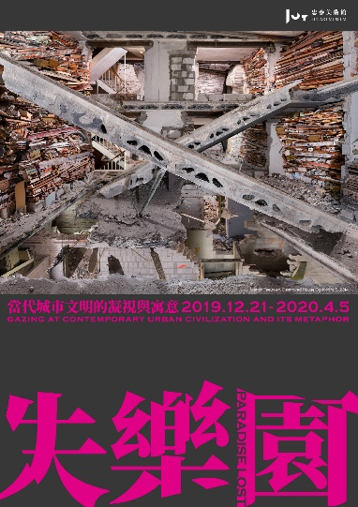
Artists
James Casebere and his artwork: Turning Hallway  photo credit: Jut Art Museum | 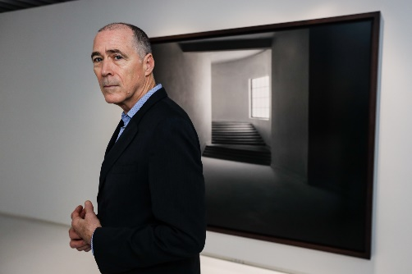
Marjan Teeuwen and her artwork: Destroyed House Bloemhof 1  photo credit: Jut Art Museum | 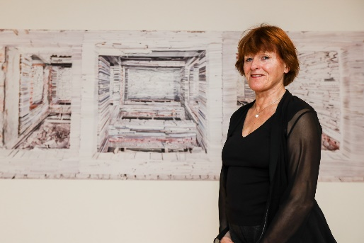
Yao Jui-Chung and his work: Roaming around the Ruins IV – Gods ＆ Idols Surround the Border (UFO Villa: Monkey)  photo credit: Jut Art Museum | 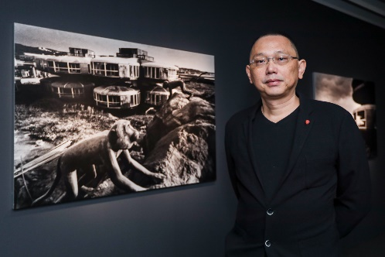
Tu Wei-Cheng and his work: Museum of Ichnofossils  photo credit: Jut Art Museum | 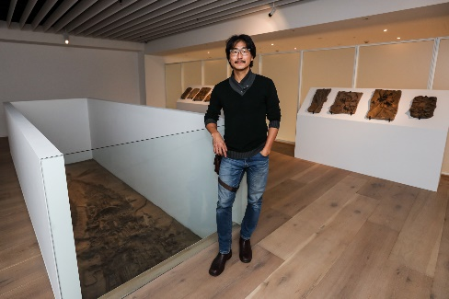
Takahiro Iwasaki and his work: Out of Disorder  photo credit: Jut Art Museum | 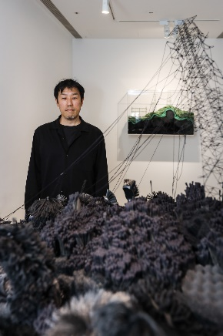
Installation view
Installation view: Paradise Lost – Gazing at Contemporary Urban Civilization and its Metaphor  photo credit: Jut Art Museum | 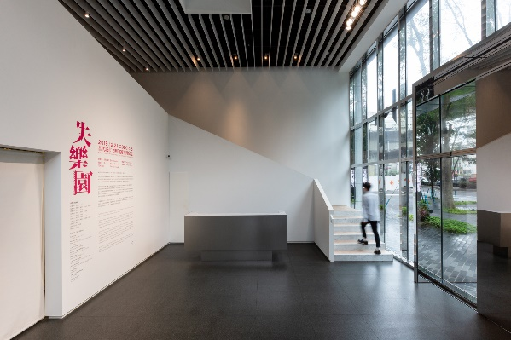
Installation view: Paradise Lost – Gazing at Contemporary Urban Civilization and its Metaphor – “Takahiro Iwasaki’s artworks”  photo credit: Jut Art Museum | 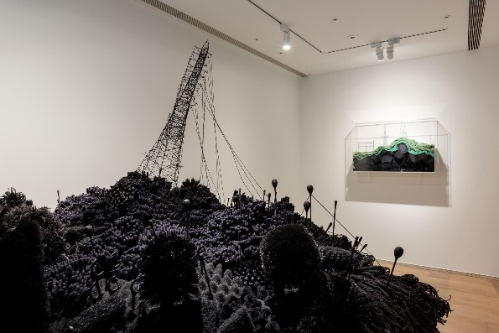
Installation view: Paradise Lost – Gazing at Contemporary Urban Civilization and its Metaphor – “Takahiro Iwasaki’s artworks”  photo credit: Jut Art Museum | 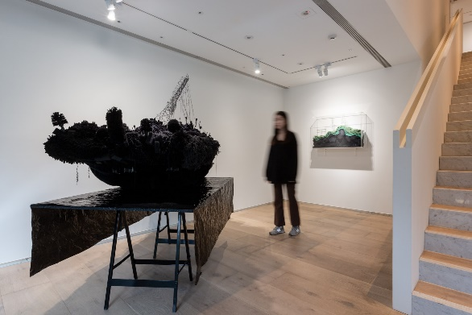
Installation view: Paradise Lost – Gazing at Contemporary Urban Civilization and its Metaphor – “ #hashtag Area”  photo credit: Jut Art Museum | 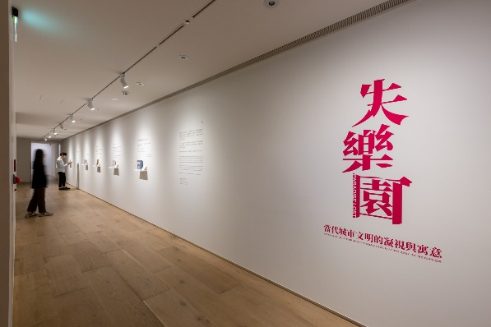
Installation view: Paradise Lost – Gazing at Contemporary Urban Civilization and its Metaphor – “ #hashtag Area”  photo credit: Jut Art Museum | 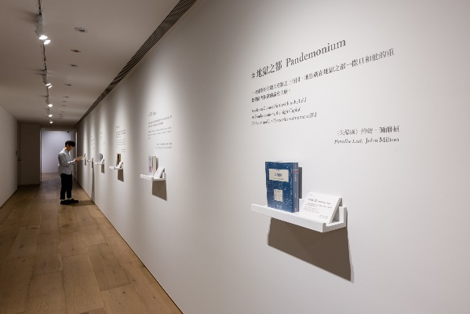
Installation view: Paradise Lost – Gazing at Contemporary Urban Civilization and its Metaphor – “James Casebere’s artworks”  photo credit: Jut Art Museum | 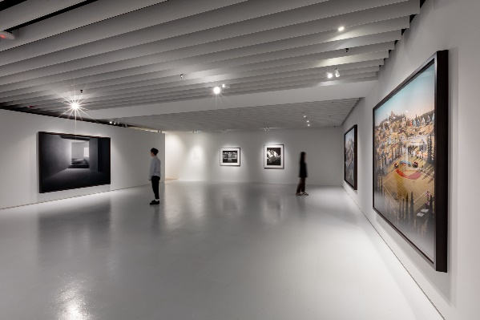
Installation view: Paradise Lost – Gazing at Contemporary Urban Civilization and its Metaphor – “James Casebere’s models”  photo credit: Jut Art Museum | 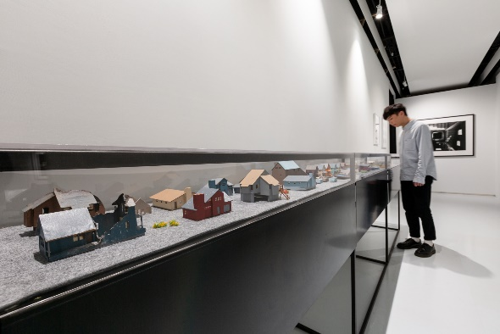
Installation view: Paradise Lost – Gazing at Contemporary Urban Civilization and its Metaphor – “Yao Jui-Chung’s artworks”  photo credit: Jut Art Museum | 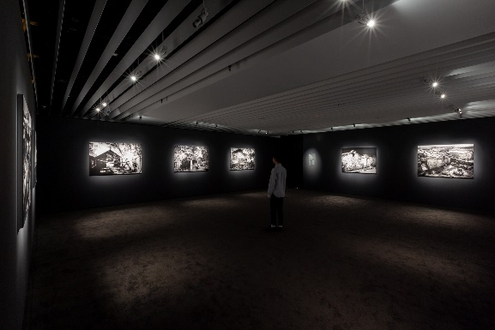
Installation view: Paradise Lost – Gazing at Contemporary Urban Civilization and its Metaphor – “Yao Jui-Chung’s artworks”  photo credit: Jut Art Museum | 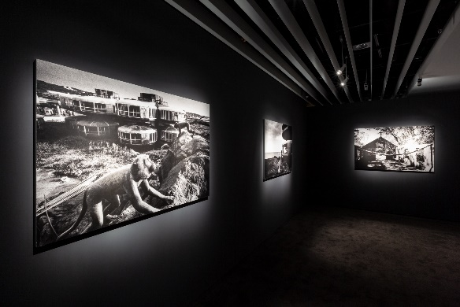
Installation view: Paradise Lost – Gazing at Contemporary Urban Civilization and its Metaphor – “Marjan Teeuwen’s artworks”  photo credit: Jut Art Museum | 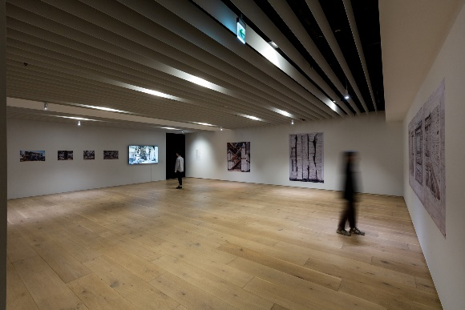
Installation view: Paradise Lost – Gazing at Contemporary Urban Civilization and its Metaphor – “Marjan Teeuwen’s artworks”  photo credit: Jut Art Museum | 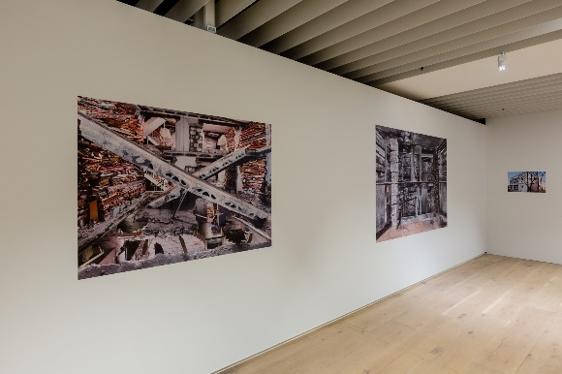
Installation view: Paradise Lost – Gazing at Contemporary Urban Civilization and its Metaphor – “Tu Wei-Cheng’s artworks”  photo credit: Jut Art Museum | 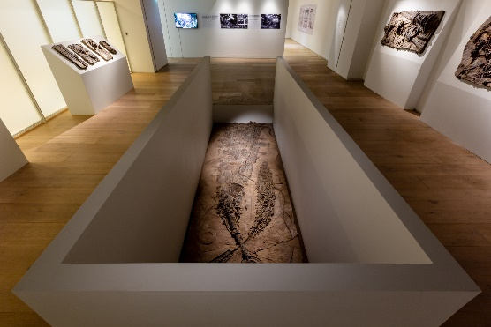
Installation view: Paradise Lost – Gazing at Contemporary Urban Civilization and its Metaphor – “Tu Wei-Cheng’s artworks”  photo credit: Jut Art Museum | 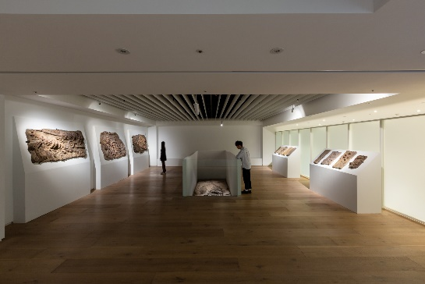

Highlights
James Casebere’s work: Stairwell, 1983-2012  © James Casebere  Courtesy: the artist and Sean Kelly, New York  *must include the complete words above | 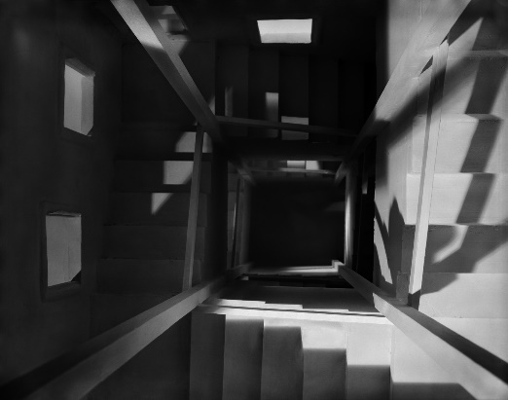
James Casebere’s work: Landscape with Houses (Dutchess County, NY) #1, 2009  © James Casebere  Courtesy: the artist and Sean Kelly, New York  *must include the complete words above | 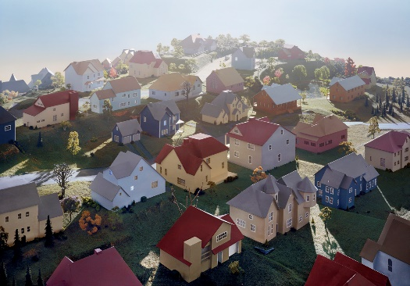
Marjan Teeuwen’s work: Destroyed House Op Noord 5, 2014  photo credit: Marjan Teeuwen | 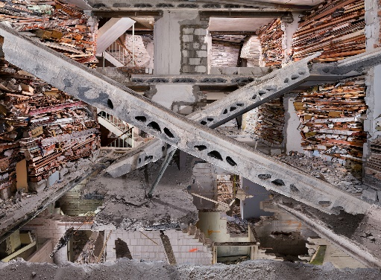
Marjan Teeuwen’s work: Archive Townhall Heerlen, 2019  photo credit: Marjan Teeuwen | 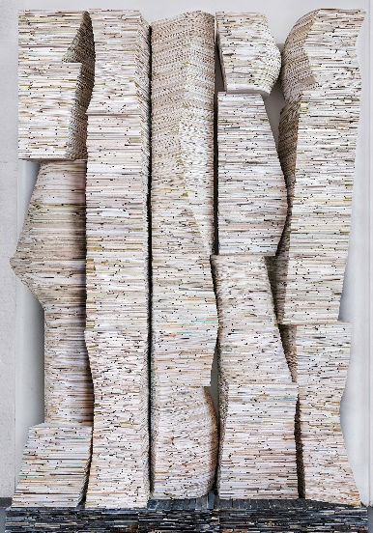
Yao Jui-Chung‘s work: Roaming around the Ruins I – The Civilization Built by Skeleton (Thirteen Stratum Copper Smelter 8)  photo credit: Yao Jui-Chung | 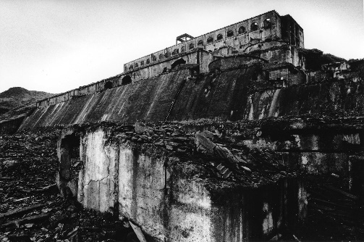
Yao Jui-Chung‘s work: Roaming around the Ruins IV – Gods ＆ Idols Surround the Border (UFO Villa: Monkey)  photo credit: Yao Jui-Chung | 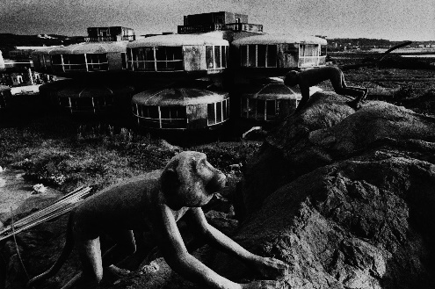
Tu Wei-Cheng’s work: Museum of Ichnofossils  photo credit: Jut Art Museum | 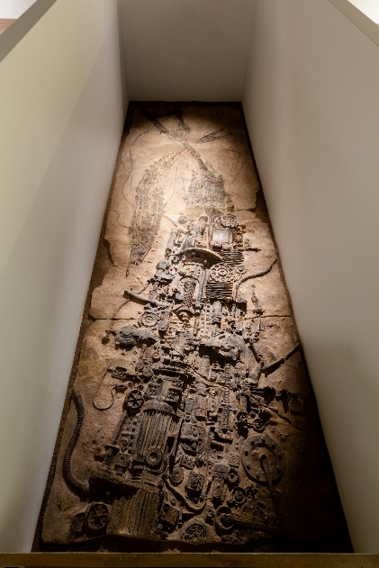
Takahiro Iwasaki‘s work: Out of Disorder (Collapse)  photo credit: Jut Art Museum | 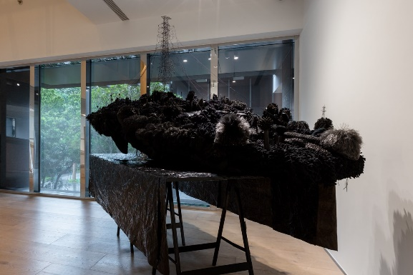
Takahiro Iwasaki‘s work: Out of Disorder (God of Destruction)  photo credit: Jut Art Museum | 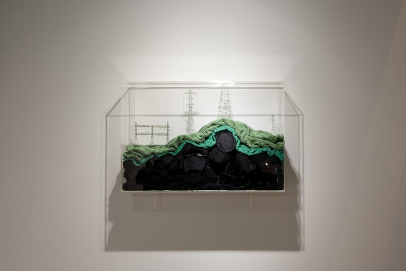

Press Conference
Paradise Lost – Gazing at Contemporary Urban Civilization and its Metaphor opening on 21st December 2019 (left to right: JAM’s director Shan Shan Huang, Takahiro Iwasaki, Tu Wei-Cheng, Yao Jui-Chung, James Casebere, Marjan Teeuwen and JFAA’s CEO Aaron Y.L. Lee)  photo credit: Jut Art Museum | 