Context

Appendix 1-Themes & Highlight works P.2~4
Appendix 2-Photos P.5~6

NOTE
- The press kits and more photos can be downloaded in the link: https://reurl.cc/WxR81x
  - The press kits for the Main Venue at the Jut Art Museum is available for download here. https://reurl.cc/bVX0Mv
- Standard Usage for Images: Images may not be cropped or changed. Dimensions must be retained. Text overlay is not permitted. Images have to be identified as an artwork using the provided complete image caption as well as the ©.

【Appendix 1- Themes & Highlight works】
ESCAPE
Escape is sometimes used as a term to describe breaking free from some form of constraint, physical or emotional, or generally fleeing any dire or merely disagreeable situation. For people fleeing war and conflict, escape has literal meaning. For the privileged inhabitants of the world, the term has a positive connotation: “getting away from it all”. We search for entertainment, relaxation and rest, or novelty, adventure and excitement. An industry of pleasure has blossomed, offering a spectacular array of “products” to its avid consumers around the globe, whilst providing rich inspiration for photographers as they pull back the curtain on the true costs of the industry.
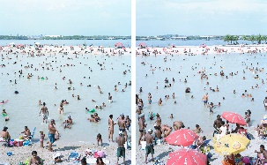 | Massimo Vitali, Piscinao de Ramos, 2012 © Massimo Vitali  Vitali’s photograph of a blinding white sand beach and bathers speaks of a global collective rite. Our animal ancestors came out of the water 400 million years ago – might there be some atavistic memory? The photographer’s primary focus is, of course, the colorful crowd, and he brings his horizon line nearly to the top edge of the composition to accommodate it, thus reversing the usual perspective of a vast ocean stretching to the horizon. Each year, millions still take pleasure in this simple escape from daily routines, sharing the desire to “get away from it all”, but actually, often, craving the companionship of others.
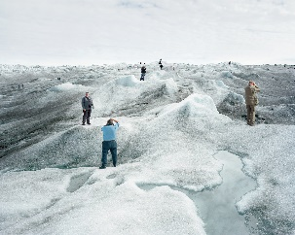 | Olaf Otto Becker, Point 660, 2, 08/2008 67°09’04’’N, 50°01’58’’W, Altitude 360M, from the series Above Zero, 2008 © Olaf Otto Becker  Becker issued this wake-up call on the unfolding environmental disaster in the Arctic more than a decade ago, and since then the problems have only accelerated. The images of this area that have been lodged in the collective imagination for centuries – of unbroken vistas of pristine snow, prowling polar bears and basking seals – are now a thing of the past. The reality today includes submarines and icebreakers looking for profitable routes for exploitation, and tourists on brief forays onto the ice from well-heated cruise ships, hunting for photographs to show off as trophies back home.
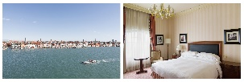 | Roger Eberhard, Venice, from the series Standard, 2015-2016 © Roger Eberhard  Eberhard travelled to thirty-two countries and every continent, booking each time a standard room in a Hilton hotel, photographing both the view and the room itself. He wonders, “Why do we travel to foreign countries and cultures and yet stay at a place that always looks the same?” Indeed, why bother to travel at all in an age of Google Maps (and Street View)? With each passing year, the world becomes ever more homogeneous, bland and anonymous; increasingly we act alike, dress alike and think alike.
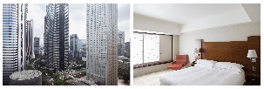 | Roger Eberhard, Tokyo, from the series Standard, 2015-2016 © Roger Eberhard  Same as above.
ALONE TOGETHER
The poet John Donne famously said “no man is an island”. Genetically, we are social animals, seeking friends, mates and partners of all kinds in order to share interests. But our social lives are not all smooth sailing. Misunderstandings, conflicts of interest, the pressure to conform versus the desire to stand out from the crowd: we crave to be “fashionable” yet recoil when we are told we are “sheep”, blindly following popular crazes. The essential human condition is to be alone — as we come into the world and will go out of it. But whilst we are alive, we live collectively. Photographs both demonstrate and reinforce our interdependence.
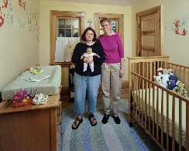 | Dona Schwartz, Desiree and Karen, 68 days, from the series Expecting Parents, 2006 © Dona Schwartz, courtesy Stephen Bulger Gallery  Schwartz’s two series, Expecting Parents and Empty Nesters, may be seen as interlocking parts of a whole. Schwartz takes as her subject parents and children – though the latter are notably invisible; the work is all the more powerful for it. The first series deals with couples anxiously or serenely awaiting the arrival of a new human being. The expectant parents are posed in the rooms of their progeny, and the environments they have created speak eloquently as to their hopes and aspirations. The second series shows parents struggling to come to terms with the moment when their adult child flees the nest.
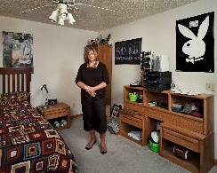 | Dona Schwartz, Jean, 2 years, from the series Empty Nesters, 2011 © Dona Schwartz, courtesy Stephen Bulger Gallery  Same as above.
Larry Sultan, Sharon Wild, from the series The Valley, 2001 © Larry Sultan, courtesy Estate of Larry Sultan
Visual pornography is a growing industry, with estimates of its revenues being in the billions. Most curious adults know what the films and photographs look like, but Larry Sultan set out to document a side of the industry no one sees: the rather ordinary behavior of the men and women who make their living as actors in the films, caught killing time between takes. By photographing them in quiet moments, Sultan strips away the sordid connotations of their work, suggesting they are, at the end of the day, people like the rest of us, doing their best to earn a living.
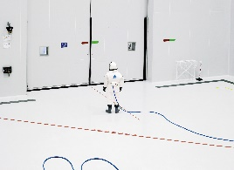 | Vincent Fournier, Ergol #1, S1B clean room, Arianespace, Guiana Space Center [CGS], Kourou, French Guiana, from the series Space Project, 2011 © Vincent Fournier  Vincent Fournier has long nurtured a fascination with space travel. He has photographed many of its sites, including the Yuri Gagarin Cosmonaut Training Center in Russia, the Baikonur Cosmodrome in Kazakhstan, NASA’s Kennedy Space Center in Cape Canaveral, and the Spaceport in French Guiana. However, his interest is not documentary. Although the images are certainly rooted in reality, it is instead the dream aspect that drives him – a collective dream he believes much of humanity shares. The astronauts he has photographed, dwarfed by their high-tech environments, are ready for their leap off the earth but nonetheless tethered to it.

【Appendix 5- Photos】
Key Visuals
Caption | Photos
Civilization: The Way We Live Now (vertical) featuring Michael Najjar’s work “orbital ascent” © Jut Art Museum | 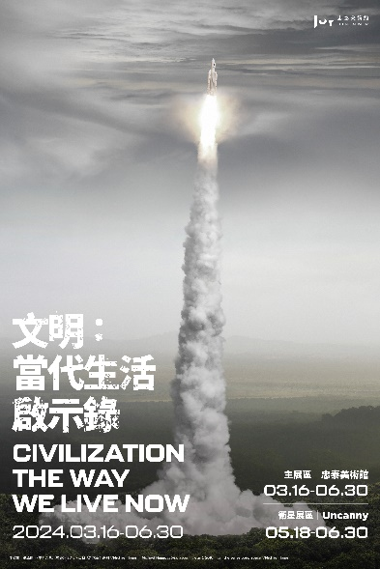
Civilization: The Way We Live Now (horizontal) featuring Michael Najjar’s work “orbital ascent” © Jut Art Museum | 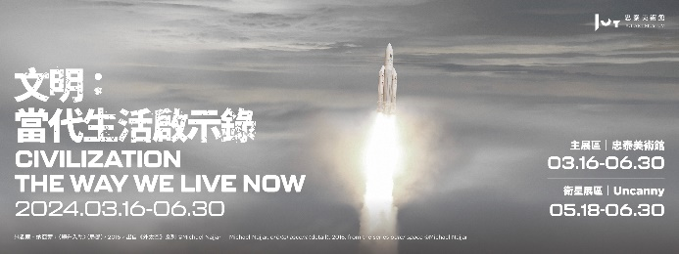
Civilization: The Way We Live Now (square) featuring Michael Najjar’s work “orbital ascent” © Jut Art Museum | 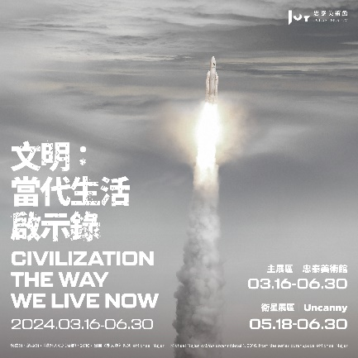

Installation views
Caption | Photos
“Civilization: The Way We Live Now” at Satellite Venue-Uncanny, Installation view ©Jut Art Museum | 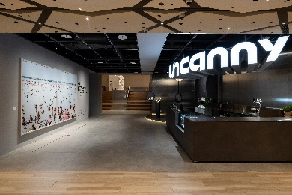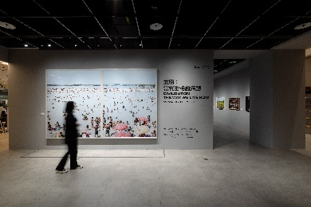  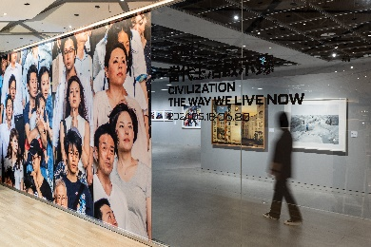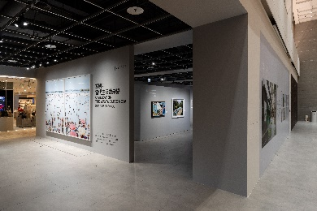  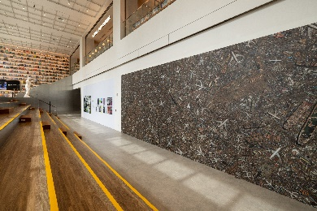
“Civilization: The Way We Live Now” at Satellite Venue, Installation view “ESCAPE” ©Jut Art Museum | 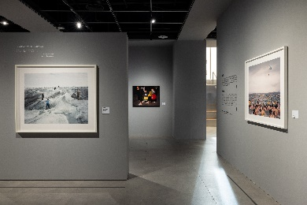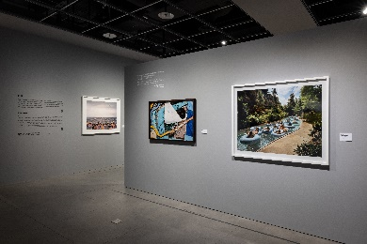  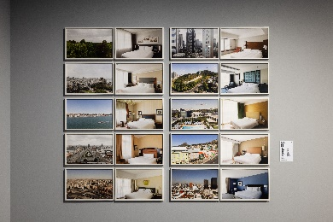
“Civilization: The Way We Live Now” at Satellite Venue, Installation view “ALONE TOGETHER” ©Jut Art Museum | 