Context

Appendix 1- About Jut Art Museum P.2
Appendix 2- Preface P.3
Appendix 3- Curator Statement P.4
Appendix 4- Artists & works P.5~20
Appendix 5- Photos P.21

NOTE
- The press kits and more photos can be downloaded in the link: https://drive.google.com/drive/folders/1DCtofaGAMgaFy_ES9ZvEm4ALH6Rbp4Sf?usp=sharing
- Standard Usage for Images: Photo credit/by must be given where applicable; and please indicate © Jut Art Museum.

【Appendix 1- About Jut Art Museum】

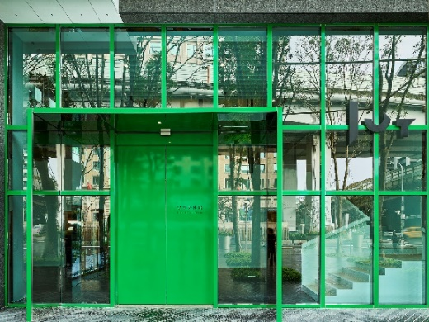 © Jut Art Museum

Mission
Jut Land Development’s 30th anniversary, and the Jut Foundation for Arts and Architecture (JFAA)’s 10th birthday, culminates in the establishment of the Jut Art Museum (JAM) in 2016. It is a milestone commemorating the history of Taiwan’s architectural aesthetics.

We anticipate that JAM to act as a new form of platform, catalyst and think tank devoted to corporate social responsibility fulfillment and addressing the societal dynamics of the 21st century. We also anticipate it to carry on the legacy of “A Better Tomorrow” that defines much of JFAA’s work, to become the first museum in Taiwan that is focused on the issues of “future” and “city.”

Vision
The Jut Art Museum, located in the heart of Taipei, is also where the Jut Foundation’s debut exhibition of “Museum of Tomorrow” is held. After ten years of circuit shows across the city, the exhibition is now back to where it all started, becoming a “showpiece in the heartland of the city and urban inhabitation.”

As an up-and-coming art establishment, JAM serves to explore what our future might hold, and transdisciplinary issues. The curation process of JAM is three-pronged: “future,” “urban architecture,’ and “contemporary art.”

Japanese architect Jun Aoki is tasked with spacing designs of JAM. The identification system is developed by Atsuki Kikuchi. This is their first museum collaboration project in Taiwan. JAM – a statement of both sophistication yet cutting-edge conception – is downtown’s new architectural and art landmark; and it is poised at remaking and bringing new energy into Taipei’s cityscape.

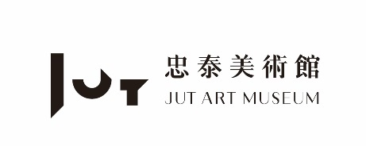 | Website https://jam.jutfoundation.org.tw/en  Facebook https://www.facebook.com/JUTARTMUSEUM  Instagram https://www.instagram.com/jutartmuseum/

【Appendix 2- Preface】

Text / Jut Art Museum

“The question of what kind of city we want cannot be divorced from the question of what kind of people we want to be.” ——David Harvey, Rebel Cities: From the Right to the City to the Urban Revolution, 2012

Cities are ever-evolving organisms, defined by constant growth, construction, and expansion. Like beacons in the darkness, they attract humans to gather, interact, and survive, becoming the vessels of culture and civilization. However, the evolution of a city is not a linear progression but a cycle of rise and fall or restoration and rupture amidst mounting tensions and changes. These urban conditions and life experiences forced into view by radical upheavals are exactly what this exhibition seeks to explore.

As a rich tapestry of history, culture, and future visions, the exhibition Fallenstadt: the Rise and Fall of Cities observes and reflects on the cyclical nature of human civilization. Structural cataclysms such as wars, climate catastrophes, industrial transformations, and the imbalance of power have left many cities in a state of precarity. These cities undergo repeated cycles of collapse, mending, and rebirth, manifesting their inherent fragility and resilience. The metamorphosis of a city is tantamount to blazing flames. While the flames may go out, the embers never die, perpetuating the cycle of prosperity and decline. Co-curated by Nobuo Takamori and the Jut Art Museum team, this exhibition focuses on non-occidental urban experiences that are less covered by mainstream narratives and have relatively limited discursive power. Through the works of 11 artists and collectives from the Philippines, Sri Lanka, Syria, Romania, South Korea, and Taiwan, this exhibition rethinks what a “city” truly looks like under varying historical, political, and economic conditions. From the demolition of historic buildings in Bucharest, the dystopian urban visions of Damascus, and the e-waste settlements of Agbogbloshie in Ghana, to the Umbrella Movement in Hong Kong and the relocation caused by industrial transformation in Tainan, Taiwan, these seemingly distant urban stories mirror the very rupture, reorganization, and remaking that our own modern cities are experiencing.

Since its inception in 2016, the Jut Art Museum has consistently addressed issues concerning the “city” and the “future” through a succession of contemporary art exhibitions, such as A Non-Existent Place, The Flying Land, Paradise Lost, and Broken Landscapes. The current exhibition, Fallenstadt, not only responds to the museum’s decade-long dedication to urban issues, but also stands at this critical juncture in history to raise essential questions about urban civilization, future lifestyles, and our collective imagination, thereby opening up a new space for further dialectical inquiry, dialogue, and contemplation.
【Appendix 3- Curator Statement】
Curator |  | Biography
Nobuo Takamori | 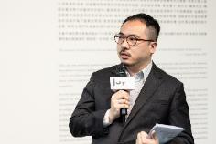  © Jut Art Museum | Independent curator; Director of “Outsiders Factory”, a curators collective; selected important exhibition curatorial works include Post-Actitud (2011, Ex Teresa Arte Actual, Mexico DF), South country, South of Country (2012, Zero Station, Ho Chi Minh City & Howl Space, Tainan), The Lost Garden (2014, Eslite Gallery, Taipei), Taiwan International Video Art Exhibition 2014 The Return of Ghosts (Hong Gah Museum, Taipei), Is/In-Land: Mongolian Taiwanese Contemporary Art Exchange Project (2018, 976 Art Gallery, Ulaanbaatar, Kuandu Museum of Fine Arts, Taipei), The Middleman, the Backpacker, the Alien Species and the Time Traveler (2019, TKG+, Taipei), and The Secret South: from Cold War Perspective to Global South in Museum Collection (2019, Taipei Fine Arts Museum, Taipei).
Curator Statement | Text / Nobuo Takamori  Since the first cities rose from the earth millennia ago, they have stood as a defining hallmark of human civilization. Agglomerating considerable populations and wealth, cities have fostered the development of cultural assets and innovative technologies throughout history. Statistically speaking, however, urban civilization does not necessarily equate to the concept of a comfortable existence. More than 50% of the world’s total population resides in cities today. However, not every city that accommodates this massive influx of people aligns with our idealized vision of urban life. Currently, there are over 80 cities worldwide with populations exceeding 5 million, a scale comparable to that of the Greater Taipei Area. Yet, among these megacities scattered across the globe, nearly half fail to provide the majority of their inhabitants with basic public services.  While cities across the developing world appear fraught with existential crises, their integration into the globalized trade system places them in a paradoxical position. They serve as hubs for trading and processing the detritus of global overproduction at the price of bearing greater environmental risks. In this sense, as humanity is ushered into an era characterized by increasingly severe living conditions and geopolitical complexities, it remains debatable whether the idealized cities of developed countries are better equipped to withstand extreme circumstances, or if the emerging cities of the developing world will prove to be the “hidden champions” in the race for survival. Our experience of the COVID-19 pandemic showed that even affluent, idealized cities may expose their potential vulnerabilities if they lack the requisite resilience and flexibility to address unforeseen, large-scale catastrophes.  Featuring artists from Taiwan, South Korea, the Philippines, Sri Lanka, Syria, Romania, and Germany, this exhibition presents scenes that resonate with Italo Calvino’s depictions in Invisible Cities. The grandeur and decadence, the courage and absurdity, as well as the wisdom and annihilation of human civilization find expression in the cities beleaguered by flooding, self-abasement, crises, global detritus, and encroaching warfare. Cities serve as a portrayal of humanity per se. Their multifaceted façades and complexities are projections of human consciousness. Acting as a mirror, cities reflect our pride, aspirations, morality, dread, desires, and depravity. Welcome to Fallenstadt, a place where reverberations linger just before the torch of civilization is extinguished.

【Appendix 4- Artists & works】(Listed in the order of the press release.)
Artists/Group | Biography
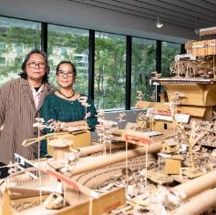  © Jut Art Museum | Isabel and Alfredo Aquilizan, The Fruitjuice Factori Studio Collective (Philippines/ Australia)  Isabel and Alfredo Aquilizan (b. 1965 and 1962) have exhibited extensively in galleries and institutions worldwide, such as at the Fukuoka Asian Art Museum (Japan), Auckland Art Gallery (New Zealand), Immigration Museum (Australia), Queensland Art Gallery | Gallery of Modern Art (Australia), Singapore Art Museum (Singapore), and Japanisches Palais (Germany). They have participated in the Busan Biennale (2019); Thailand Biennale (2018); Gangwon International Biennale, South Korea (2018); Sharjah Biennale, UAE (2013); Asia Pacific Triennale, Australia (2009); Singapore Biennale (2008); Biennale of Sydney, Australia (2006); Gwangju Biennale, South Korea (2004), Venice Biennale, Italy (2003), amongst others.  Their works are included in the major collections such as the Sherman Contemporary Art Foundation (Australia); Singapore Art Museum; Fukuoka Asian Art Museum; Queensland Art Gallery | Gallery of Modern Art; MAIIAM Contemporary Art Museum (Thailand); and Lopez Museum Foundation (Philippines). In 2019, the Aquilizans (Fruitjuice Factori Studio) were commissioned to create a site-specific work at Facebook’s headquarters at Menlo Park, California, USA.  The Fruitjuice Factori Studio  In 2012, contemporary artists Alfredo and Isabel Aquilizan acquired a former nata de coco and fruit-juice factory in Los Baños, a town where they once nested and raised their five children prior to emigration. This site now serves as a base for the Fruitjuice Factori Studio (FFS) collective. Alfredo and Isabel Aquilizan practice with their five adult children as the art-making collective. The history of the factory as being a place of production has long connected the local community to transnational spheres. FFS is borderless, often involving different artists and artisans in nomadic iterations of their installations. This synergy of the past and present foregrounds the collective’s role in creating a community that transcends local, national and regional borders.  The studio sets out to create globalized neighborhoods through cultural production, where local communities are engaged in participatory art works. The studio nourishes networks that encourage cultural practice which creates change. As well as this, the artists focus on what the Aquilizans often state as ‘making do’, with strong concentration on upcycling.  The Fruitjuice Factori Studio responds to historical legacies as well current issues we face. They work to disrupt and dissolve colonizing harmful practices in art ecologies, prioritizing the self-determination and autonomy of creatives. The Fruitjuice Factori Studio uses art’s role in cultural vitality and resistance as foundations of their work; to connect, to witness, to educate and record.  This iteration involves Aditya Kurniawan, Amihan Aquilizan, Aniway Aquilizan, Diego Aquilizan, Le Aquilizan, Lindy Brown, and Zoe Taylor-Fardon. All active core members of the Fruitjuice Factori Studio reside between Brisbane/ Melbourne (Australia), Australia and Los Baños, Laguna (Philippines).

Artwork Description
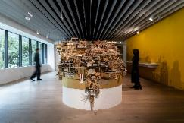  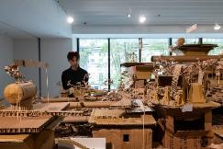  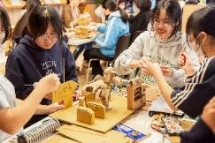  © Jut Art Museum | Habitations: (At Some Place) Project Another Country  2026  Wood, transport pallets, used cardboard, Dimensions variable  In their works, Filipino artists Isabel and Alfredo Aquilizan have long drawn on their migratory experiences to envision urban possibilities. For the first time, the artists have brought their renowned Project Another Country to Taipei for a site-specific residency. Frequently utilizing easily accessible cardboard boxes as their primary medium, they invite local communities to participate in the creative process.  This Taipei edition was realized in collaboration with The Fruitjuice Factori Studio Collective—an art collective founded by the artists, their family, and friends—and engaged students from Taipei Municipal Zhongshan Girls High School as well as colleagues from the Jut Group to collectively construct an imaginary city belonging to Taipei’s residents.  It is an island city featuring serpentine valleys and bristling with water tanks and viaducts. It also represents the “island on the other shore” envisioned by Alfredo Aquilizan, who grew up on the northern coast of Luzon.

Artists/Group | Biography
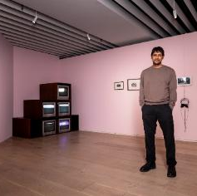  © Jut Art Museum | Abdul Halik Azeez (Sri Lanka)  Abdul Halik Azeez is based in Colombo, Sri Lanka. A multidisciplinary artist and organizer, his work explores relationships between colonialism, late capitalism, memory/history making, and identity politics. Azeez has a MA in Linguistics from the University of Granada, and an MA in Financial Economics from the University of Colombo. He spent many years practicing as a journalist, economist, and critical discourse analyst before turning to art practice full time. He is co-founder of The Packet, a collective formed in 2019. He has exhibited at the Asia Pacific Triennial (2024), Videobrasil (2023), Berlinale (2023) and documenta fifteen (2022), and received invitations to residencies and fellowships with the Delfina Foundation (2025), Akademie Schloss Solitude (2025-2026), Alserkal Arts Foundation (2025), Prince Claus Fund (2023) and the Sharjah Art Foundation (2022).
Artwork Description
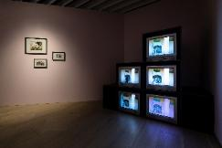  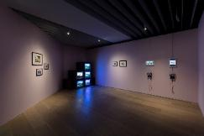  © Jut Art Museum | Stranger in a Strange Land  2024  Five-channel video, CRT screens  Sri Lankan artist Abdul Halik Azeez’s works consistently explore the intricate relationship between globalization and local contexts. Merging home video footage with pop culture elements, his work Stranger in a Strange Land examines the massive, globalization-driven influx of South Asian labor into the Middle East.  The artist weaves a sui generis audiovisual narrative by reference to his coming-of-age story and a montage-style collage of family photo albums, interviews with relatives, as well as traditional and popular symbols.

Artists/Group | Biography
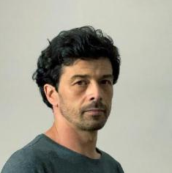  © Sebastian Moldovan | Sebastian Moldovan (Romania)  Sebastian Moldovan, born in 1982, is a Romanian artist working with video, installations and site-specific interventions, all seen and used as extensions to the qualities of drawing. Recurrent in his works are subjects like cohabitation with man-made or natural structures and systems, ecology of everyday life, natural phenomena, the perception and effects of time, colorizations or the balance of power. His works span from poetic to rebellious, seeking equilibrium and beauty or highlighting absurdity, abuse or injustice. In this frame, the elements used are sometimes found objects, features and materials, recycled, reinvested and integrated with immaterial ones like wind, fog, light reflections or sound. Some works are simply hidden or installed as traps, demanding engagement and presence. His works have been shown in less conventional venues, but also in biennials and museums among which we mention: Casino Luxembourg – Forum d’art contemporain; Cabaret Voltaire, Zurich; Havana Biennale; Art Encounters Biennale, Timișoara, Romania; Venice Biennale; Prague Biennale; Bucharest Biennale; The Contemporary Art Gallery of the Brukenthal National Museum, Sibiu, Romania; Tbilisi Museum of Art, Georgia; Kharkov Art Museum, Ukraine; Times Museum, Guangzhou, China; National Museum of Modern and Contemporary Art - MMCA, Korea; Osage Gallery, Hong Kong. Sebastian Moldovan lives and works in Bucharest.
Artwork Description
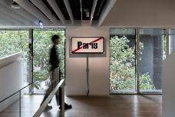  © Jut Art Museum | The Paris Project  2006  Single-channel video, 7’13”  Romanian artist Sebastian Moldovan’s iconic work, The Paris Project, was created in 2006, the year before Romania joined the European Union. Holding a city limit sign indicating “Exit from Paris,” the artist wandered through the dilapidated streets of the capital, Bucharest, which symbolized the economic woes of the post-communist era.  For Romanians, “Paris” is not simply a popular destination for overseas employment, but a promised land representing the better life they yearn for. Through a performative gesture, the artist attempts to summon the long-lost “Little Paris,” evoking the transience and continual transformation of the city.

Artists/Group | Biography
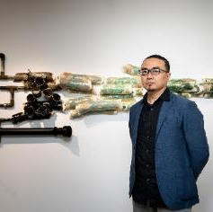  © Jut Art Museum | Kuen-Lin Tsai (Taiwan)  Kuen-Lin Tsai, born in 1979 in Tainan, lives and works in Taipei, Taiwan, is a multidisciplinary artist who excels at revealing the depth and intricate details of sounds he hears through visual expression. His works not only redefine our perception of sound but also establish a novel connection between form and content. Tsai employs this method to interpret the intricate relationship between modern humanity and the natural environment, reflecting on the current global situation through his creations.  His pieces have been exhibited at the IA&A Art Center in Washington, SAC Gallery in Bangkok, National Art Museum of China, Taipei Fine Arts Museum, Tainan Art Museum, National Taiwan Museum of Fine Arts, and Mori Art Museum in Tokyo.  He has also participated in artist-in-residence programs in countries like Australia, the United States, Japan, Norway, Thailand, and Taiwan.
Artwork Description
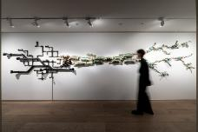  © Jut Art Museum | Who is the Beginning? What is the End?  2026  Soil, audio device, PVC, underwater sound, 135x685x23cm  A work commissioned by Jut Art Museum, Taiwanese artist Kuen-Lin Tsai draws on his extensive fieldwork experience to investigate Taipei’s water systems. The artist gathered underwater audio recordings and soil samples spanning from Fushan—the source of Taipei’s water systems—down through the Xindian River and into the city’s irrigation canals. The collected soil, subsequently fired into ceramic ware, not only symbolizes the hydrology of Taipei but also physically intertwines with PVC pipes, embodying the entangled networks of the city’s irrigation and railway systems, as well as the cyclical and interdependent relationship between urban development and the natural environment.

Artists/Group | Biography
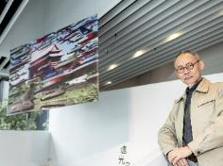  © Jut Art Museum | Dean-E Mei (Taiwan)  Born in Taipei in 1954, Dean-E Mei graduated from the Department of Fine Arts at Chinese Culture University in 1977. His early career was marked by recognition such as the Silver Medal at the Taiyang Art Exhibition and the Hsiung Shih Newcomer Award, followed by teaching positions at Fu-Hsin Trade and Arts School and Hsieh-Ho High School of Industry and Commerce. In 1983, he went to the United States to pursue his research on Dadaism, earning his MFA from the Pratt Institute in New York in 1985. During his stay in the U.S., his work centered on issues concerning politico-cultural identity, and he engaged in politically charged art exhibitions addressing community consciousness.  After his return to Taiwan in 1993, he joined the faculty of the Department of Fine Arts at both Taipei National University of the Arts and National Changhua University of Education. He also participated in the Taiwan Nativist Art Debate, continuing to create works touching upon socio-political subjects while publishing papers on the history of printmaking in the early period after Taiwan’s Retrocession. In 1999, he authored Taiwan Art Criticism Series: Ho Tie-Hua. In 2003, he was invited by the Museum of Contemporary Art Taipei (MoCA Taipei) to hold a 20-year retrospective exhibition. His distinguished career has been recognized with numerous awards, including the Taishin Arts Award (2004), the Golden Seal Award from the Taiwan Society of Printmaking (2006), the Wu San-Lien Award (2013), and the National Award for Arts (2013).
Artwork Description
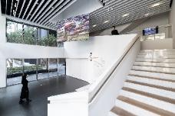  © Jut Art Museum  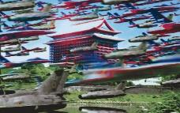  © Dean-E Mei | Decisive Battle Outside Territory Series  2000  Graphic print, 125x200cm  In his Decisive Battle Outside Territory Series created in 2000, Taiwanese artist Dean-E Mei responded to the national defense policies of that period with absurd digital collages. Renowned for his politically and historically allegorical works, the artist combined then-emerging computer graphics with printed images he appropriated from official propaganda magazines to depict Taipei in the post-Cold War atmosphere. Today, over 25 years since its creation, this series remains profoundly resonant as we look at it.

Artists/Group | Biography
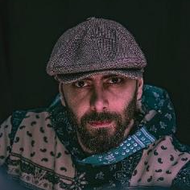  © Ayham Jabr | Ayham Jabr (Syria)  Ayham Jabr is a filmmaker and visual artist based in Damascus, Syria. His practice spans collage, 3D digital composition, and experimental film, often weaving mythic narratives with speculative futures. Having lived through the full duration of the Syrian civil war, Ayham’s work is deeply informed by survival, memory, and the symbolic architecture of a city suspended between destruction and reinvention.  Born and raised in Damascus, Ayham witnessed firsthand the transformation of his environment from a place of layered history to a landscape marked by rupture and resilience. Rather than documenting this change in literal terms, he chose to respond through visual mythology. His works do not depict war; they ritualize its aftermath. Through surreal compositions and symbolic structures, Ayham reimagines the ruins of his city as portals to alternate realities, spaces where ancient belief systems collide with digital aesthetics, and dystopia becomes a site of philosophical inquiry.  Ayham’s artistic language is rooted in contradiction: the sacred and the synthetic, the handmade and the algorithmic, the nostalgic and the prophetic. His collages often feature fragmented bodies, cosmic backgrounds, and architectural motifs that evoke both ritual and ruin. In his 3D compositions, he constructs speculative cities and spiritual landscapes that challenge viewers to reconsider the boundaries between memory and imagination, history and myth.  The civil war left a profound mark on Ayham’s worldview, but it did not define his creative identity. In recent years, as the political and social climate began to shift, he experienced a personal awakening, a moment of clarity that led to the creation of new mythic series. These works reflect a belief that dystopia is not merely a destiny, but a necessary passage. For Ayham, the dystopian future is a mirror held up to society, a fantastical reckoning with what has been lost and what might still be gained. It is not a lament, but a ritual of transformation.  Ayham’s work has been exhibited in over a dozen exhibitions across the world, including shows in Europe, Asia, and the Middle East. His visual language continues to evolve through dialogue with curators, institutions, and fellow artists. He approaches collaboration as a philosophical exchange, valuing feedback and curatorial insight as part of the mythic journey. Through his art, Ayham invites viewers to enter a space of resonance, where the personal becomes cosmic and the political becomes poetic. His goal is not to offer answers, but to provoke reflection. In a world increasingly shaped by technology and displacement, Ayham’s work stands as a testament to the power of myth, memory, and visual storytelling.
Artwork Description
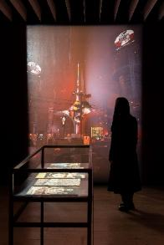  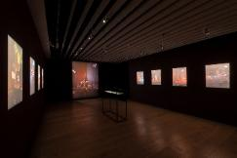  © Jut Art Museum | Damastopia Series  2024-2025  3D composition Print, each 42x29.7cm, 9 pieces in total  A real war entails not just the flashes of explosions seen in news footage. It is more profoundly defined by the plight that civilians silently endure in the darkness. Syrian artist Ayham Jabr has long been confined to Damascus, yet he continues to share his surrealistic works via social media platforms.  Spanning from his early retro-sci-fi collages to his latest series Damastopia, which envisions a future Damascus under techno-totalitarian rule, the artist’s sci-fi creations serve not only as psychological escapism from wartime existence but also as a prophetic indictment against war and society.

Artists/Group | Biography
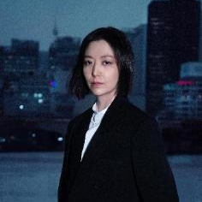  © Kanghyuk Lee(snakepool) | Ayoung Kim (South Korea)  Ayoung Kim weaves reality anew through a tapestry of hybrid narratives, integrating geopolitics, mythology, technology, techno precarity, and speculative temporalities into her work. The outcomes of synthesized narratives result in far-reaching speculation, establishing connections between biopolitics and border controls, the memories of stones and virtual memories, and ancestral origins and imminent futures across various media. Her practice incorporates discourses on optical and post-optical media, performativity, game simulation, and the narrativity of fiction. Kim often depicts entities whose resistance or misalignment leaves behind strange and singular traces as they deviate from prescribed trajectories.  Kim’s works have been presented at MoMA PS1, New York (2025); M+, Hong Kong (2025); Hamburger Bahnhof, Berlin (2025); Tate Modern, London (2025); The National Museum of Art, Osaka, Osaka, (2025); Atelier Hermès, Seoul (2025); Copenhagen Contemporary, Copenhagen (2025); Mori Art Museum, Tokyo (2025); ACMI, Melbourne (2024); MoMA, New York (2024); M+, Hong Kong (2024); Sharjah Biennial (2023); Ars Electronica, Linz (2023); International Film Festival Rotterdam (2023); Asian Art Biennial, Taichung (2021); Berlin International Film Festival (2020); Busan Biennale (2020), among others. She has received the LG Guggenheim Award from the Solomon R. Guggenheim Foundation, United States (2025); the ACC Future Prize from the National Asian Culture Center, Korea (2024); the Golden Nica Award at Prix Ars Electronica, Austria (2023); and the Terayama Shuji Prize at the Image Forum Festival, Japan (2023).  Her works are in the collections of the MoMA, US; Tate museums, UK; ACMI, Australia; Frac Lorraine, France; The National Museum of Art, Osaka, Japan; Sharjah Art Foundation, UAE; Kadist, US and France; the MMCA (National Museum of Modern and Contemporary Art), Korea, and the Leeum Museum of Art, Korea, to name a few.
Artwork Description
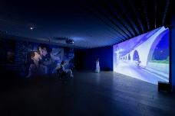  © Jut Art Museum | Delivery Dancer’s Sphere  2022  Single-channel video, 25’16”  Ayoung Kim, a South Korean artist known for her sci-fi-inspired works, was particularly struck by the sight of delivery riders being the sole figures racing through the vast, deserted streets of Seoul during the Covid-19 pandemic. The artist consequently envisioned a future Seoul dictated entirely by algorithms. In this city, delivery workers—referred to as “Dancers”—move ceaselessly and rapidly along the shortest possible routes between two points.  By integrating elements of anime and pop culture, the artist leaves viewers in a state of ambiguity, uncertain of the truth behind the entanglements, affections, confrontations, and even murders that unfold among the protagonists.

Artists/Group | Biography
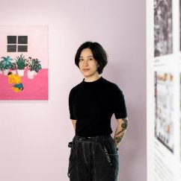  © Jut Art Museum | Hai-Hsin Huang (Taiwan)  Hai-Hsin Huang was born in Taipei in 1984 and received her BA degree from National Taipei University of Education in 2007. In 2009 she received a MFA from the School of Visual Arts in New York. She currently lives and works in Brooklyn and Taipei. Huang composes works that explore the space between humor, tragedy, and horror. Her works delve into the threat of violence and fear in society and the contradictions ones encounters in daily life. While often executed in a colorful and lighthearted palette, at their heart, her whimsical narratives express a dark and unique sense of humor. Her work has been included in group exhibitions at Taipei Fine Arts Museum, National Taiwan Museum of Fine Arts, Museum der bildenden Künste Leipzig, Taipei Cultural Center in New York, and Herzliya Museum of Contemporary Art in Israel, Centre Pompidou-Metz, and Le Lieu Unique in Nantes, France, Das Weisse Haus in Vienna. Her paintings are in the permanent collections of the Taipei Fine Arts Museum, White Rabbit Gallery in Sydney, Artbank in Taiwan, UBS Art Collection and Art Gallery of Western Australia and AMMA Foundation in Mexico City.  Huang has also participated in several artist residency programs, including The Shandaken: Storm King residency (NY 2025), Das Weiss Haus (Vienna 2025), 3331 Arts Chiyoda (Tokyo, Japan, 2018), PILOTENKUECHE (Leipzig, Germany, 2017), Arteles Creative Residency Program (Finland, 2016), New York ISCP (NY, USA, 2013), and Vermont Studio Center (VT, USA, 2013). Huang was recently selected as one of the 2024 NYSCA/NYFA Artist Fellows.
Artwork Description
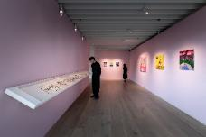  © Jut Art Museum | Drunk-Tank Pink  2013  Oil paint on canvas, 98.5×91cm  Home, sweet home #2  2012  Oil paint on canvas, 61x51cm  New York-based Taiwanese artist Hai-Hsin Huang excels in portraying the absurdities and anxieties of modern urban dwellers through her paintings. Beneath her iridescent color palettes, viewers can see her subjects either dismissing crises with a cynical mindset or simply burying their heads in the sand to evade looming realities.

Artists/Group | Biography
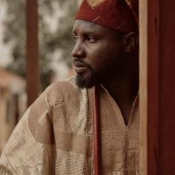  © Elom 20ce  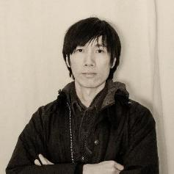  © Musquiqui Chihying  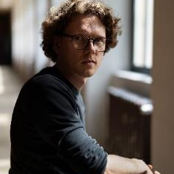  © Gregor Kasper | Elom 20ce (Togo)  Elom 20ce is a musician and filmmaker based in Togo, West Africa. He uses art as a vessel to excavate the past, question the present and archive the future. The link between the intimate, the spiritual and the political is at the heart of his work. He calls himself a “knocker of the invisible”.  Musquiqui Chihying (Taiwan)  Musquiqui Chihying is an artist and filmmaker based in Taipei and Berlin. Specializing in the use of multimedia such as film and sound, he investigates the human condition and environmental system in the age of global capitalization and engages in the inquiry of and research on issues of subjectivity in contemporary social culture in the Global South. His recent works have explored the unique historical context of ethnic groups and technological exchanges in Africa, Asia, and the African-Asian maritime region.  Gregor Kasper (Germany)  Gregor Kasper is an artist and filmmaker based in Dresden, Berlin. Using a variety of media such as film/video, sound and installation, often in collaborative and participatory constellations, his artistic practice focuses on the construction and mediation of history and remembrance, social contemporary analyses in the context of global capitalism, and emancipative futures, pursuing the interrelations between personal approaches and social counter-hegemonic narratives and power relations.
Artwork Description
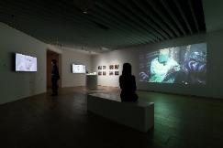  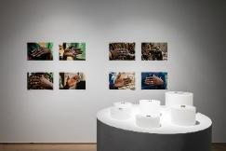  © Jut Art Museum  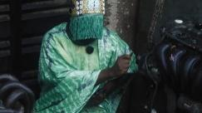  © Musquiqui Chihying | The Currency - Agbogbloshie - The Rings Series  2025  Recycled metal  Double-channel video, 9’07”  Photography, each 30x45cm, 8 pieces in total  Togolese artist Elom 20ce, Taiwanese artist Musquiqui Chihying, and German artist Gregor Kasper have a long-standing focus on the impacts of globalization across Africa. For this exhibition, the artists turn their gaze toward Agbogbloshie in Ghana, West Africa’s largest e-waste processing and distribution hub, as well as Ladipo in Nigeria, West Africa’s nerve center for automobile parts dismantling and trading. These communities bear the brunt of the mass-produced, discarded products from advanced countries (Taiwan included), with locals forced to dismantle and scavenge these materials for their livelihoods, often devoid of any protective gear or safety measures.  In this exhibition, these artists’ works reveal how artisans in Agbogbloshie recast precious metals salvaged from e-waste into traditional rings, while artist Elom 20ce, donning shamanic ritual attire, attempts to seek out “abandoned voices” within the chaotic auto parts market of Ladipo.

Artists/Group | Biography
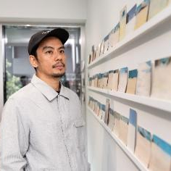  © Jut Art Museum | Mark Salvatus (Philippines)  Mark Salvatus was born in Lucban, Philippines, in 1980 and currently lives in Quezon City. He studied advertising at the University of Santo Tomas in Manila. His artistic practice is centered on the concept of “Salvage Projects,” through which he examines the remnants of urban politics, layered national histories, and the fluid conditions of contemporary life. Working across diverse  media—including objects, photography, video, installation, and participatory art—his work creates direct and indirect forms of engagement that reveal the complex interplay of energy, meaning, and experience. Salvatus has exhibited internationally at major institutions and events such as the Venice Art Biennale, Sharjah Biennale, Guangzhou Triennial, Gwangju Biennale, Mori Art Museum, Mill6 CHAT in Hong Kong, the National Museum of Modern and Contemporary Art in Seoul and Art Jameel, Dubai. He has undertaken residencies at the Asia Culture Center in Gwangju, Rijksakademie in Amsterdam, IASPIS in Sweden, and MMCA Goyang Art Studio in South Korea. In 2006, he co-founded the street art collective Pilipinas Street Plan; in 2012, the multidisciplinary platform 98B COLLABoratory; and in 2016, together with Mayumi Hirano, the Manila-based curatorial and research project Load na Dito in which they have participated at the 1st Public Art Abu Dhabi.
Artwork Description
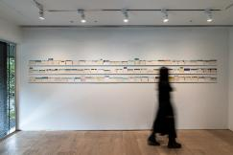  © Jut Art Museum | Watermarks  2026  90 second-hand postcards, Dimensions variable  Filipino artist Mark Salvatus enjoys unearthing vintage postcards across Manila. Due to the Philippines’ long history of having a massive migrant workforce overseas, the messages left on many of these postcards document the workers’ yearning for foreign cities and their longing for loved ones back home.  However, the artist’s postcard collection was damaged by the increasingly frequent flooding in Metro Manila. Influenced by this experience, the artist began to manually erase tourist attractions and landmarks from these collected postcards. This series, titled Watermarks, implies not only the loss of memory but also the climate crisis driven by global warming.

Artists/Group | Biography
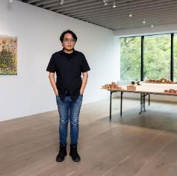  © Jut Art Museum  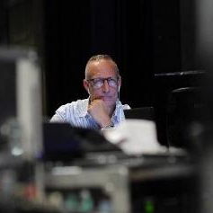  © Wayne Ashley | Shu-Kai Lin (Taiwan)  Shu-Kai Lin was born in Tainan, Taiwan in 1983. He graduated from the Department of Fine Arts, Taipei National University of the Arts, from which he also earned a master’s degree. He currently lives in Tainan.  Graphic art and spatial installation are the staple forms of Lin’s oeuvre. Tainan, the place in which Lin came of age, is an ancient capital bristling with temples, serpentine lanes, and religious totems. The artist internalized these visual elements and spatial experiences, dismantling and reassembling the constituents of his personal life and epiphanies, thereby excavating the symbols buried deep within his subconscious. These symbols in an elaborate style gradually formed fantastic buildings that embody the cities and islands in his imagination, which resulted in his sui generis art series the Balcony City Civilization. Apart from creating images with religious implications, the artist seeks to turn the wooden molds left in his father’s factory into models of futuristic city, so as to reveal the myriad metamorphoses of cities and islands.  He has been invited to international and domestic large-scale exhibitions at Kaohsiung Museum of Fine Arts, Taipei Fine Arts Museum, National Taiwan Museum of Fine Arts, Asian Culture Center (South Korea) and Hiroshima City Museum of Contemporary Art (Japan). He has also worked as an artist-in-residence and presented his works in Germany, the United States, the Netherlands, and Thailand.  Wayne Ashley (FuturePerfect Studio) (U.S.A)  Wayne Ashley is a producer and creative director working across immersive media, live performance, and emerging technologies. He is the founder of New York-based FuturePerfect Studio, an interdisciplinary studio focused on the research and production of mixed-reality, XR, and spatial works.  Over the past two decades, Ashley has worked at the intersection of culture and technology, developing projects that bring together art and technology. He has developed projects spanning virtual and mixed reality, installation, and performance, collaborating with world-renowned artists and institutions including Brooklyn Academy of Music, NY Live Arts, the Danish Ministry of Culture, the Norwegian Consulate, O. Festival Rotterdam, William Kentridge, Ralph Lemon, and Will Ryman. His practice emphasizes long-form development and cross-disciplinary collaboration, exploring how immersive technologies can engage embodied experience and shared cultural memory.
Artwork Description
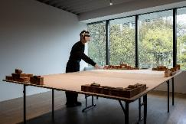  © Jut Art Museum | City of Apparition — Chapter One: The Rupture  2025  Participatory mixed-reality  Prompted by the traumatic early-life experience of his family home being demolished for urban renewal, Taiwanese artist Shu-Kai Lin developed his surrealistic painting series The Balcony City Civilization.  Lin’s father used to run a handmade wooden mold factory, and Lin has extensively utilized these wooden molds carved by his family to construct building-block-like cityscapes. As his father’s factory—part of a sunset industry—approaches its end amidst the sweeping tides of Taiwan’s industrial transformation, the artist has collaborated with the American VR team FuturePerfect Studio, employing virtual storytelling to document his father’s “Building-Block City” and inviting viewers to voyage into the boundless universe alongside this fading industry.

Stories of the Eastern District of Taipei
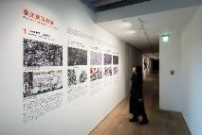  © Jut Art Museum | Text｜Nobuo Takamori, Tsuei-Yi Jang  Illustration｜Ying Chen  Photo courtesy｜Center for GIS, RCHSS, Academia Sinica, Department of Urban Development, Taipei City Government: Taipei Historical Maps  Stories of the Eastern District of Taipei is a micro-research project collaboratively launched by curator Nobuo Takamori and the Jut Art Museum team. The project seeks to chronicle the development of Taipei’s “Eastern District” from the post-war era to the present day in a lucid manner.  The ambiguous concept of the “Eastern District” not only indicates the physical location of the Jut Art Museum but also serves as the spatial anchor for post-war Taiwan’s imagination of modern life. From the establishment of Taipei’s first supermarket and McDonald’s to the first Taipei Metro line, how did this metropolitan space—a symbol of modern, globalized life—come into being? And where is it heading in the future?  “Stories of the Eastern District of Taipei are stories of you and me — ever unfolding, always in the making. We welcome you to share your story in the visitor questionnaire.”

【Appendix 6- Photos】
Caption | Photos
Fallenstadt: The Rise and Fall of Cities (Vertical Version) Key Visual © Jut Art Museum | 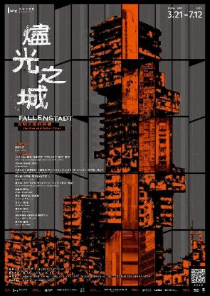
Fallenstadt: The Rise and Fall of Cities (Horizontal Version) Key Visual © Jut Art Museum | 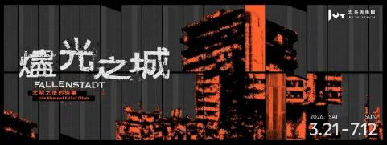
Group photo of the curatorial team and artists © Jut Art Museum  (From left to right)  Back row:  Mark Salvatus, Abdul Halik Azeez, Alfredo Aquilizan, Isabel Aquilizan, Nobuo Takamori, Dean-E Mei, Kuen-Lin Tsai, Shan-Shan Huang  Front row:  Hai-Hsin Huang, The Fruitjuice Factori Studio Collective, Shu-Kai Lin | 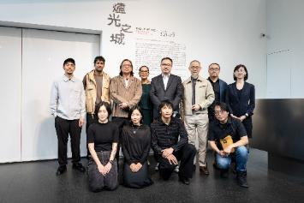
Shan-Shan Huang, Director of Jut Art Museum, and Nobuo Takamori, Curator © Jut Art Museum | 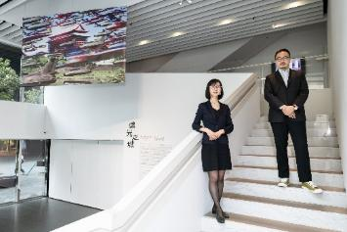
Shan-Shan Huang, Director of Jut Art Museum, giving an address © Jut Art Museum | 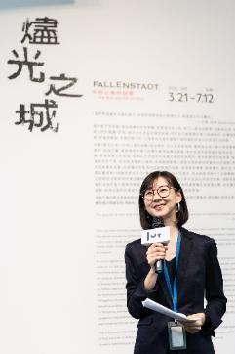
Nobuo Takamori, Curator, giving an address © Jut Art Museum | 