**“Creating for the Everyday: Aino, Elissa and Alvar Aalto,” Finnish Iconic Architect Alvar Aalto’s First Major Retrospective in Taiwan Opens at the Jut Art Museum on 16 August 2025.**

Featuring over 160 original drawings, design objects, and scale models that outline the collaborative journey of Alvar Aalto and his two architect wives.

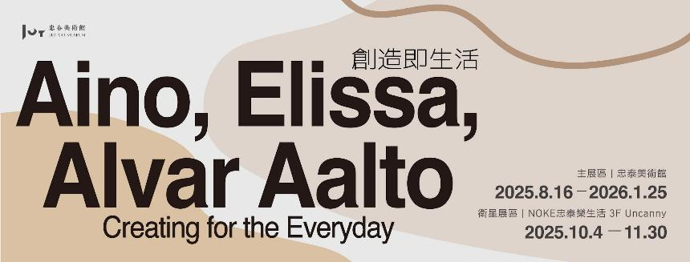

The Jut Art Museum presents the first major retrospective in Taiwan of Finnish iconic architect Alvar Aalto—“Creating for the Everyday: Aino, Elissa and Alvar Aalto”—on 16 August 2025. Curated jointly by the Jut Art Museum and the Alvar Aalto Foundation, this exhibition focuses on how Alvar Aalto worked with his two architect wives—Aino and Elissa—in developing their philosophy of architecture and design as well as in expressing Nordic culture’s emphasis on nature, light, and living spaces.

This exhibition will unfold in two venues. More than 160 pieces original drawings, design objects and scale models will be on display in the main venue—the Jut Art Museum—from 16 August 2025 to 25 January 2026, delving deep into the lives and careers of three architects. From 4 October to 30 November 2025, the satellite venue “Uncanny” at NOKE will host the extended exploration of the philosophy and applications of the Aaltos’ furniture design.

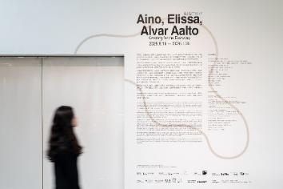 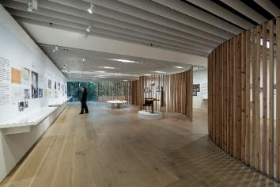

**The Jut Art Museum and the Alvar Aalto Foundation join hands to interpret the Aaltos’ “home” and “co-creation.”**

This year, the Jut Art Museum and the Alvar Aalto Foundation—an iconic institution in the field of Nordic modern architecture research—co-curated Alvar Aalto’s first major retrospective in Taiwan. Instead of celebrating the achievement of any single architect, this exhibition presents Alvar Aalto’s partnerships with his two architect wives—Aino and Elissa Aalto—in architecture, design, and daily life, exploring the connection between architecture and people’s quotidian existence from the perspectives of their “home” and “co-creation” along the axes of their five “homes.” In their close collaborations, “home” was a space for living and working, as well as the fountainhead of inspiration and creativity that embodied their philosophy of “creating for the everyday.”

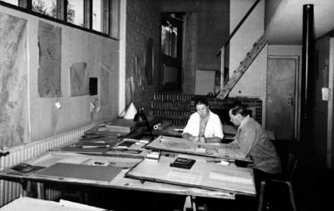 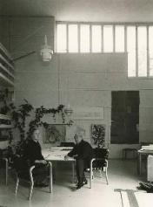

Aaron Y. L. Lee, CEO of the Jut Foundation for Arts and Architecture, said “In the 21st century when our environment and lifestyle are undergoing a sea change, the Jut Art Museum seeks to revisit the Aaltos’ 50-year journey of co-creation, appreciate the emphasis of Nordic culture on nature, light, and living spaces, and stimulate visitors’ cogitations on creativity, cooperation, and symbiosis with nature, thereby raising new possibilities for cities and future living.”

Timo Riekko, Chief Curator of Alvar Aalto Foundation, remarked that Taiwan, like Finland, is blessed with abundant natural environments, which makes him feel a sense of familiarity, and he hopes the exhibition will inspire Taiwanese audiences in their daily lives. Mari Murtoniemi, Chief Curator of Alvar Aalto Museum added that although Alvar Aalto never visited Taiwan, meeting Taiwanese audiences through this exhibition is a rare and wonderful experience.

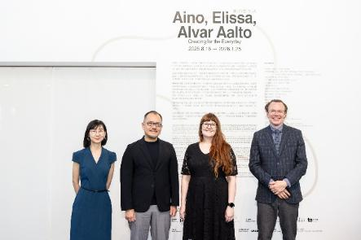

**“Alvar Aalto”—A Finnish design paradigm established by three architects**

Alvar Aalto was one of the most influential Nordic architects of modern times. Yet, “Alvar Aalto” is not only a personal name, but also a symbol of the half-century collaboration and attainment of design ideals by three architects: Alvar, Aino, and Elissa.

  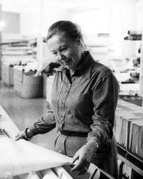

Aino Aalto, his first wife, forged her design career alongside Alvar Aalto from the 1920s to the 1940s after they got married. As a couple, they founded the renowned furniture brand “Artek,” with Aino serving as the brand’s first design director and establishing its signature style. Many years after Aino’s death, Elissa Aalto, Alvar’s second wife, had engaged actively in the core work of Aalto’s office since the 1950s. Following Aalto’s decease in 1976, Elissa dedicated her life to carrying on Alvar Aalto’s philosophy, led the architect’s office and its building projects, and participated in the inner workings of the Alvar Aalto Foundation, so as to perpetuate the spirit of Alvar Aalto’s design.

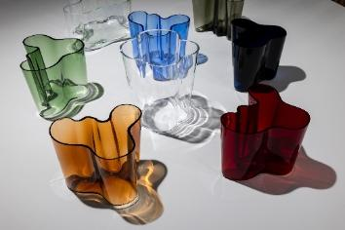 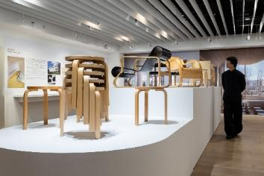

These three architects collaborated in relays, creating designs that encompassed residential buildings, public buildings, furniture, and lighting. Together, they formed the humanistic architectural style of “Alvar Aalto,” setting great store by people, nature, and ideal lifestyle. Living in the post-1920 period when Finland just declared independence and entered modernization, these three architects treated their native culture as the point of departure and responded to the international society through architecture. Their works embodied the importance that Finnish society attaches to the spirit of democracy and the quality of life, becoming one of the indispensable emblems of Nordic modern architecture and design aesthetics.

**The warmth of “home”: Incubating ideal living spaces in nature**

Finland, a “land of a thousand lakes,” is known for its remarkable forest cover. Its one-of-a-kind natural environment has influenced the local living culture. The Aaltos tended to incorporate natural elements into their designs. Starting from “home,” this exhibition features multiple magnum opuses by the Aaltos in which the Finnish philosophy of life finds expression, including the “**Villa Flora**” designed by Aino for her family in 1926, a summer retreat well blending wood and plants with the surroundings whilst mirroring the Finnish lifestyle in a symbiotic relationship with nature. Designed by Alvar and Aino, “**The Aalto House**” is a building that reconciles the functions of a family’s home and an architect’s office. A huge amount of natural materials and large windows connect the interior with the exterior, conveying a sense of living in harmony with nature. Managed by the Alvar Aalto Foundation, the Aalto House has been a museum open to the public all year round. These works not only demonstrate the Aaltos’ meticulous handling of living spaces and respect for nature, but also radiate the warmth of “home”—a congenial place where one can live in harmony with nature and incubate an ideal lifestyle.

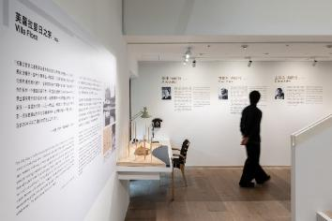 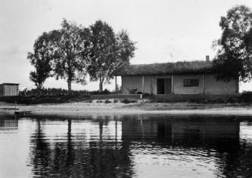 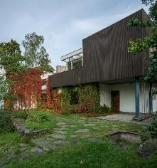

**Caring for “cities”: Public Buildings that meet people’s physical and mental needs**

Finland has been ranked the happiest country in the world for eight years in a row since 2018. Its emphasis on equality, caring, and social well-being had been indicated as early as in Alvar Aalto’s design in the early 20th century. Addressing the tuberculosis patients’ needs and aiming to facilitate their physical and mental recovery, the “**Paimio Sanatorium**” in a pine forest in southwestern Finland was designed as a healing building in terms of lighting, acoustics, furniture, interior design, and air quality. Currently located in Russia, the “**Viipuri Library**” was designed with readers’ experience at its core. There are 57 skylights providing plenty of light for reading without glare, creating a bright, comfortable, and well-organized reading space. The “**Seinäjoki Cultural and Administrative Center**” in western Finland comprises a large cluster of public edifices — the church and parish center, town hall, library, theater, and government offices, forming a symbolic city center. After Alvar’s decease, Elissa brought this project to completion, making it one of his masterpieces that materialized his urban design philosophy.

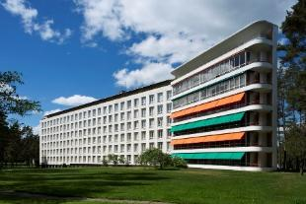 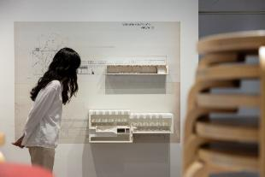

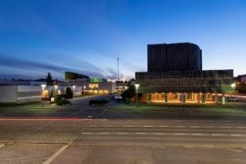 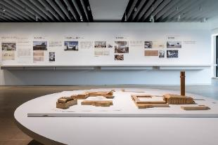

**More than architecture: Experimenting with materials and design details to create a paradise on earth**

Alvar Aalto treated each building as a “complete work of art.” He not only focused on the spatial forms of buildings, but also created different textures and sensory experiences for living spaces by experimenting with challenging materials and details. He deliberately rendered the red-brick texture visible on the façades, instead of covering them with plaster and paint as was more conventional in public architecture. He worked with ceramics factories in developing rod-shaped tiles, showing the rhythmic interplay between light and shadow on the façades. Alvar Aalto and master metalsmith Viljo Hirvonen also joined hands to develop the “**Beehive**” lamp and a series of bronze home decoration items. Furthermore, inspired by natural totems, the Aaltos designed some printed fabrics that extended architectural vocabulary to people’s quotidian existence. Alvar and Elissa built a “**Muuratsalo Experimental House**”. They used this lakeshore summer house as an experimental site for living, ranging from sundry brick arrangements in the courtyard to designing a boat to get to the island, reflecting the philosophy of “creating for the everyday” in all aspects.

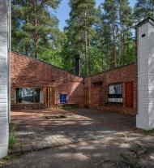 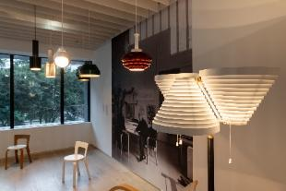 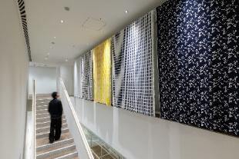

**The two exhibition venues work in tandem to present a comprehensive perspective on architecture and life.**

The Jut Art Museum has long focused on dialogues between architecture and cities, with exhibition content covering architectural art, architectural trend research, and globally celebrated architects. This retrospective on one of the iconic figures in the field of Nordic modern architecture also aims to continue the museum’s exploration of cities and future life through a multicultural perspective that transcends geographical confines.

This exhibition is presented across two venues. The main venue, Jut Art Museum, opens from 16 August 2025 to 25 January 2026 and requires a ticket for entry. Tickets can be purchased on-site or online via Klook. Classic furniture such as the legendary “Stool 60” is also on display in the main venue to offer visitors firsthand experience.

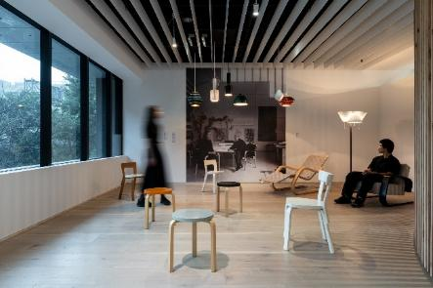

The satellite venue, Uncanny, will open on 4 October 2025 with free admission. This space features the extended exploration of the philosophy and applications of the Aaltos’ furniture design. The Jut Art Museum expects to connect architecture with life via these two venues, revealing a full picture of the Aaltos’ practical philosophy of “creating for the everyday.” Thematic lectures and expert guided tours will be offered during this exhibition. For detailed information, please visit the museum’s official website.

**Information**

***Creating for the Everyday – Aino, Elissa and Alvar Aalto***

<https://jam.jutfoundation.org.tw/en/exhibition/107/5183>

**Date**｜2025.8.16 SAT-2026.1.25 SUN

**Main Venue｜Jut Art Museum** (No.178, Sec. 3, Civic Blvd., Da'an Dist., Taipei City 106, Taiwan)

**Date**｜2025.8.16 SAT-2026.1.25 SUN

**Opening Hours**｜TUE-SUN 10:00-18:00 (Closed on Mondays)

**Admission**｜General TWD 150, Concessions TWD 100 (Student, seniors aged 65 and above, and groups of 10 or more)

**Free Admission** for the disabled and a companion, children aged 12 and under (Concessions or Free Admission upon presentation of valid proof)

**Student Day**｜Free Admission once on WED (With valid student ID)

**Tickets Available Online via Klook** | <https://reurl.cc/mYpO0l>

**Satellite Venue｜NOKE 3F Uncanny** (No. 200, Lequn 3rd Rd., Zhongshan Dist., Taipei City 104, Taiwan)

**Date**｜2025.10.4 SAT- 2025.11.30 SUN

**Opening Hours**｜SUN-THU 11:00-21:30, FRI-SAT 11:00-22:00

**Admission**｜Free admission

Organizer｜Jut Art Museum

Curatorial Team｜Jut Art Museum, Alvar Aalto Foundation

Cultural Partner｜eslite member

Media Partners｜La Vie, MOT TIMES, ta magazine

Event Partners｜MOT CASA, Nordic lifestyle, NOKE JUT RETAIL, ONIBUS、Slice

Satellite Venue Partner｜Uncanny

**Exhibition Team**

* **Exhibition Supervisors**｜Aaron Y. L. Lee, Alex Y. H. Lee, Shan-Shan Huang
* **Curatorial Team｜**Timo Riekko, Mari Murtoniemi  (Alvar Aalto Foundation)

Shan-Shan Huang, Ying-Peng Chen, Chia-Ching Lin (Jut Art Museum)

Yao-Ting Wu (Exhibition Advisor)

* **Coordinators**｜ Yen-Hsiu Chen, Yu-Chen Tsai, Tsuei-Yi Jang
* **Communications and Marketing**｜Yen-Shan Li, Chi-Yun Chang, Yu-Chin Liou, Yi-Ning Lin
* **Public Service**｜Tsung-Ping Hung, Pei-Chun Tsai, Yu-Tzu Lin
* **Administration Coordinator**｜Hsin-Yi Lin
* **Visual Design**｜Idealform Co.
* **Special Design**｜Very Studio｜Che Wang Architects
* **Exhibition Graphic Design**｜60 DEGREE
* **Timeline Graphic Designer**｜Min-Wei Liu
* **Lighting Design**｜LighTemp
* **Multimedia Design**｜UN ART