The Jut Art Museum invites Tadao Ando to stage the exhibition “TADAO ANDO: ENDEAVORS” in Taiwan, the land of “dialogue” and the final stop on his global exhibition tour.

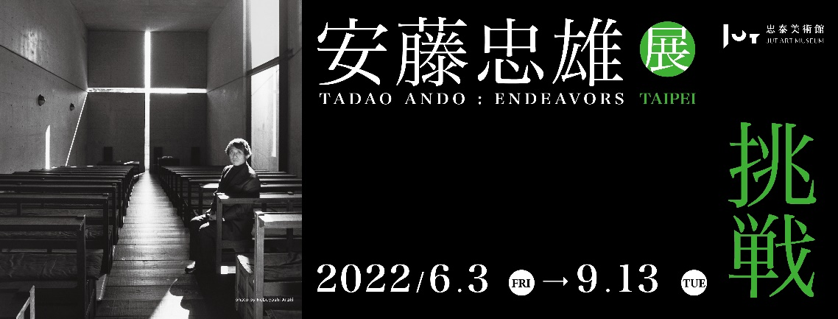
TADAO ANDO ENDEAVORS (TAIPEI) -Key Visual ©Jut Art Museum

As the first art museum focusing on the issues of “future” and “city” in Taiwan, the Jut Art Museum, after celebrating the 5th anniversary of its establishment, works in tandem with the Tadao Ando Exhibition Committee and invited the Japanese-trained architect Kokuei Ryu as the curatorial advisors to introduce the grand retrospective exhibition “TADAO ANDO: ENDEAVORS” into Taiwan this summer. A winner of the Pritzker Architecture Prize, Ando states that “this exhibition has toured five cities in five years, and it’s absolutely a meaningful coincidence that the final stop is Taiwan, the ‘land of dialogue.’ I expect this exhibition to afford the visitors an opportunity to cogitate upon the origin of architecture.” The exhibition is currently on view at Warehouse No. 1, Songshan Cultural and Creative Park till 13rd September 2022.

Divided into four major themes, namely “Primitive Shapes of Space,” “An Urban Challenge,” “Landscape Genesis” and “Dialogue with History,” this exhibition features more than 300 pieces of works that encompass Ando’s design manuscripts, architectural models, videos, and photographs, together with his travel sketches made during his autodidactic period. An exact 1:1 scale replica of the classic architectural space Church of the Light is displayed at the venue as well. These exhibits range from the architect’s early works to his recent projects, presenting a systematic, in-depth dissection of Ando’s architectural philosophy.

Following “SOS Brutalism—Save the Concrete Monsters!” co-organized with the Deutsches Architekturmuseum in 2020 that addresses the architectural trends of the times, and “Drawing Ambience: Alvin Boyarsky and the Architectural Association” in collaboration with the Alvin Boyarsky Archive in 2021 that reveals the spirit of experimentation and transformation inspired by architectural education, this elaborately orchestrated event also counts as a grand transnational exhibition hosted by the Jut Art Museum. By virtue of these exhibitions, the Jut Art Museum seeks to facilitate international exchange in architectural education, insofar as to stimulate people’s reflection on the potential of architecture and promote the overall development of urban culture.

For more detailed information about the venue and the exhibition, please visit the official website http://jam.jutfoundation.org.tw/en

