Contents

- Preface / Jut Art Museum P.2
- Curator’s Biography P.3
- Artists and works Introduction P.4~16
- Photos P.17~19

NOTE
- The press kits and more photos can be downloaded in the link: https://reurl.cc/K33OK9
- Standard Usage for Images: Photo credit/by must be given where applicable; and please indicate © Jut Art Museum.

About Jut Art Museum
Jut Land Development's 30th anniversary, and the Jut Foundation for Arts and Architecture (JFAA)'s 10th birthday, culminates in the establishment of the Jut Art Museum (JAM) in 2016. It is a milestone commemorating the history of Taiwan's architectural aesthetics.

We anticipate that JAM to act as a new form of platform, catalyst and think tank devoted to corporate social responsibility fulfillment and addressing the societal dynamics of the 21st century. We also anticipate it to carry on the legacy of "A Better Tomorrow" that defines much of JFAA's work, to become the first museum in Taiwan that is focused on the issues of "future" and "city."

Website https://jam.jutfoundation.org.tw/en
Facebook https://www.facebook.com/JUTARTMUSEUM
Instagram https://www.instagram.com/jutartmuseum/

【Appendix I. Preface / Jut Art Museum】

We, in the Future

Have you ever imagined yourself as a cyborg, a human-machine system with mechanical implants in your body?

Today, artificial intelligence has an ever-widening range of applications. It works in tandem with technologies and algorithms. While they’re inventing new ways to alter the environment, their influence extends as far as the modality and evolution of life. In this sense, humans and technologies have co-constructed an unprecedented context of life. The fluidity of “life” and “body” in terms of definition and cognition has led to the gradual acceptance of machines as a form of life, which ushered in an era of a new relational network interlaced by “humans” and “machines.”

If “humanity” is the ideological foundation for life, the exhibition Dasein—Born to Be Human that ended recently could be understood as an endeavor to cogitate upon the existence and essence of humankind from the angle of a mortal “human being,” with the aim of collating the relationships between humans and themselves, humans and others, as well as between humans and the environment. Looking into the time to come, the exhibition The Future Life, Future You – Digital, Machine and Cyborgs further explores the forms and meanings of life, viz., its raison d’être. As life is gradually transcending the physical confines of the corporeal body whether in the realm of reality or that of virtuality, human beings, animals, and organisms of all stripes have taken on a brand new form of life against the contemporary social milieu. In view of this, how do we redefine our very existence?

Jut Art Museum has maintained a long-term focus on issues concerning “city” and “future” through contemporary art exhibitions. This exhibition features a total of 15 artists/artist groups from the United Kingdom, France, Germany, Japan, and Taiwan, who use their respective artistic vocabulary to reflect the diversity of future life-forms and challenge the viewer’s limited imagination about known natural creatures. Since our contemporary life evolves constantly with technologies, how do we adapt and move forward accordingly? We expect the dialogues unfolding in this exhibition to provide future human beings with refreshing narratives and creative imaginations about life.

【Appendix II. Curator’s Biography】
Curator |  | Biography
Bo-Cheng Shen | 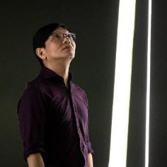  ©Jut Art Museum | Ph.D. in Art Creation and Theory from National Tainan University of the Arts. Now he is a visiting assistant professor and art critic of the Sculpture Department of the National Taiwan University of Arts. Because of his admiration for MacGyver, he decided to study chemistry in university, worked as a materials engineer. Because of his yearn for Indiana Jones, he once worked in archaeological research. He admired the Austrian school’s view of economics as a concept of human behavior, so he went to work as a researcher at Chung-Hua Institution Economic Research. He likes exhibitions, so started as a part-time curator. He has served as special guide for the National Taiwan Museum of Fine Arts, and the MOCA Taipei for many times, and also writes columns for art magazines such as Artco, ARTouch…etc.
Life and its meaning have been the most profound questions throughout human history. The contemplation and imagination of life have served as the driving force behind intellectual pursuits, artistic creations, and various forms of creative expression. Like philosophy and science, art continues to explore and represent life through boundless imagination. The exhibition The Future Life, Future You - Digital, Machine and Cyborgs aims to portray the new environment of life shaped by artificial intelligence, cyborgs, and human intervention in species, within the era of Techno Re-Genesis.

If the question “What life is（for）?” has been the fundamental inquiry behind the works of artists throughout history, then contemporary artists inevitably strive to direct their focus towards the future of “life" as the great works of the past have done. Consequently, the exhibition The Future Life, Future You - Digital, Machine and Cyborgs intends to project not only the “technology” related to life but also the humanistic contemplation and aesthetic concerns about “the faces of life” in the context of new technological scenarios. When viewers gaze upon the artworks of the artists, they are truly contemplating inquiries, imaginations, and reflections about various new “lives” and the circumstances surrounding them.

Just as English environmentalist James Lovelock (1919-2022) says: “Life clearly does more than adapt to the Earth. It changes the Earth to its own purposes. Evolution is a tightly coupled dance, with life and the material environment as partners. From the dance emerges the entity Gaia.” Humans and technology have co-constructed entirely new life scenarios, and artists are leading viewers to contemplate these novel issues of life.

Curatorial Statement (Full Version) HERE

【Appendix III. Artists and works Introduction】
Artist/Group | Biography
© Universal Everything | Universal Everything (U.K)  Universal Everything is a global collective of digital artists, media artists, experience designers and future makers, established in 2004. They use emerging display technologies as our canvas and take a stylized, playful approach to design, architecture, nature and digital life. Universal Everything’s subvert cinematic CGI, physics simulations and real-time generative design create new forms of moving image, interaction and immersive spaces. They also engage in collaborations including future R&D with Apple, immersive spaces with Hyundai, generative audiovisual apps with Radiohead, and interactive spaces with Zaha Hadid Architects.
Introduction
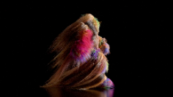  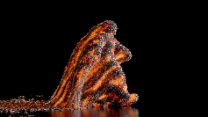  ©Universal Everything | Transfiguration  2020, 4K video, 6’ 24”  What does evolution look like? The ever-changing walking figure in Transfiguration depicts a figure that transforms in front of our eyes, echoing our own emotional upheaval. This take on nature is elemental, with a focus on fire, rock and water. The further they walk, the more they evolve, their stone footsteps echoing metal, liquid, wood. It is as if we are rebuilding life itself in some primal form. The figure feels familiar but also larger than life. The sound design heightens its sense of colossal realism, as if the geological building blocks of life are forming as we watch.
Artist/Group | Biography
© Kazuaki Koyama | JIZAI ARMS project team (Japan)  The JIZAI ARMS project, a collaborative endeavor between the Information Somatics Lab and the Prototyping Lab of the University of Tokyo, explores the intersection of art, technology, and design. This work was supported by the Exploratory Research for Advanced Technology program of Japan Science and Technology Agency (JST ERATO). The team was led by Masahiko Inami, a professor at the University of Tokyo. The team includes: Daisuke Uriu, Mitsuru Muramatsu, Yusuke Kamiyama, Shin Sakamoto, Nahoko Yamamura, Shunji Yamanaka.
Introduction
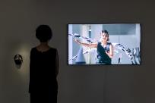  ©Jut Art Museum  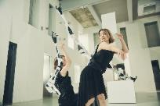  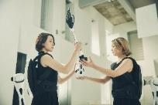  ©JIZAI ARMS project team | JIZAI ARMS  2022, Video, 3'02''  Half a century since the concept of a cyborg was introduced, digital cyborgs (JIZAI Bodies), enabled by the spread of wearable robotics, have been the focus of much research in recent times.  JIZAI ARMS is a modular, wearable robotic arm system. It comprises a base unit with six terminals to which custom-made robotic arms can attach, along with an associated set of robotic arms. This system empowers wearers to attach, detach, replace, edit, and alter the arms they are wearing while the system is online. Namely, given multiple people with the system, a wearer can exchange, gift, or be gifted arm(s) by another wearer.  The system was designed to enable social interaction between multiple wearers, such as an exchange of arm(s), and explore possible interactions between digital cyborgs in a cyborg society. The designers created JIZAI ARMS from the ground up, focusing not only on its rationality as a machine but also incorporating the rhythm of the human body’s shape into its design. Their goal was to create a system that seamlessly harmonizes with the human body when worn by a person.  By designing and conducting social interactions with JIZAI ARMS, the designers seek to understand interactions that occur between multiple “digital cyborgs.” By doing so, they hope to predict the near future in which people freely and flexibly adopt human-machine integration technologies and make use of them in social settings.
Artist/Group | Biography
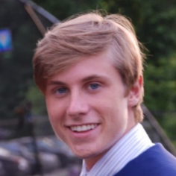  © Aiden Faherty | Aiden Faherty (U.S.A)  Aiden Faherty, a 23-year-old digital artist from New York, is the creative mind behind and owner of the social media brand @coolacloy. With a degree in Computer Information Systems, Faherty combines his passion for philosophy, science, and technology to create captivating 3D designs, animations, and videos. Influenced by Eastern philosophy and the vastness of the universe, his art tells fascinating stories through visuals, often accompanied by the voices of renowned figures like Alan Watts, Michio Kaku, and Neil deGrasse Tyson. By staying up-to-date with the latest technologies, Faherty continually pushes the boundaries of digital art, demonstrating the transformative power of technology in artistic expression.
Introduction
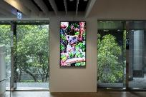  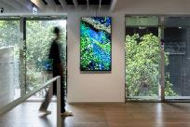  ©Jut Art Museum  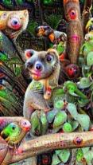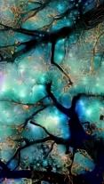  ©Aiden Faherty | A Journey Through the Transcendental Forest  2021-2023, Video, 2'32''  “Through our eyes, the universe is perceiving itself. Through our ears, the universe is listening to its harmonies. We are the witnesses through which the universe becomes conscious of its glory, of its magnificence.”- Alan Watts  This collection of artwork serves as an exploration of nature’s profound beauty and intricate details, infused with a unique twist—an altered state of consciousness. Going beyond the ordinary, these pieces transcend the boundaries of perception, inviting viewers into a realm where reality merges seamlessly with imagination. With a touch of surrealism, they capture the very essence of nature’s wonders. As a result, familiar landscapes and elements are transformed, offering a fresh and enchanting perspective on the natural world. This exploration of altered consciousness in relation to nature injects new vitality into the artwork, stimulating the audience with their thoughts to contemplate the interplay between perception, imagination, and the natural world.
Artist/Group | Biography
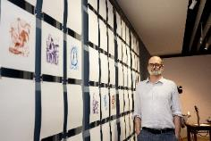  © Jut Art Museum  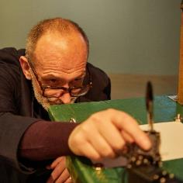  © Ara Art Center | Patrick Tresset (France)  Born in France in 1967, Patrick Tresset now lives and works in Brussels, Belgium. He graduated in 2006 from Goldsmiths College in London, UK, with a master's and with a MPhil degree in Art and Technology in 2013. Patrick Tresset is best known for his performative installations, drawings, and generative computational works. His work explores the representation of human experience using computational systems, robotics, and traditional media. His work has been exhibited in association with major museums worldwide, including the Pompidou Center and the Grand Palais in Paris, the Prada Foundation in Milan, the Tate Modern and the V&A in London, MMCA in Seoul, and BOZAR in Brussels.
Introduction
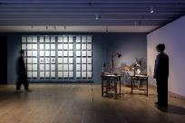  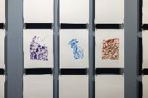  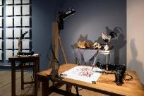  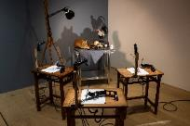  ©Jut Art Museum | Human Study #2, La grande Vanité au Coq et au Renard, etc...  2023, School desks, easel, cameras, computers, custom software, robotics parts, stainless steel table, skull, cowry shell, taxidermied animals and other objects, Dimensions variable  “La Vanité” is a theatrical installation. A sketching robot stripped down to its bare essentials endlessly draws an updated vanitas. The robot here is a little story machine, it is constructed to build stories about humanness. It is not self-contained, but dependent on our gaze. Having a soulless robot meditating on our mortality raises numerous candid, existential and meaningless questions. It is an allegory of what has been called our posthuman condition: man’s face finally washed out by the ocean, not recognizable anymore as an important figure of knowledge or merely one of its tropes.
Artist/Group | Biography
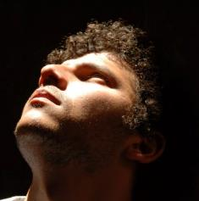  © Mohamed Moanis | Hassan Ragab (Egypt)  Born and raised in Egypt, Hassan combines contemporary technology with the historical built environment. His work is a reflection of his belief in the philosophy of architecture and the importance of exploring new visual language for geometry which could disclose new meanings to our built environment. With over 13 years of experience in architecture, museography, computational design, furniture design, construction and generative arts, Hassan has become a respected figure in the art and design world. Hassan Ragab has explored a variety of mediums, including computational design, AI, and graphic design tools.
Introduction
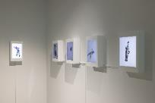  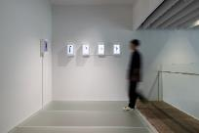  ©Jut Art Museum  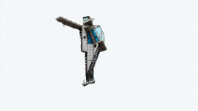  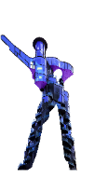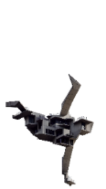  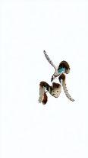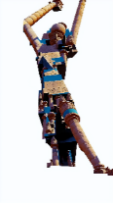  ©Hassan Ragab | Architectural Beings - Brutal Criminal  Architectural Beings - Modern Skyscraper at the Disco  Architectural Beings - Skydiving Brutalism  Architectural Beings - Brutal Angel  Architectural Beings - Oh Summer  2023, Video, 0'20'', 0'23'', 0'15'', 0'39'', 0'19''  In the grand ballet of existence, where do we find architecture? Has it been relegated to sterile edifices of concrete and glass, cold and senseless structures that serve geopolitical schemes or mere feats of practical engineering? Or, does it resonate with a pulse of life, embodying a dynamic participant in the dance of cosmos?  Architectural Beings rises in response to this predicament. Birthed at the intersection of artificial intelligence and art, this series transforms the fluid grace of human dance into an extraordinary language for architecture, often perceived as rigid and static. It dares to view architecture not as fixed forms but as moving entities, embracing the dance of life. Could architectures carry a consciousness, a visual identity that surpasses its physical shell?  Architectural Beings emerges as a mirror to our understanding, contesting its rigidity and unveiling the fluid potential for new thought. It invites us to perceive architecture not as silent observers, but as active participants in the ebb and flow of existence.
Artist/Group | Biography
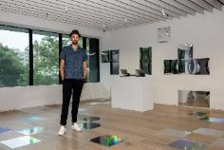  © Jut Art Museum  © Martin Backes | Martin Backes (Germany)  Born in 1977 in Germany, Martin Backes is a Berlin-based artist, creative technologist, director, hacker and composer. He studied Media Art & Design as well as Sound Studies at the University of Arts in Berlin. In his works, he often uses media technologies to reflect certain functionalities, effects, ideologies, and human perception, playing with the ambiguity between the physical world and the digital realm, reflecting the blurred boundaries between analog and digital, reality and simulation, stability and disruption, figure and abstraction. Backes cross-border and experimental field of activity in the intermediate area of art, science, technology, and culture ranges from augmented reality (AR) and multimedia sound works to theater dance pieces and installations, as well as sculptural and computer/video works.
Introduction
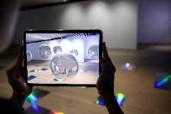  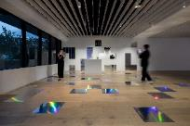  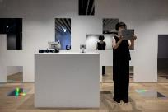  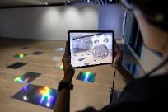  ©Jut Art Museum | What do I know? I am just a machine?!  2019, Spatial installation, tablet, custom-made, augmented reality app, audio headphone, Dimensions variable  What do I know? I am just a machine?! is an augmented reality work asking questions about identity, repression, inequality and injustice, which focuses on the experience of a marginalized group – the machines. The machines talk to us! They emote! They banter! They are on the very cusp of consciousness! You are invited to enter a relationship with them and explore the ever-changing modes of (augmented) reality. The future might be mildly confusing, occasionally profound and frequently hilarious. But who knows?!
Artist/Group | Biography
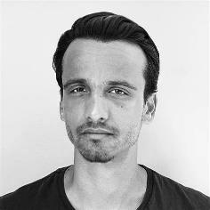  © Charlotte Kay | Markos Kay (U.K)  Markos Kay is a multidisciplinary artist and director with a focus in art & science and generative art.  He is best known for the artificial-life video art experiment aDiatomea (2008), first exhibited at Phyletic Museum in Germany, the generative short film The Flow (2011), shown worldwide, and the series of particle simulation paintings Quantum Fluctuations (2016). His art and design practice ranges from screen-based media to print and has been featured in museums, exhibitions, festivals, and publications such as the ArtScience Museum, Museum of Contemporary Digital Art, Bill and Melinda Gates Foundation, Ars Electronica, National Geographic, Wired and Vice.
Introduction
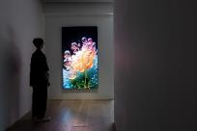  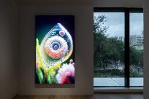  ©Jut Art Museum  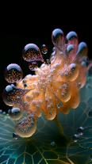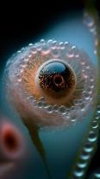  ©Markos Kay | aBiogenesis  2022, Digital moving image, 1’20’’  A conceptual reimagining of the “lipid world” theory which postulates that life originated from lipids forming membranes which would then envelop matter and nutrients to form protocells. This theory is one of many interconnected theories of abiogenesis, the study of how life originated on Earth. It is a complex and mysterious subject, and scientists have proposed many different theories to try to understand how life first emerged.
Artist/Group | Biography
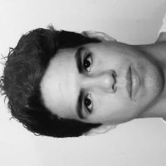  © Mal Bueno | Mal Bueno (Mexico)  Mal Bueno, a Mexican artist, discovered the wonders of coding and the internet at age 13, leading to an evolution of his explorations. His focus now encompasses themes like transformation, dynamism, the digital revolution, and our present essence. Through vibrant colors, shapes, and language, his artwork reflects the rhythms of life, offering a window into a fully digitalized future where humans and machines coexist harmoniously. Growing up in the technology era, he recognizes the significance of light and color in revolutionizing our perception of art and television. Integrating visuals and interactive programming to invite viewers to immerse themselves in digital scenarios. His art invites us to delve into the interplay between the tangible and the digital, offering a fresh perspective on the possibilities within our reach.
Introduction
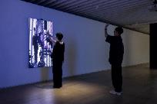  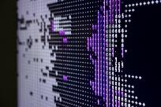  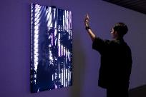  ©Jut Art Museum | Final  2023, Interaction installation, Dimensions variable  Prepare to be captivated by an extraordinary world of kinetic energy and visual storytelling. Mal Bueno's visionary creation blurs the lines between the physical and the ethereal, the tangible and the ephemeral. This singular piece invites you to witness the captivating dialogue between human form, horizontal perspectives, and the transcendent language of light. It is an invitation to ponder the interplay between movement and perception, and to contemplate the transformative power of art in capturing the essence of human expression.  In this captivating journey, Final unveils a profound revelation—a testament to the power of dance and light in evoking emotions, telling stories, and inviting introspection. It is an immersive testament to the symbiotic relationship between human movement, visual perspectives, and the transcendent realm of artistic expression.
Artist/Group | Biography
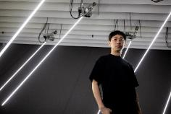  © Jut Art Museum  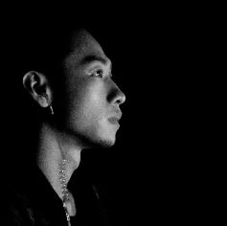  © Yi Chen | Yi Chen (Taiwan)  Yi Chen graduated from the Graduate Institute of Technology Art, Taipei National University of the Arts. He won the Taipei Art Awards in 2006, and co-founded LuxuryLogico with his friends. In the practice of interdisciplinary art, Chen explores various issues, such as existence, consciousness, desire, data, environment, politics, economy, and society, through his observation of and comparison between reality and virtual consciousness. With the method of landscaping, he reconstructs ideas, mediums, issues, and site-specific context, with which he forms a basis embedded with the dialectics of his personal philosophy and artistic vocabularies. Chen has been featured at IRCAM linked with the Centre Pompidou, Paris (2023), the Echigo-Tsumari Art Triennale (2022), the Thailand Biennial (2018), and the Asia Triennial Manchester (2014).
Introduction
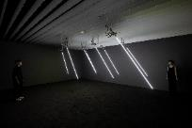  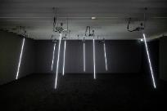  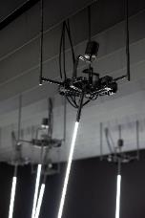  ©Jut Art Museum | Windy Field  2023, aluminum, LED, servo motor, electronic control system, PC, speaker, Dimensions variable  The kinetic installation simulating movement caused by wind is part of Yi Chen’s “Duplication of Nature” project, which postulates that nature will disappear after the extreme development of technology, and tries to capture data from natural environment to be learned, imitated and represented through AI technology. The artist gathers air volume, wind direction, and sonic information of wind to form an experimental project, utilizing AI algorithm to generate corresponding models of respective data. He then creates a mechanical installation to run the data generated by the AI models and simulate the swaying movement caused by wind. The artist intentionally avoids referencing the physical air flow to represent the natural phenomenon of blowing wind. Instead, with the absence of nature, he uses a group of thin and long LEDs, and creates a mechanical device at the base to generate the movement of the LEDs, while using subtle glistening of light to symbolize the glimmers of natural materials, such as plants or water surface, caused by the blowing wind. In this project, nature is the goal pursued collectively by humans for survival. Humans try to harness nature, and creates substitutes as the method. Beginning with imitation, the process is repeated until the truth of nature is obtained.
Artist/Group | Biography
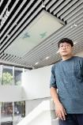  © Jut Art Museum  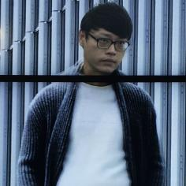  © Wan-Jen Chen | Wan-Jen Chen (Taiwan)  Born in Hsinchu in 1982, Wan-Jen Chen started his creation with video art as a starting point. He utilizes various contemporary image creations and image making machines, mobile devices, monitors and screens to formulate his creative expression. His practice fully engages in engendering collisions between moving images and everyday sites, with an emphasis on the theatrical experience of images and transmedia collaboration, infusing his image and video works with contemporary meanings. To create his works, Chen begins with observing, recreating or filming the life of modern people at different locations, and then, repeatedly edits the images using techniques of digital post-production, such as collaging and appropriating. Through the process, the artist intentionally enlarges trivial moments unnoticed by people in physical life, creating endless loops of these moments. Through his keen observation and non-linear thinking, he converts real life into surreal, humorous fantasies, transforming his works into visual poetry that coagulates fleeting moments into eternity.
Introduction
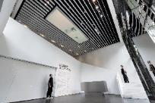  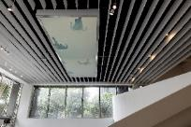  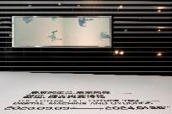  ©Jut Art Museum  ©Wan-Jen Chen | Stagger Moment  2022, Video installation, 5’00’’  Through the visual expression of light and shadow, the work blurs the boundary between reality and virtuality, and constructs an uncanny atmosphere that is elusive and indescribable in people’s familiar living environment. The flickering, moving light creates a sense of voyeurism, as if the viewer is looking through frosted glass. The realistic but somehow ethereal moving images prompt the projection of the viewer’s experience, opening up a space of imagination in everyday life. Like the playback of an eerie memory (or dream), the viewer perceives the elusive distance, which is reminiscent of an unintentional glance and responds to the conflicts of modern society, in which people are aloof yet yearning for intimacy. As the virtual world becomes a bridge, it still fails to facilitate correct understanding and connection, denying the viewer a clear sight of reality.
Artist/Group | Biography
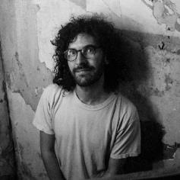  © Teodora Kosanovic | Jake Elwes (U.K)  Born in 1993, living and working in London, UK. Jake Elwes studied at The Slade School of Fine Art, UCL from 2013 to 2017. Searching for poetry and narrative in the success and failures of AI systems, Jake Elwes investigates the aesthetics and ethics inherent to AI. Elwes’ practice makes use of the sophistication of machine learning, while finding illuminating qualities in its limitations. Across projects that encompass moving-image installation, sound and performance, Elwes seeks to queer datasets, demystifying and subverting predominantly cisgender and straight AI systems.
Introduction
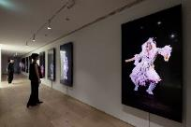  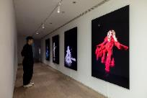  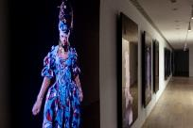  ©Jut Art Museum  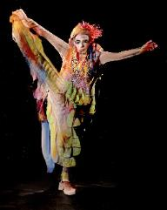  ©Jake Elwes | Zizi in Motion: A Deepfake Drag Utopia (Movement by Wet Mess)  2023, Video, 20'35''  A silent video series consisting of life-size deepfakes of a range of London drag performers. How can we as a queer community subvert deepfake technology, using it in an ethical and consensual way to celebrate queer bodies? Everyone involved in the project has power over their own data and involvement as well as all being part of the same community. In this piece forms are re-animated by drag legend Wet Mess who’s improvised movement causes the AI to beautifully break down and fail, imagining an alternate queer utopia for AI.
Artist/Group | Biography
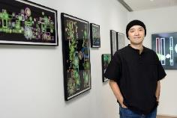  © Jut Art Museum  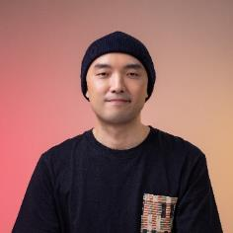  ©Newyellow | Newyellow (Taiwan)  The settlers of the new media world, the new immigrants of the crypto world.  He started exploring interactive new media in 2014, and head into the world of crypto art, and began creating NFTs in 2021. His work Resonance like Water has won the akaSwap Water Art Award and has been exhibited at the Taipei Museum of Contemporary Art, showcasing pieces such as Blooming and 100HEN - Not Without You.He also released several Generative Art on the blockchain, such as Overstacked, Flossom, and Recursive and Blocks.
Introduction
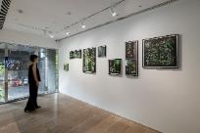  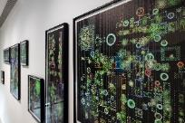  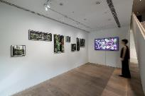  ©Jut Art Museum  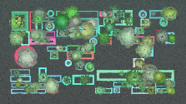  © Newyellow | Generative Sketch: Succulent Garden  2023, Real-time generative image installation, Dimensions variable  This artwork is a sketch that uses generative art to break down everyday scenes into geometric forms created by a program. By using different random seeds in the code, it can generate an endless variety of arrangements of potted plants and leaf shapes.  The artwork’s main structure is based on the Subdivision algorithm, which divides the canvas recursively into differently sized blocks. Inside each block, rectangular, square, or circular potted plants are randomly placed. The number of succulent plants that each pot can produce depends on the pot’s shape. The leaves of each plant are intricately drawn using random Easing Curve functions, creating a multi-layered structure with varying quantities.  The overall visual style is achieved through dense brush strokes that simulate the texture of a physical canvas in painting. The density of the brush strokes is also randomly generated, resulting in a varied level of density in each generated composition.
Artist/Group | Biography
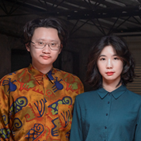  © Simple noodle art - Zi-Yin Chen & Gotop Chuang | Simple noodle art - Zi-Yin Chen & Gotop Chuang (Taiwan)  Founded in 2019 by Zi-Yin Chen and Gotop Chuang, Simple noodle art is an art collective working with installation, video, net art, photography and artificial intelligence. With a background in art and information technology respectively, Chen and Chuang focus on the interactions between technological products and humans, along with how such interactions alter and influence our lifestyle. Through interdisciplinary thinking, they aim to create works that are like a simple bowl of noodles, which has uncomplicated ingredients but a great taste. Simple noodle art is the recipient of the Prix Ars Electronica (Jury’s Honorary Mention, 2023), and their works have been shown at various institutions, among which are National Taiwan Museum of Fine Arts, MOCA Taipei, C-LAB, and 182ARTSPACE.
Introduction
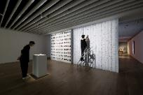  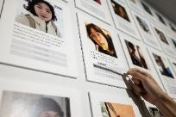  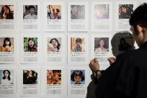  ©Jut Art Museum | Inter net - Labeling me  2023, Space installation, Dimensions variable  Crowdsourcing is often used to train AI models for image recognition and generation. Also it’s used in large image datasets as the “baseline” (image classification, description, etc.) These labeling through crowdsourcing can be done by Amazon Mechanical Turk. Labeling through crowdsourcing is theoretically the “collective opinion of the public” and matches the goal of maintaining as objective as possible requested of many AI systems.  Inter net - Labeling me is extended from the art series, Inter net. The work comprises two walls, one of which is covered by photos put into the category of the artist, Zi-Yin Chen’s “self” by AI in cellphones. The descriptions below the photos are “labels” obtained via crowdsourcing by Amazon Mechanical Turk. The other wall is covered by all of the artists’ unselected search entries since they began using Google over a decade ago: these include worries about budding romantic relationships, hesitation about choosing a major in college, anxieties over political situations, or a simple desire to find a deli to eat. The Google search entries form a personal profile unconsciously created and accumulated over more than ten years. Audiences are welcome to tear down the Google search entries and paste them below the photos, and conduct an alternative “crowdsourced labeling” using the artists’ self-writing of “I.”
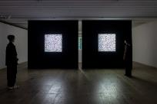  ©Jut Art Museum | The Crowd’s Portrait of Me  My Self-Portrait  2023, Single-channel algorithmic image installation, Dimensions variable  These two videos are a piece extended from the artist collective’s art series, Inter net. The videos shown in this piece are The crowd’s portrait of me and My Self-portrait. Both appearing in noise-like images, they convey descriptions of “I” respectively through crowdsourced labeling and the Google search entries in the form of self-writing.  The crowdsourced labeling and Google search entries in Inter net - Labeling me use the technology of text embedding to convert these textual descriptions of the artists into eigenvectors before converting the eigenvectors again into color blocks that are arranged into matrix based on a chronological order. The textual descriptions that are more similar in terms of semantics will produce blocks of more similar colors. These seemingly random noise images in fact reveal the distribution of the artists’ descriptions of “I.” As time progresses, the descriptions of “I” also become fluid and different, and the color distribution changes accordingly.  Contrasting the two different types of descriptions of “I” in this work is also an attempt to project the self into these noises that are difficult to identity but highly meaningful.
Artist/Group | Biography
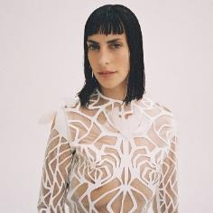  © Carlos Montilla | Moon Ribas (Spain)  Moon Ribas is a Catalan cyborg artist best known for developing the Seismic Sense, an online seismic sensor that allows her to perceive earthquakes taking place anywhere in the planet through vibrations in real time. In order to share her experience, she then translates her seismic sense on stage. Ribas transposes the earthquakes into either sound, in her piece Seismic Percussion; or dance, in Waiting For Earthquakes. In these performances the Earth is the composer and the choreographer; and Ribas, the interpreter.  Ribas’ seismic sense also has allowed her to feel moonquakes, the seismic activity on the Moon. Ribas believes that by extending our senses to perceive outside the planet, we can all become senstronauts. Adding this new sense allowed her to be physically on Earth while her feet felt the Moon, so in a way, she could be on Earth and space at the same time.
Introduction
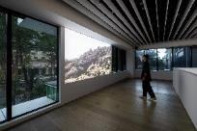  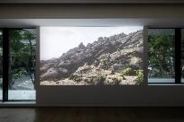  ©Jut Art Museum  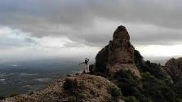  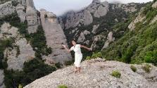  © Moon Ribas | Waiting for Earthquakes in Montserrat  2020, Video, 17'36''  Waiting for Earthquakes is a dance piece based on the interaction between the movement of the earth and Moon Ribas. Moon's seismic sense allows her to feel earthquakes in real time from anywhere in the planet. During the piece, Moon waits for an earthquake to take place, and when this happens she moves according to the intensity of the earthquake (she can feel earthquakes as small as 1 in the Richter scale).  In general, there are small earthquakes every 6-12 minutes. If there are no earthquakes during the time of the performance, there will be no dance. The piece is a duet, where the planet dictates the tempo and the intensity, and Moon interprets it.
Artist/Group | Biography
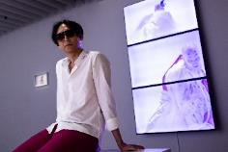  © Jut Art Museum  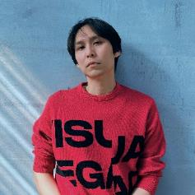  ©Hui-Yu Su | Hui-Yu Su (Taiwan)  Su obtained an MFA from Taipei National University of the Arts in 2003, and has remained active in the contemporary art scene and the film society ever since. His “Re-shooting” series centers around Taiwanese and East Asian history, memory, re-imagination and transgression. His recent projects engage collective memories and ideologies while exploring the mechanism of oppression and liberation tied to Taiwan cultural values. He has been invited to present his works in art museums at home and abroad. In 2019, Su won the 17th Taishin Arts Award- Visual Art Award. In 2023, Su’s first museum solo production The Trio Hall was exhibited in MOCA Taipei, curated by Eugenio Viola.
Introduction
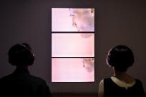  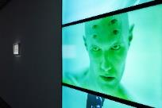  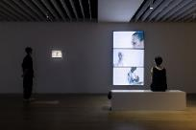  ©Jut Art Museum  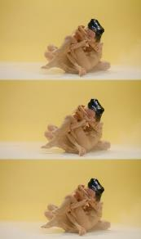  ©Hui-Yu Su | The White Waters  2019, Three channel video installation, photography, Dimensions variable  “Critical Point Theater Phenomenon” was established in the late 1980s by Chi-Yuan Tian and others. As the first publicly documented college student with AIDS, Tianand Critical Point not only launched a new era of experimental theater in Taiwan, but also represented a significant moment in the history of gay culture. In 1993, Critical Point presented its seminal work, White Water—a contemporary reinterpretation of “The Flooding of Jinshan Temple” episode in The Legend of the White Snake, which explored themes of homosexuality, love, and political identity; and touched conceptually on the domain of the post-human and anti-anthropocentrism. The White Waters uses Chi-Yuan Tian’s classic as leverage in a return to the classic legend. This work will focus on imagery such as flood/fluidity, death, violence, sex, gender, illness/death, post-human, and integration, etc., so as to contemplate the numerous thoughts and fissures in both The Legend of the White Snake and White Water, hence enabling the cognitive structures of desire, life, morality, and identity to be laid bare once more. In form, this work utilizes colors to create structurally distinct segments, and showcases the artist’s many flights of fantasy regarding the above. Technically, The White Waters is a multi-channel installation that can be performed on-site through the actions and operations of the performers.

【Appendix IV. Photos】
Installation view
Caption and Credit | Photo
Installation view 1F Lobby ©Jut Art Museum | 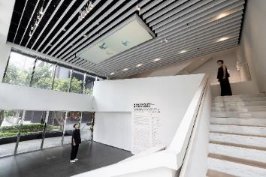
Installation view 1MF ©Jut Art Museum | 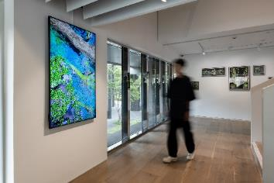
Installation view 2F ©Jut Art Museum | 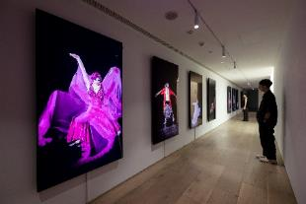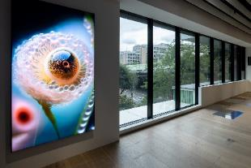  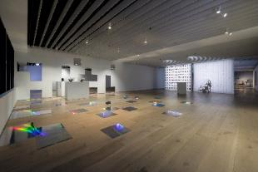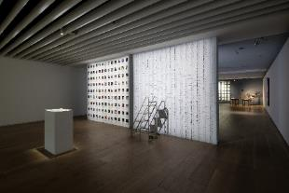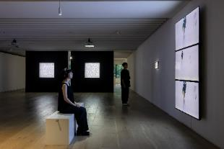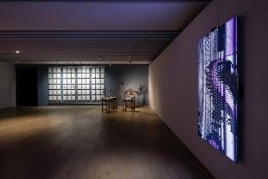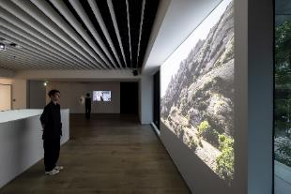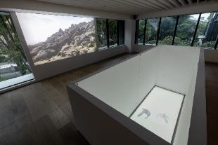

Key Vision
Caption and Credit | Photo
The Future Life, Future You – Digital, Machine and Cyborgs key vision (vertical) © Jut Art Museum | 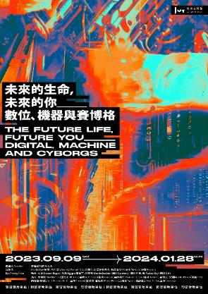
The Future Life, Future You – Digital, Machine and Cyborgs key vision (horizontal) © Jut Art Museum | 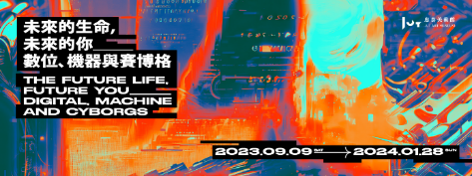

Opening Press Conference
Caption and Credit | Photo
CEO of the Jut Foundation for Arts and Architecture- Aaron Lee © Jut Art Museum | 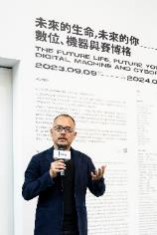
Curator: Bo-Cheng Shen © Jut Art Museum | 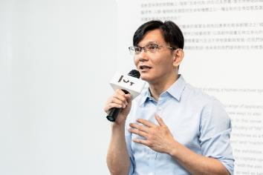
Group photo© Jut Art Museum  (left to right)  - Director of Jut Art Museum: Shan-Shan, Huang  - CEO of Jut Foundation for Arts and Architecture: Aaron Lee  - Hui-Yu Su  - Wan-Jen Chen  - Yi Chen  - Newyellow  - Martin Backes  - Patrick Tresset  - Curator: Bo-Cheng Shen  - Curatorial Executive: Sean C.S. Hu | 