The Jut Art Museum stages two exhibitions
“Sense on Site” and “Off-Site Project—Manifestation”.
To start from physical senses, blur the creator-viewer boundary, and redefine the work of art and the route of viewing experience.

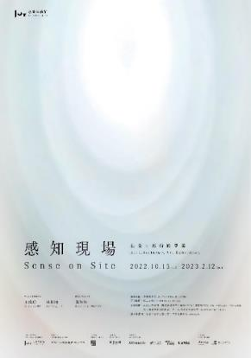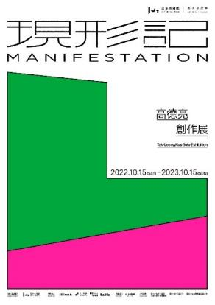

The Taipei-based Jut Art Museum has devoted continuing efforts to three major fields— “issues about future,” “urban architecture” and “contemporary art”. It is hosting two innovative experimental exhibitions, namely Sense on Site – Architecture x Art Exhibition at the museum and Off-Site Project—Manifestation - Tak-Leong Kou Solo Exhibition in the vicinity.

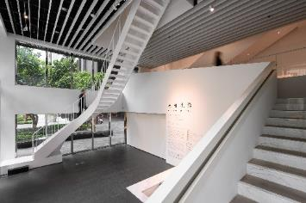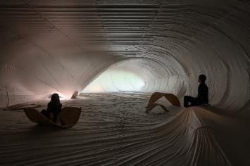
Curated by Shan-Shan Huang (director of the Jut Art Museum), Sense on Site features the transdisciplinary collaboration between artist Te-Yu Wang and architect Bo-Yang Lin. Treating “space” and “sense” as the creative keywords and discussing the issues concerning traffic flow and spatial arrangement, they create a refreshing space that transcends rigid confines and thereby transmute the museum’s interior into a mesmerizing work of art. They seek to liberate the viewer from the long-established pattern of visiting exhibition, and guide the visitor to explore, experience and define this “site” with personal physical senses, that is, to let the right of interpretation revert to the viewer. The exhibition remains on view until 12th February 2023.
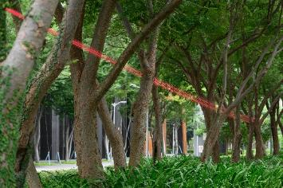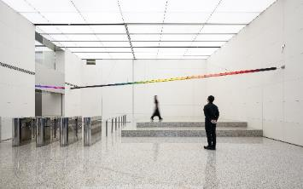
Manifestation - Tak-Leong Kou Solo Exhibition is the latest episode of the Jut Art Museum’s long-term artistic practice “Off-Site Project.” It features the museum’s cooperation with artist Tak-Leong Kuo who captures existing contextual elements and blends them into his personal viewpoint, through which he not only guides the visitor to explore the intangible border of urban life from an alternative perspective, but also heightens our visual perception of quotidian spaces. Pin and Roaming are the two brand new site-specific works that headline this exhibition, respectively focusing on the neighborhood park and the Jut headquarter in the vicinity of the museum. The exhibition is on view until 15th October 2023 (outdoor work until 12th February 2023).

Treating the purest human senses as the point of departure, the two innovative exhibitions hosted by the Jut Art Museum are intended to harness their experimental nature to redefine the pattern of visiting exhibition and spark broad discussions about more diversified forms of exhibition. For detailed information on the exhibitions, please visit the official website of the Jut Art Museum.

Information
Sense on Site – Architecture x Art Exhibition
Date｜2022.10.15(sat)-2023.2.12(sun)
Venue｜Jut Art Museum (No.178, Sec. 3, Civic Blvd., Da'an Dist., Taipei City 106, Taiwan)
Opening Hours｜TUE-SUN 10:00-18:00 (Closed on Mondays)
Admission｜By appointment only, and Entry will open according to vacancy. General TWD 100, Concessions TWD 80 (Student, seniors aged 65 and above, and groups of 10 or more) Free Admission for the disabled and a companion, children aged 12 and under (Concessions or Free Admission upon presentation of valid proof)
Student Day on WED｜Free Admission once on Wednesdays upon presentation of valid student ID
Exhibitors｜Te-Yu Wang, Bo-Yang Lin
Curator｜Shan-Shan Huang
Organizer& Coordinator｜Jut Art Museum
Website｜http://jam.jutfoundation.org.tw/en/exhibition/56/3771

Off-Site Project—Manifestation - Tak-Leong Kou Solo Exhibition
Date｜2022.10.15(sat)-2023.10.15(sun)
Venue｜Jut Headquarter Lobby (No.178, Sec. 3, Civic Blvd., Da'an Dist., Taipei City 106, Taiwan) and the outdoor park area
Opening Hours｜Mon-Fri 10:00-17:00, closed on weekends and national holidays.* (Outdoor on view until 2023.02.12)
Admission｜Free
Artist｜Tak-Leong Kou
Organizer& Coordinator｜Jut Art Museum
Website｜http://jam.jutfoundation.org.tw/en/exhibition/107/3772

