The Jut Art Museum presents the new contemporary art exhibition “Dasein—Born to Be Human” on the theme of “humanity”

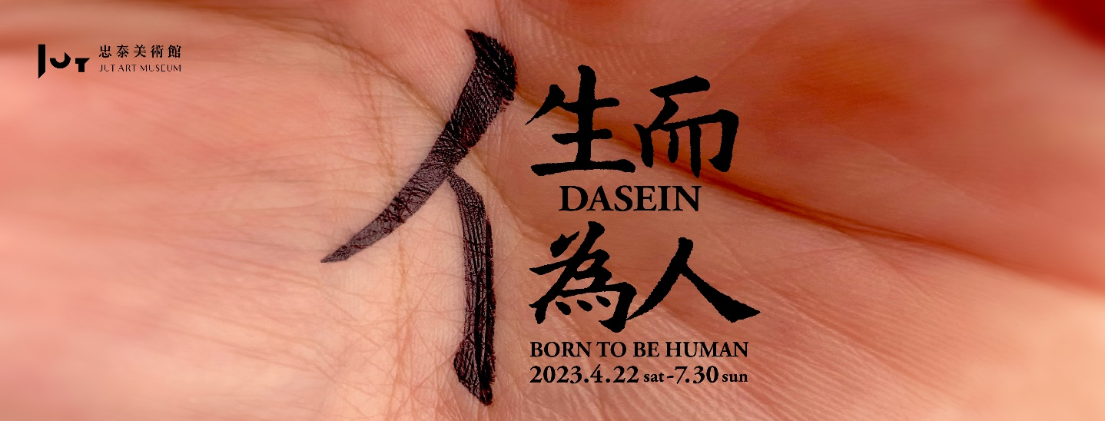

As the first art museum focusing on the issues about “future” and “city” in Taiwan, the Taipei-based Jut Art Museum has long served as a prestigious venue for exhibitions on urban architecture and contemporary art. The museum stages its latest contemporary art exhibition Dasein—Born to Be Human which is on view from 22nd April to 30th July 2023. This exhibition revisits the essence of human beings, seeking to trigger multi-layered reflections and philosophical debates on the existence of “humanity” in the world, insofar as to set the viewers out on an exploratory journey across the meaning of “born to be human.”

What does humanity mean to this world in the present era, in which the AI revolution has transformed the globe and digital technology has gradually replaced the human brain and physical labor? What makes us human? How do we comport ourselves to be truly human? Organized by the team of the Jut Art Museum, the exhibition Dasein—Born to Be Human revolves around “human beings,” the most basic units of a city and a humanistic society. To denote the state of existence of human in this world here and now, the exhibition title draws on German philosopher Martin Heidegger’s “Dasein,” a term he coined to inquire into the essence and condition of human existence.
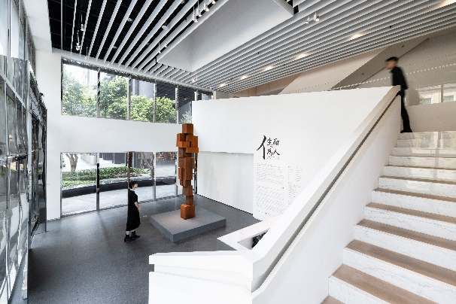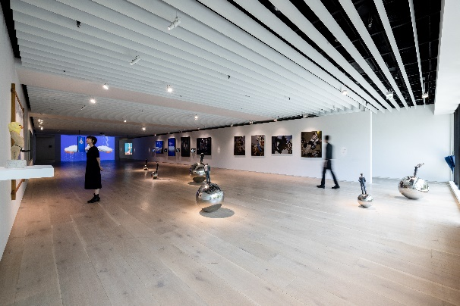
This exhibition features a total of 11 artists, namely Antony Gormley, Candy Bird, Chieh-Sheng Keng, Hao Ni, Isa Ho, Kawita Vatanajyankur, Kuang-Yu Tsui, Meng-Si Jiang, Shih-Chiang Yeh, Wolfgang Stiller, and Yung-Hsien Chen. Through their respective works of contemporary art in sculpture, photography, video, installation, and painting that cover four subthemes — “Body Politics and Incarceration,” “Internal Dialogue,” “Construction of Individual-Community Relations,” and “Non-existent Existence” — these artists collectively explore the intertwined relations between humans and themselves, humans and others, as well as between humans and the environment, so as to stimulate multi-layered reflections and philosophical debates on the existence of “humanity” in the world. Within such an ever-changing overall context, the Jut Art Museum has also endeavored to be a continuous driving force behind the social deliberations on human beings, spaces, and the environment.

Information
Venue｜Jut Art Museum (No.178, Sec. 3, Civic Blvd., Da'an Dist., Taipei City 106, Taiwan)
Opening Hours｜TUE-SUN 10:00-18:00 (Closed on Mondays)
Admission｜General TWD 100, Concessions TWD 80 (Student, seniors aged 65 and above, and groups of 10 or more) Free Admission for the disabled and a companion, children aged 12 and under (Concessions or Free Admission upon presentation of valid proof)
Student Day on WED｜Free Admission once on WED (With valid student ID)
Website｜http://jam.jutfoundation.org.tw/en/exhibition/107/4160

Artists｜Antony Gormley, Candy Bird, Chieh-Sheng Keng, Hao Ni, Isa Ho, Kawita Vatanajyankur, Kuang-Yu Tsui, Meng-Si Jiang, Shih-Chiang Yeh, Wolfgang Stiller, Yung-Hsien Chen

Organizer & Coordinator｜Jut Art Museum

