Jut Art Museum Broken Landscapes contemporary art exhibition poses pandemic era inquiry: “Have Our Cities Failed?”

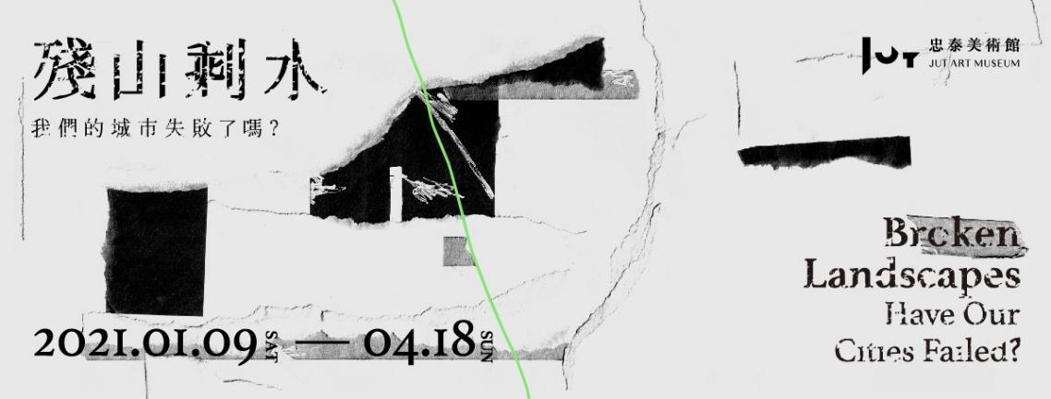

As the world enters 2021 in the midst of a pandemic era, Jut Art Museum -- poised to guide the public in exploring and contemplating the city and its strides into the future -- has launched a new contemporary art exhibition entitled Broken Landscapes: Have Our Cities Failed. Curated by Executive Director Sean C.S. Hu of Hu's Art Company, the exhibition invites 12 artists representing countries including Taiwan, Germany, Korea, Canada, and Japan: Shih Meng-Hsin, Wu Tsan-Cheng, Isa Ho, Andreas Gursky, Suh Do-Ho, Yuan Goang-Ming, Chen Chieh-Jen, Chang Li-Ren, Chia Chien-Ju, Liao Chien-Chung, Liam Morgan, and Aki Inomata; to respond to urban modalities in confronting global geopolitics, economic rivalries, and ethnic conflicts in the pandemic era through five subthemes. The exhibition, which runs from now until April 18, engages the audiences to ponder “Have our cities failed?”.

Five subthemes explore future possibilities beyond optimism for humankind and the city
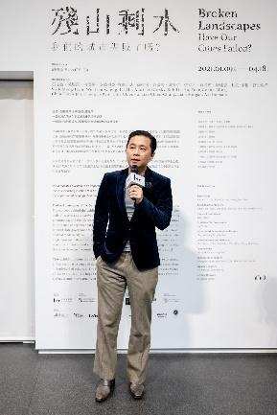
At the intersection of politics, the economy, and culture -- the “city” is a location of multiple narratives that highlight mainstream values while simultaneously suppressing the urban experience and the life-realities of other disparate collectives. Broken Landscapes: Have Our Cities Failed? explores future possibilities for humankind and the city through the five subthemes of “Disappearing and invisible existences,” “Extraordinary scenes of destruction and rebirth,” “Places of captivity and parasitism,” “Battlefield of others,” and “The Promised Land”. The artists’ diverse interpretations, including on-site installations, interactive designs, video, and photographic documentary works break through the optimism of modernist progression through interrogation, and ponder the complexities that confront the city in this era of accelerated development.

“How do human beings seize opportunities and respond to their immediate situations while located in the midst of an impermanent state of life? This is the core concept that Broken Landscapes attempts to express through the acute sensibilities and intuitive prophesies of the artists,” curator Sean C.S. Hu says. “The title of the exhibition posits the theme as a question. Regardless of whether this is a query or a rhetorical warning about the future, the realities that confront our cities cannot be ignored. The successes or failures of the city reflect the future possibilities for human civilizations, and everything hinges on our actions.”

Broken Landscapes – projecting the true predicament of contemporary human civilization
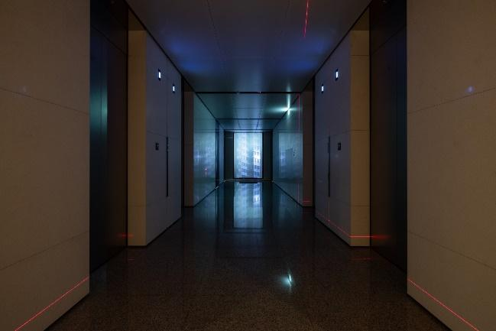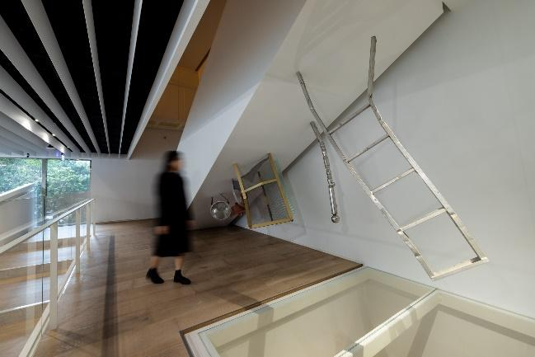
Histories, natural ecologies, and cultural traditions that existed in cities have gradually vanished as a result of continued capitalist expansion. In the subtheme “Disappearing and invisible existences,” artist Wu Tsan-Cheng’s work Wanderer 004 conjures quotidian soundscapes in the city’s memory through recordings of ambient sound in Taiwan and utilizes the lobby area to expand the visitors’ audiovisual experience. Artist Shih Meng-Hsin’s work, T, adeptly uses the inclined wall face under the staircase of the museum to showcase what is seen and unseen in the city, by using familiar industrialized ready-made objects to evaluate the irregular and oppressive space under the stairs.

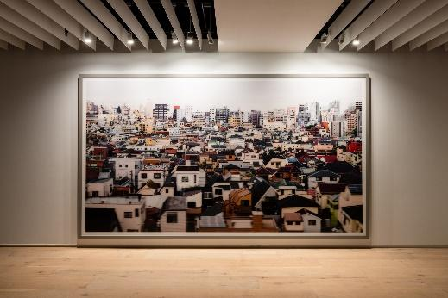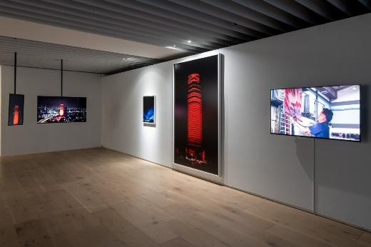
Construction and destruction are seen as two sides of the same coin. Driven by the huge profits of urban development, the cityscape metamorphosizes rapidly before our eyes like computerized images and hypermarkets. Three works by international artists have been invited to make their Taiwan debut for the subtheme “Extraordinary scenes of destruction and rebirth.” As human beings enter the globalized, urbanized 20th century, the fate of endless destruction and rebirth for urban spaces is presented in works such as Tokyo under the lens of German photographer Andreas Gursky -- renowned for his grand narratives; and in Korean artist Suh Do-ho’s Robin Hood Gardens, Woolmore Street, London E14 0HG which captures the final images of the Robin Hood Gardens housing project. In his work, Monument, Canadian artist Liam Morgan projects flashing red lights, without permission and in guerrilla-style, onto an abandoned building in Bangkok that once represented power and luxury, to highlight evidence of an era of conspiracy between capitalism and power.

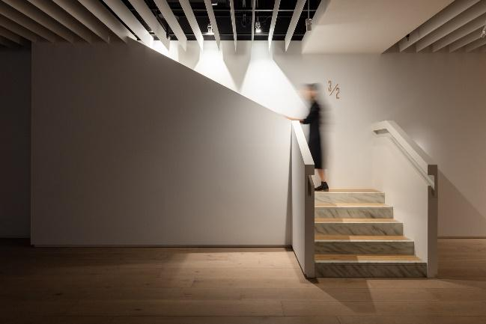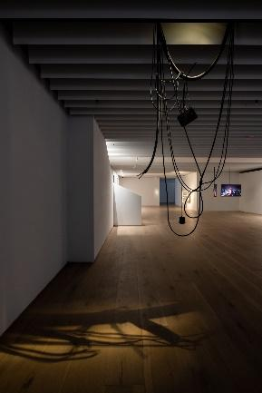
In the same subtheme, Taiwanese artist Liao Chien-Chung premieres two new installation works: Outlier and 3/2. Everyday objects are realistically simulated, including a false staircase that seemingly connects the second-floor exhibition space to a third floor -- representing nonfunctional architecture that occupy spaces in spheres of human life throughout the city, which have become the scars of failed urban planning.

The City: human life in captivity and class battlefield

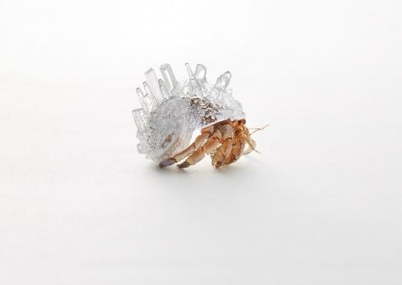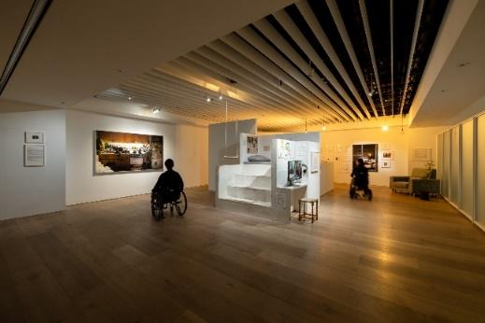
Displacement caused by acts of war, climate change, and the commercialization of urban spaces have resulted in an increase in the disadvantaged classes and, by extension, their housing issues. The city has become a place where political and economic refugees are confined. In the subtheme “Places of captivity and parasitism,” transparent customized shells for hermit crabs have been created with the cityscapes of various metropolises in Japanese artist Aki Inomata’s series, Why Not Hand Over a “Shelter” to Hermit Crabs? The work serves as metaphor for issues of immigration and of refugees around the world today who are forced to migrate due to international conflicts, climate change, etc. The commercialization of spaces brings a corresponding set of housing justice issues that Taiwanese artist Isa Ho’s work Westbeth Project responds to, by documenting the lives of elderly artists residing in the Westbeth Artists Housing in New York. To invite the audience to experience the observational perspective of aging and elderly artists, a house space is recreated within the exhibition venue with a wheelchair as a part of the installation.

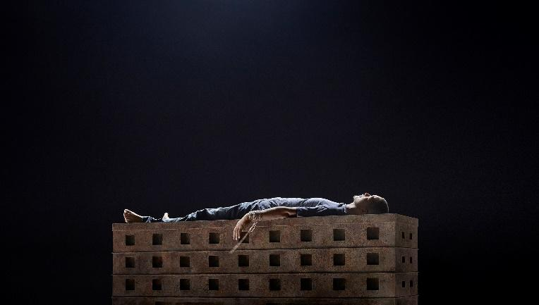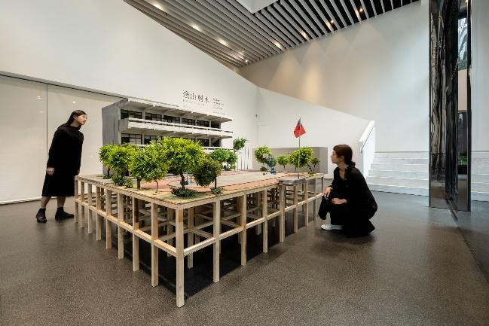
The subtheme “Battlefield of others” is a discussion of ways in which the flourishing of technology and financial capital dominate spaces more than any mode of governance that existed in the past -- resulting in a city delineated by capital to gradually become a class battlefield. Artist Chen Chieh-jen’s work A Field of Non-Field expresses how, in contemporary “globally imprisoned, locally exiled” dispatch work, laborers move about like the walking dead, progressing toward what could be a point of origin or an end, as if located in a place of limbo that is topsy-turvy and without an exit. The work attempts to lead the audience to contemplate a state of human survival under domination and surveillance. A scaled model of a city and animation in artist Chang Li-Ren’s work Battle City 1: The Glory of Taiwan provide a fictionalized interpretation of a society’s projected desires in its collective pursuit of success and superiority, as well as the sense of powerlessness of being trapped in a melancholy city -- demonstrating micropolitics with vision and uniqueness specific to Taiwan.

The Future of Tomorrow: an alternate imagination and prophesy

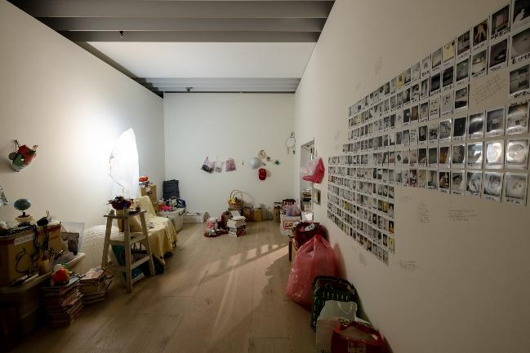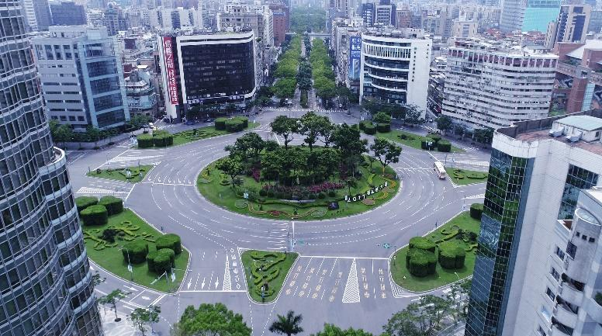
The final subtheme “The Promised Land” asks: what possibilities exist for the future of humankind and cities in the aftermath of a raging pandemic and natural and man-made disasters in 2020, as we re-adapt to new spatial densities, perceptions of distance, modes of consumption, and interpersonal relationships. Members of the audience exchange images and names with everyday objects in the work Name of Daily Objects by artist Chia Chien-Ju. Ready-made objects convert into another method of exhibition, leading the audience to ponder the “before” and “after,” and to experience the dual corporeal sensations of “existing / fleeing” and “returning / invading.” Artist Yuan Goang-Ming’s work Everyday Maneuver captures arial images of the deserted streets of Taipei on the day of the Wan’an Air Raid Drill. The visual angle, reminiscent of surveillance or scanning, is a metaphor for the normalization of the threat of war, and makes one ponder whether this is a prophesy of a brand-new possibility of a future human civilized society or its ultimate demise.

Jut Art Museum focuses on the issues of future and city, inspiring contemplations, and imaginations of life

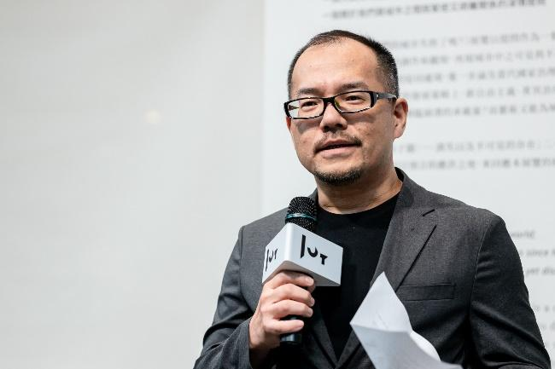
Jut Art Museum has always been focused on the issues of future and city. Since its inception in 2016, the museum has curated a succession of exhibitions, such as A Nonexistent Place, The Flying Land, and Paradise Lost – Gazing at Contemporary Urban Civilization and its Metaphor. These attempt to consider the contemporary city, its residential spaces, and the relationship between humankind and urban civilization through diverse artistic genres and perspectives. Broken Landscapes: Have Our Cities Failed? continues in the vein of past exhibitions in an exploration of and response to a multiplicity of social phenomena and appearances from the perspective of contemporary art.

“Through practical exhibition activities and continued exploratory action, we hope that Jut Art Museum will continue to serve as a platform and to provide an arena beyond the typical viewing experience that will trigger the viewers’ rumination and imagination about life in the future,” says Executive Director Aaron Y. L. Lee of the JUT Foundation for Arts and Architecture.

In addition, the curator, participating artists, and experts will lead guided tours throughout the exhibition period to provide readings of Broken Landscapes from the diverse perspectives of practitioners. For more information on exhibition activities and special offers, please visit the museum’s website.

【Appendix 1: Exhibition Information】

Broken Landscapes: Have Our Cities Failed?
http://jam.jutfoundation.org.tw/en/exhibition/107/2764

- Curator｜Sean C.S. Hu
- Artists｜Shih Meng-Hsin (Taiwan), Wu Tsan-Cheng (Taiwan), Isa Ho (Taiwan), Andreas Gursky (Germany), Suh Do-Ho (Korea), Yuan Goang-Ming (Taiwan), Chen Chieh-Jen (Taiwan), Chang Li-Ren (Taiwan), Chia Chien-Ju (Taiwan), Liao Chien-Chung (Taiwan), Liam Morgan (Canada), Aki Inomata (Japan) (In the order of the number of strokes in Chinese surnames)
- Venue｜Jut Art Museum (No.178, Sec. 3, Civic Blvd., Da'an Dist., Taipei City 106, Taiwan)
- Opening Hours｜TUE-SUN 10:00-18:00 (Closed on Mondays)
- Admission｜General TWD 100, Concessions TWD 80 (Student, seniors aged 65 and above, and groups of 10 or more).
Free Admission for the disabled and a companion, children aged 12 and under (Concessions or Free Admission upon presentation of valid proof).
- Student Day on WED｜Free Admission once on Wednesdays upon presentation of valid student ID

- Organizer｜Jut Art Museum
- Coordinator｜ Hu’s Art Company
- Official Display Partner｜SONY
- Cultural Partner｜eslite member
- Event Partner｜MOT CAFÉ
- Official Hotel Partner｜Hua Shan Din by Cosmos Creation
- Media Partners｜Art Emperor、MOT TIMES、La Vie
- Special Thanks｜Yageo Foundation、Chi-Wen Gallery、Karma Medical、Accolade Wines

【Appendix 2: Curator and Artists’ Biography】
Standard Usage for Images: Photo credit/by must be given where applicable; and please indicate “© Jut Art Museum” .
Download ink: https://reurl.cc/l09Ez9

Curator |  | Biography
Sean C.S. Hu | 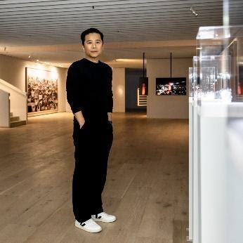  © Jut Art Museum | Born in Taiwan, Sean C.S. Hu graduated from The Broadcasting & Television Section of Mass Communication Department, Fu Jen Catholic University. He then received M.A. degree in Art Administration in Fashion Institute of Technology, State University of New York in 1998. Hu was on worked as an art curator for Fubon Art Foundation and the director general of the Association of Visual Arts in Taiwan. He was also adjunct Lecturer at National Taiwan University of Arts. Now is honorary member of the board for Jut Foundation for Arts & Architecture, the Adviser of the Association of Visual Arts in Taiwan, Taipei City Government Policy Consultant, VT Artsalon Co-Founder, as well as Doubles Square Curator, the CEO of Hu’s Art Company and the director of Taipei’s 2018 & 2019 Nuit Blanche.

Artist |  | Biography
Shih Meng-Hsin  (Taiwan) | 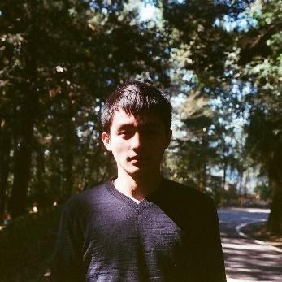  © Shih Meng-Hsin  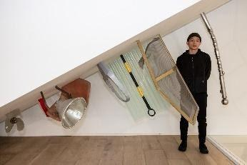  © Jut Art Museum | Born in Taichung, Taiwan in 1995, Shih Meng-Hsin is now studying in Graduate Institute of Plastic Arts, Tainan National University of the Arts. In 2020, Shih has won the first prize of Kaohsiung Awards with his work “A.” Shih tends to create in the form of sculpture and installation art. The artist often assembles or transforms “found objects” in daily life to fill in the unused space in buildings and evokes conversation between objects and the space. Meanwhile, the artist also pays attention to peripheries that are seldom used or noticed. Through his art works, Shih intends to change the way people seeing these remaining spaces.
Wu Tsan-Cheng  (Taiwan) | 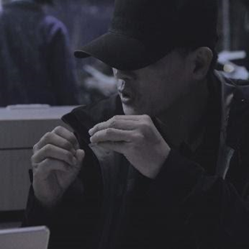  © Pan Yun-Ci  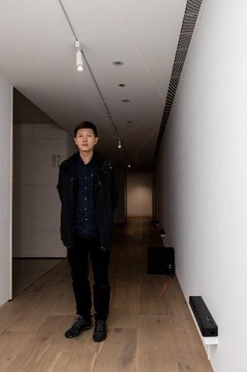  © Jut Art Museum | Born in Yunlin, Taiwan in 1973, Wu Tsan-Cheng earned his M.F.A. in Graduate Institute of Plastic Arts, Tainan National University of the Arts. Through recordings and the sound elements created in the combination and change of sounds, the artist intends to interpret the environments where people live and gradually imitate the characteristics and flows of sound cultures of the place. According to the artist statement: “Through hearing, we can recall the fraction of our memories and again reshape them. Listen carefully to our daily life, since the ordinary sounds may embed another form of archeology in the future.”
Isa Ho  (Taiwan) | 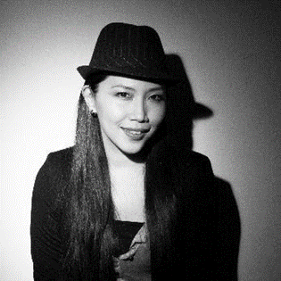  © Isa Ho  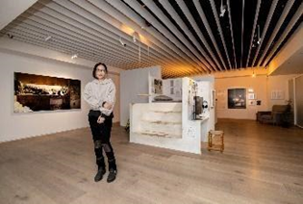  © Jut Art Museum | Born in Keelung, Taiwan in 1977, Isa Ho earned her M.F.A. in School of Fine Arts, Taipei National University of the Arts and is now creating through digital photographs. With delicate composition skills obtained from her oil painting experience as the foundation of her photographs, Ho looks into the values of modern people and the society and utters a unique language through the camera. Ho’s works are collected in National Taiwan Museum of Fine Arts, Kaohsiung Museum of Fine Arts, Kuandu Museum of Fine Arts, MOT/ARTS, Hong-gah Museum and White Rabbit Gallery in Australia.
Andreas Gursky  (Germany) | 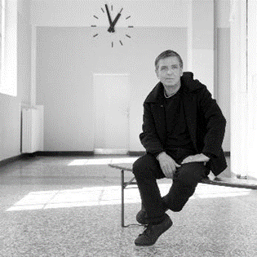  ©Ralph Goertz, IKS-Medienarchiv | Born in Leipzig, Germany in 1955, Gursky grew up in a family of photographers. In 1981, he entered Kunstakademie Düsseldorf to study photography under the guidance of the conceptual artists Hilla and Bernd Becher. Gursky opened his way of photography with novel skills and become an important photographer in the contemporary world. Since 90s, Gursky uses computer programs to tear down daily life images into pieces and reshape them into breathtaking pictures when seeing from above. The grandeur of his works will amaze the viewers, make what is once familiar become strange and remind the viewers of the destruction-rebirth circulation between human and nature. Hence, people are enabled to re-inspect the issues they are facing in this society, such as globalization, standardization, and capitalization.
Suh Do-Ho  (Korea) | 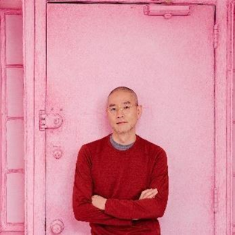  Photography: Daniel Dorsa  Courtesy the Artist, Lehmann Maupin, New York, Hong Kong, Seoul, and London and Victoria Miro, London and Venice | Born in Seoul, Korea in 1962, Suh Do-Ho earned his M.F.A. in Sculpture in Rhode Island School of Design, U.S. in 1994. With themes including “home,” “discrete and stray,” “spatial memory” and “cultural identity,” Suh’s works have received attention around the world. Through creation, Suh looks into the boundary of culture at the end of time and space. And through portraying places out of our living space, the artist also intends to transform memory, personal experience and sense of security into a spiritual perception.
Yuan Goang-Ming  (Taiwan) | 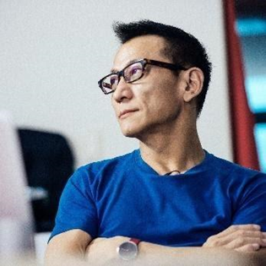  © TEDxTaipei | Born in Taipei, Taiwan in 1965, Yuan Goang-Ming is the pioneer of video arts in Taiwan. With symbols and metaphors combined with technical materials, Yuan precisely presents people’s status of life, and describes senses and consciousness of people in an extremely poetic way. Yuan’s works were exhibited in Taiwan Pavilion at the 50th Venice Biennial, ICC Biennial ’97 in Japan, Auckland Triennial, Guangzhou Image Triennial, Liverpool Biennial, and Singapore Biennial.
Chen Chieh-Jen  (Taiwan) | 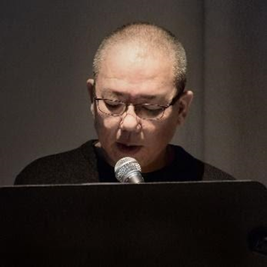  © Chen Chieh-Jen | Born in Taoyuan, Taiwan in 1960, Chen Chieh-Jen mainly focus on politic issues. When facing the spirits, phenomenon, body memory and experience that cannot be told by words, the artist believes that “writing” of these themes through arts is not merely to fight against forgetting; it also raises new imagination regarding the form of “citizen writings” and “pluralist democracy.” Chen’s art works have been exhibited in several international events including Venice Biennial, Lyon Biennial, Liverpool Biennial, Istanbul Biennial, Moscow Biennial, Sydney Biennial, Taipei Biennial, Shanghai Biennial, Gwangju Biennial and Aichi Triennial.
Chang Li-Ren  (Taiwan) | 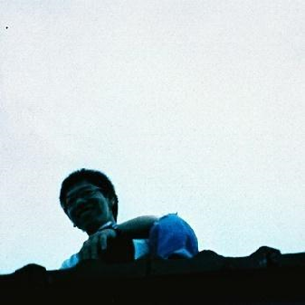  © Chang Li-Ren & Chi-Wen Gallery  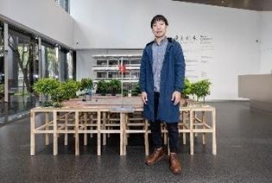  © Jut Art Museum | Born in Taichung, Taiwan in 1983, Chang Li-Ren earned his M.F.A. in Graduate Institute of Plastic Arts, Tainan National University of the Arts, and has once won the first prizes of Taipei Art Awards and Kaohsiung Awards. Through his delicate handcraft and narrative skills, the artist is sophisticated in creating virtual worlds that exist between imagination and the reality. Also, Chang skillfully grasps the boundary between virtuality and reality in filming. With intriguing stories, his video works serve as metaphors of the living situations of politic and human. Chang was nominated for the 8th Taishin Arts Award in 2010 and has won the first prize of both Taipei Art Awards and Kaohsiung Awards in 2009.
Chia Chien-Ju  (Taiwan) | 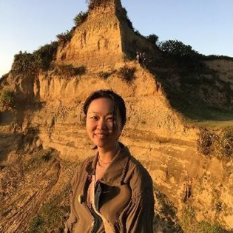  © Chia Chien-Ju  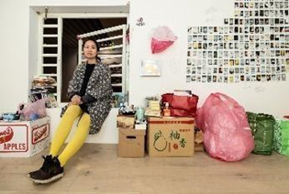  © Jut Art Museum | Born in Taipei, Taiwan in 1984, Chia Chien-Ju earned her M.F.A. in School of Fine Arts, Taipei National University of the Arts. Chia is sophisticated in handling materials, and sense of mass, volume and physical sensations generally defined in sculptures are used as the primary axes for how her art works are finally presented. Drawing inspiration from the experience of daily life, Chia will select a suitable ready-made object as a response and make the object as the highlight of the work. Using the most fitting method to present the appeal of the material and meanwhile reflecting properly its states in daily life are the basis of Chia’s art works.
Liao Chien-Chung  (Taiwan) | 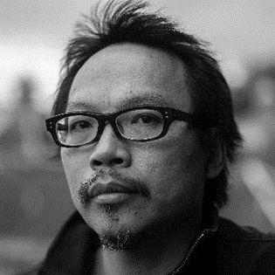  © Liao Chien-Chung  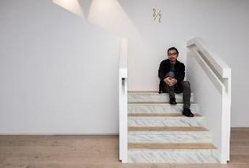  © Jut Art Museum | Born in Taipei, Taiwan in 1972, Liao Chien-Chung earned his B.F.A. in School of Fine Arts, Taipei National University of the Arts. Through his exquisite craftmanship, Liao’s works in recent years vividly imitate machinery or vehicles commonly seen around the cities. With these artworks, the artist also intends to tackle with various dilemmas and problems encountered when living in this generation. Liao’s solo exhibitions have been held in Yu-Hsiu Museum of Art, IT Park, Double Square, VT Art Salon, and Absolute Space for the Arts. Liao also served as an artist-in-residence in Cité internationale des arts in France and the Glenfiddich Distillery in Scotland.
Liam Morgan  (Canada) | 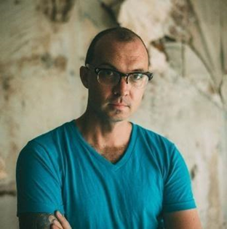  © Liam Morgan  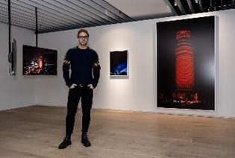  © Jut Art Museum | Born in City of Saint John, Canada in 1982, Liam Morgan is both a visual artist and a cinematographer. Morgan's familiarity with politics, anthropology, art and city development began in 2002 at Chiang Mai University. His works usually apply methods that evoke intervention or fracture and the artist often uses light as the major medium. Morgan's works have been widely exhibited in Asia, Europe, Australia, and North America, and are collected by MAIIAM Contemporary Art Museum and many private collectors. Morgan is also a co-founder and co-director of the Bangkok Biennial.
Aki Inomata  (Japan) | 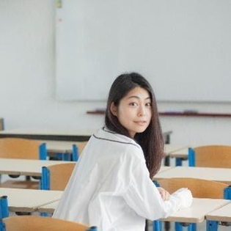  © Kenshu Shintsubo | Born in Tokyo, Japan in 1983, Aki Inomata earned her M.F.A. in Inter Media Art, Tokyo University of the Arts. By interacting with creatures through technology, her works present the relationship between human, nature, city and animal. In 2009, Inomata embarked on art works featuring hermit crabs. Through 3D printing, the artist created shells in the shape of different cities for the hermit crabs; these works also demonstrate the ecological crisis due to human’s abuse of natural resource. Inomata won the first prize of YouFab Global Creative Awards in Japan in 2014.

【Appendix 3: Artist’s work and photography】
works
Artist | Overview |  | Caption and Copyright
Shih Meng-Hsin  (Taiwan) | T  Year: 2020  Material: Found objects, board  Size: Dimensions variable  Looking for abandoned and peripheral objects in the corners of the city, Shih intends to make these urban fragments the main theme of his artwork. Shih is good at observing the city; through assembling the found objects, the artist brings up conversations in the corners that are easily neglected. His work T is exhibited on the tilting wall under the stair in Jut Art Museum. In the face of the wall, the ordinary objects commonly seen in daily life adapt to, fight against, or float above the place, forming an urban scenery featuring center/periphery, familiarity/strangeness, and destruction/rebirth. By emphasizing the suffocating space under the stair through cultural measuring, the artist enables the viewers to see and perceive the objects in the city in a different way, which are at the same time familiar yet strange. |  | 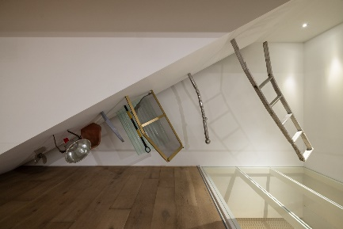  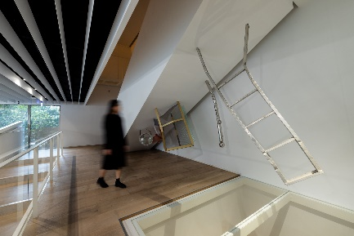  © Jut Art Museum
Wu Tsan-Cheng  (Taiwan) | Wanderer 004  Year: 2020  Material: Sound and image device  Size: Dimensions variable  Starting from 2019, the Wanderer series moves around the daily scenes in the city and has performed or reshaped the urban tales by scanning the city: from the ground to the top, inside or outside the frame. Just as what Wu said: “Sounds are always there; however, they are never noticed due to our negligence,” to the artists, there is an energy flowing underneath sounds that evokes/constructs spaces and events; sounds are also the basis composing mental activities and emotions of individuals as well as the thoughts and conscious of the world. As people move constantly on the track of the modern city between life and work; dislocation of the messages emerged from image and sound has created the difference in time perception. The phenomenon presents a certain kind of margin of our living status; it also resonates with the sub theme of this exhibition: “disappearing and invisible existences.” Through hearing, people may recall the fragment of memory in the city and listen to the sounds scattering in their daily life. |  | 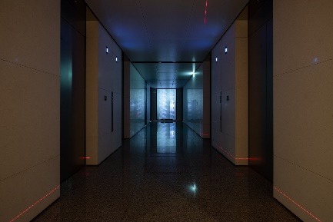  © Jut Art Museum
Isa Ho  (Taiwan) | Westbeth Project  Year:2013-2020  Material: Photograph, videos, TV, wood, objects, documents  Size: Dimensions variable  The Westbeth Artist House has been opened to artists with cheap rent since 1970 and has harbored the later years of numerous artists from all over the world. More than half of the artists living in this story-filled historical house age 60-100 years old. In this aged place that reminds people of nursing home, Ho got to know different forms of art works of the artists and unveil their life stories through pushing wheelchairs, fixing stuff and joining gatherings. Out of curiosity towards diverse cultures and meaning of life, Ho tossed herself into the project to search for the answer of life across the whole century. The apartment, with special terms including rent discounts, has provided nutrients for creation that are necessary to the artists. As they grow old, it seems that the artists are “imprisoned” in this apartment. However, after spending decades accompanying each other, the apartment and the artists have gradually developed an interdependent relationship. Through the photos of the apartment, portraits of the artists, and conversations with them, the artists’ life in this apartment as well as the self-evident bond observed in their artworks have inspired Ho in re-perceiving the idea of “aging.” |  | 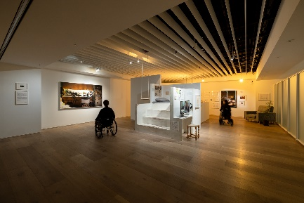  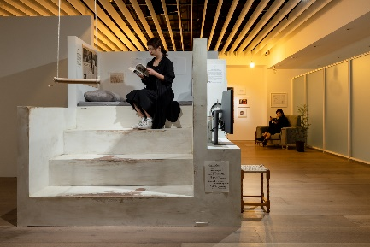  © Jut Art Museum
Andreas Gursky  (Germany) | Tokyo  Year: 2017  Material: Photography  Size: 394 x 216 cm  Gursky has once chosen train journeys as a metaphor for his creation skills; this metaphor is then directly translated into his work Tokyo. On one of his many train journeys through Japan, Gursky was captivated by the pictorial quality of the passing skyline of Tokyo. Intensified by the blur, the houses became color fields and the individual elements blended into an abstract pictorial composition, even though individual details still stood out sharply. In order to capture this specific impression, the artist travelled back to Japan, took the train from Tokyo to the suburbs again and again and captured the city rushing by through the lens. After returning to his studio, Gursky united hundreds of individual shots in an overall composition that seems more reminiscent of painting than of photography. With this image, Gursky captures the fast pace of our times and the mobile society of the globalized world. |  | 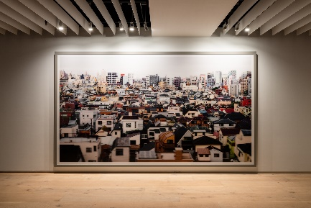  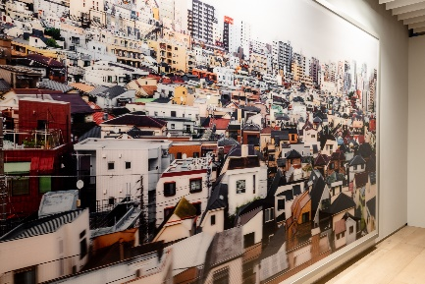  © Jut Art Museum
Suh Do-Ho  (Korea) | Robin Hood Gardens, Woolmore Street, London E14 0HG  Year: 2018  Material: Single-channel video, sound, looped  Time: 28'33''  In 2018, Suh was commissioned by Victoria and Albert Museum (V&A) in filming Robin Hood Gardens before it was torn down. Suh’s work was then exhibited in Venice Biennale in the same year. Suh’s work is a panorama film taken in a specific place within a specific duration. With his camera, the artist led us move around slowly, and this slow-motioned movement enables the viewers to peep into the home and the memories of the residents in Robin Hood Gardens. Suh has filmed 4 apartments, with 3 of them still occupied. Adapting skills such as time-lapse photography, drone, 3D scanner and photogrammetry, Suh always kept the camera right in front of the objects in a stable pace. The film not only highlights details in each apartment, but also brings up a controversial serenity before the destruction visits. |  | 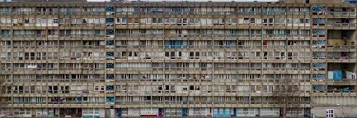  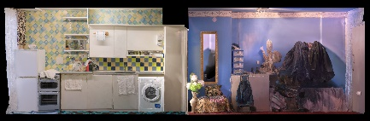  © Do Ho Suh  Courtesy of the artist, Lehmann Maupin New York, Hong Kong, Seoul, and London, Victoria Miro London / Venice  Photo: Taegsu Jeon
Yuan Goang-Ming  (Taiwan) | Everyday Maneuver  Year: 2018  Material: Single channel video  Time: 5'57"  Since 1978, Wanan Air Raid Drill has been held annually until now, even after the lifting of Martial law in 1987. Covering the main and outlaying islands, the drill aims to reduce damage from air raid and at the same time reminds the people of the threats across the strait. Wanan Air Raid Drill therefore becomes a spectacle in the contemporary society that stands for “war in daily life” or “war becomes daily life.” From 13:30 to 14:00 on the day of the drill, the artist filmed the 5 main streets in Taipei City with 5 drones simultaneously. Flying right above the streets, the drones overlooked the city, making the film like a scan of the city, or a surveillance over the city. An uncomfortable phenomenon is therefore created under the unique skill of the artist. As the air defense alarm went off, the hustling city suddenly became empty, forming a surreal urban spectacle. Under the threat of war, is the city with no man indicating a brand-new possibility of human civilization and society in the future, or foreseeing an ultimate termination? |  | 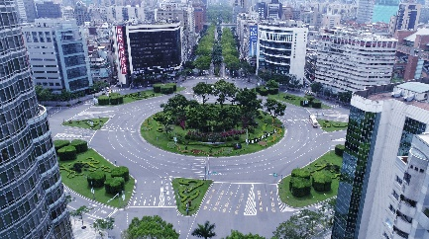  © Yuan Goang-Ming
Chen Chieh-Jen  (Taiwan) | A Field of Non-Field  Year: 2017  Material: Single-channel video  Time: 61'07"  The development of financial/technological capitalism has resulted in a global control technology that is even more penetrative than the governing forms before. The new technology not only leads to the increment of temp workers that are “globally imprisoned, locally exiled,” but also makes it more difficult to unveil the desire, feeling and thoughts of the contemporary society and individuals, which are all covered and penetrated by the global control technology in post-internet generation. Living space in this society therefore becomes a battlefield, on which everyone is contesting with each other. In the face of the difficult issue that has no simple answer: “Is there any other way out?”, the artist turns to “Emptiness” in Madhyamaka created by Nagarjuna and implements the “Middle Way” in Madhyamaka that possesses the spirit of multiple dialectics. Through these classics, the artist intends to establish different epistemology, speculation and value of life in the world covered and penetrated by the global control technology and to use these methods as one of the ways to change the global control technology. |  | 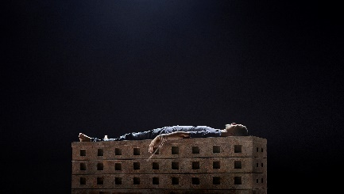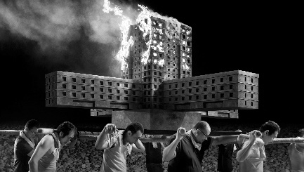  © Chen Chieh-Jen  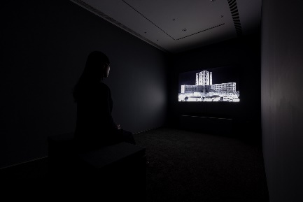  © Jut Art Museum
Chang Li-Ren  (Taiwan) | Battle City 1 - The Glory of Taiwan (Model)  Year: 2010-2017  Material: Board, mixed media  Size: 240 x 240 x 180 cm  Battle City 1 - The Glory of Taiwan (Animation)  Year: 2010-2017  Material: Single-channel Video, colour, sound  Time: 46'06''  Spending 7 years composing a story called “Battle City” since 2010, Chang tends to illustrate his imagination about city through a trilogy and has completed Battle City 1 – The Glory of Taiwan. The term “the glory of Taiwan” has revealed a peculiar phenomenon: it seems that to the world, Taiwan is always in a dark cave, undiscovered and uncivilized. The word “Formosa” exclaimed by the Portuguese has pierced the dim mist named the world and becomes the first “glory of Taiwan.” Centered on this term, the first work in Chang’s trilogy aims to illustrate the sense of helplessness and inferiority of this kind. Through the story of the protagonist Zhi-Qiang, a micro-scaled politics specifically found in Taiwan is presented. The collective pursuance of success and superiority in the society has eventually denied the existence of individual and led to a disaster called “the glory of Taiwan.” |  | 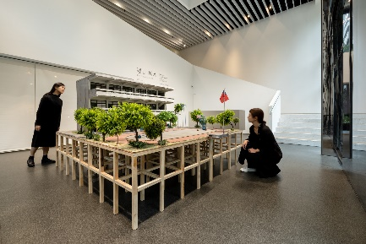  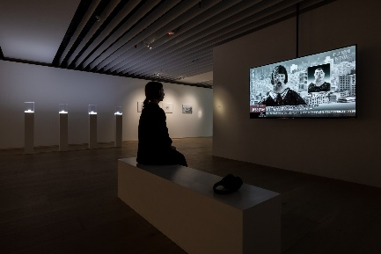  © Jut Art Museum
Chia Chien-Ju  (Taiwan) | Name of Daily Objects  Year: 2014  Material: Polaroid, found objects  Size: Dimensions variable  The objects displayed in the work Name of Daily Objects starting from 2014 were collected between each “moving-out”. These objects, instead of being disposed, are kept uselessly in the house. To the artist Chia Chien-Ju, objects are “alive” before being “disposed.” This transference inspires the artist to give names to these objects. Viewers participating in the project are welcomed to pick an object, take a photo of it and leave with their signature. Through this exchanging ceremony, in which the viewers give out their names in exchange of an object, the viewers take away the “body” of the “object,” while the object receives a “name” and can “live” in photos ever since. Display of this work is made onsite, with its theme responding to one of the sub theme of this exhibition- “The Promised Land”. Background of this “moving-out” is set at the place where objects are “left behind” during “the fleeing at the end of the world.” The barred windows enable the viewers to experience the two body perceptions during “existing/fleeing” and “returning/invading,” just like an adventurer visiting a ruin. They may thus interact with the work as a bystander or a collector. |  | 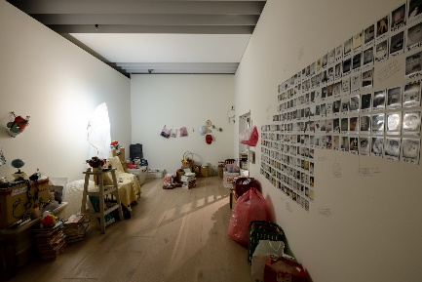  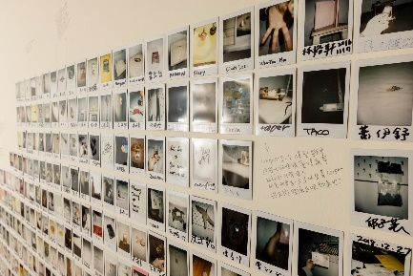  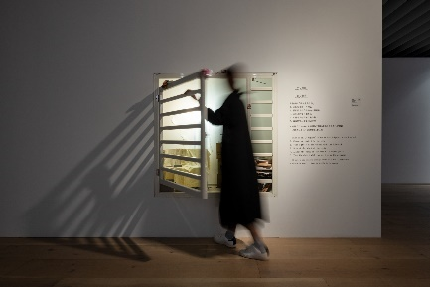  © Jut Art Museum
Liao Chien-Chung  (Taiwan) | Outlier  Year: 2020  Material: High density gaskets  Size: Dimensions variable  3/2  Year: 2020  Material: Wood  Size: 500 x 200 x 283cm  With his skills, Liao vividly recreates the original objects. Through creating simulations, Liao overlaps art and the real scene, enabling his works to wander on the uncertain boundary between reality and virtuality. Perception of the viewers are therefore deceived: they believe what they see when they simply look at the works, and then exclaim when realizing that they have been cheated. Liao’s works invite us to re-inspect the environment which we have taken for granted. From the imitated objects he invokes the life stories of individuals and further brings up attentions on several social issues. Liao’s works Outlier and 3/2 are presented in this exhibition. “The Outlier” is a lump of unknown object hanging on the grill ceiling. It is difficult to tell if the work is an art piece to be appreciated or a broken facility waiting for repairment. On the other hand, the work 3/2 presents a stair leading to the upper floor. However, viewers may discover at the landing that the space becomes narrower as the stair goes up. Is this disappearing route a mistake of the building design itself, remains after the space was rebuilt, or the artist’s reflection on the disorder derived from the rapid development of the city? |  | 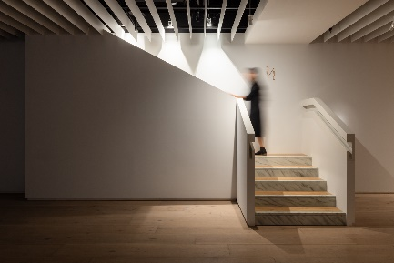  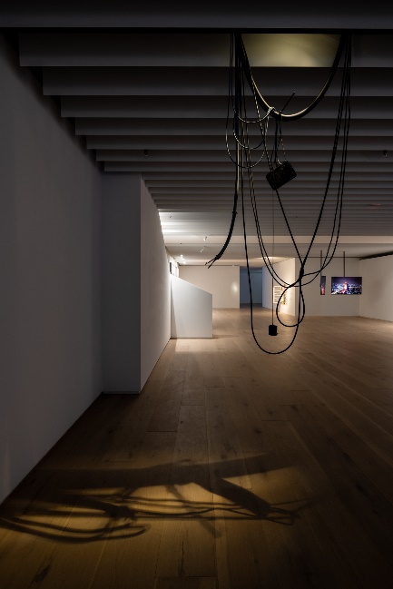  © Jut Art Museum
Liam Morgan  (Canada) | Monument  Year: 2018  Material: Single-channel video, Double-channel video, photography  Time: 2:54', 15', 150 x 240 cm, 60 x 75cm  Monument is a visual documentation that Liam Morgan made in Bangkok in 2014. The work recorded the process of the artist’s 3-hour urban intervention in the city, unannounced and without permission. Sathorn Unique, a renowned, 50-storey building sitting along the side of Chao Phraya River in Bangkok, was beamed under powerful red film-making light. Colloquially known today as the “Ghost Tower”, this enormous, unfinished, abandoned building was once primed as the most luxurious property in the country. The building has witnessed aspiration, greed, corruption and Elitism in the 1990s yet stepped into its ultimate failure as the Asian Financial Crisis took hold in 1997. The artist further relates this history with Thailand’s power struggle between Yellow and Red through the first 20 years of this century. The art intervention occurred in 2014, while Thailand was under martial law shortly after the military coup occurred in the same year. The furnace red cast on the massive, crumbling structure points to a tension within the country which continues to build. The artist has his eyes on this spectacle of failure and uses it, almost as a ready-made, to consider the nature and fallacy of the power that is getting out of control in the contemporary world. |  | 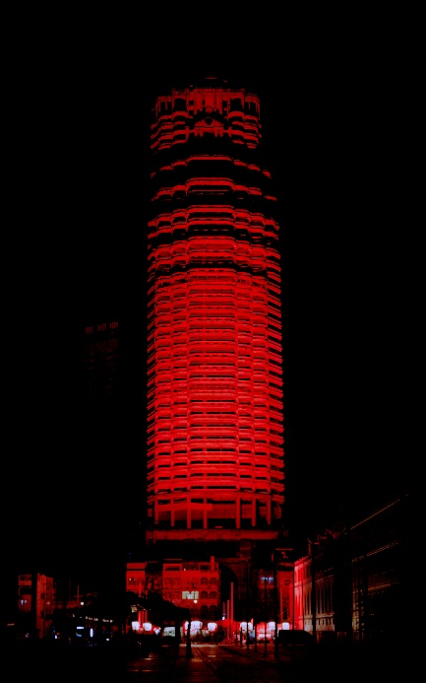  © Liam Morgan 2014  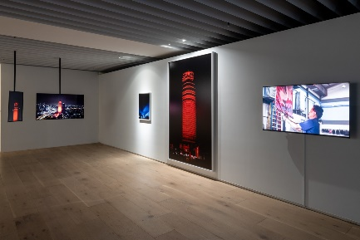  © Jut Art Museum
Aki Inomata  (Japan) | Why Not Hand Over a “Shelter” to Hermit Crabs?-Tokyo-  Year:2009  Material: Photography  Size: 60.2W x 42.8H x 3D cm  Why Not Hand Over a “Shelter” to Hermit Crabs?-Border-  Year: 2009-  Material: Resin  Size: 7×7×7 cm  The artist Aki Inomata created transparent shells, in the shape of cities around the world, for hermit crabs as their temporary accommodation. Inomata got her inspiration from the exhibition “No Man’s Land” in 2009. Hosted by the French Embassy, Tokyo, the exhibition looks into the “permanence” of land and the “impermanence” of regimes. The exhibition reminded Inomata of the habit of hermit crabs, the animal that change their shells for various factors. Even with different appearance after changing their shells, the hermit crabs sheltered in different “cities” still have the same body. On the other hand, alternation of regimes will bring changes to the people living in the place. Through exchanging accommodations, Inomata’s work aims to express that regardless of countries, alternation of regimes will change the life of people even if the land on which they stand remains the same. Her work further reflects the global-observed issue of immigrant and refugee, who are forced into migrating and straying owing to international conflicts and environmental changes. |  | 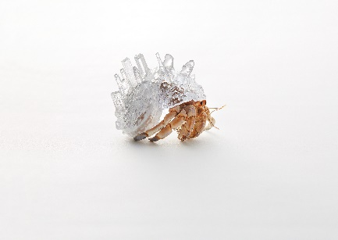  © Keizo Kioku  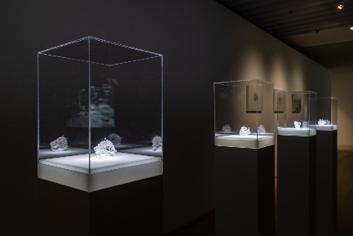  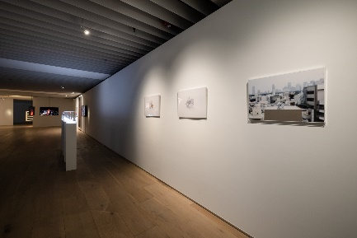  © Jut Art Museum
Photos from the Opening Press Conference
Caption |  | Photo and Copyright
Address by the curator of Broken Landscapes: Have Our Cities Failed? - Sean C.S. Hu. © Jut Art Museum |  | 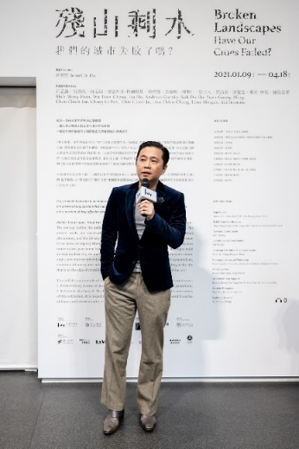  © Jut Art Museum
Address by Jut Foundation for Art and Architecture Executive Director, Aaron Y. L. Lee. © Jut Art Museum |  | 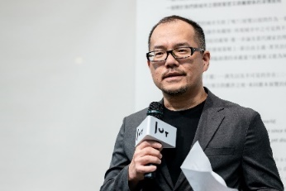  © Jut Art Museum
The Broken Landscapes: Have Our Cities Failed? curator, museum representatives and artists. © Jut Art Museum  From left to right:  Artist - Isa Ho  Artist - Wu Tsan-Cheng  Artist - Shih Meng-Hsin  Artist - Liao Chien-Chung  Curator - Sean C.S. Hu  Artist - Liam Morgan  CEO of JFAA - Aaron Y. L. Lee  Director of Jut Art Museum - Huang Shan-Shan  Artist - Chang Li-Ren  Artist - Chia Chien-Ju  © Jut Art Museum |  | 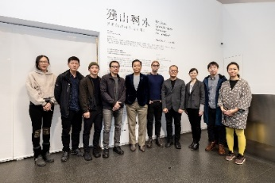  © Jut Art Museum

Exhibition Venue Photos
Caption | Photo and Copyright
Jut Art Museum 1st floor lobby (Chang Li-Ren’s work). | 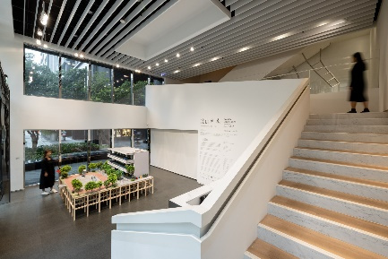  © Jut Art Museum
Jut Art Museum 2nd floor Hallway (Wu Tsan-Cheng’s work). | 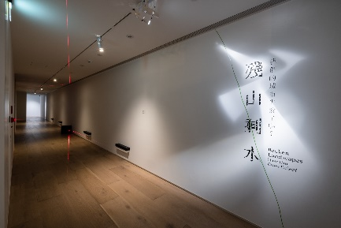  © Jut Art Museum
Jut Art Museum 2nd floor (Isa Ho’s work). | 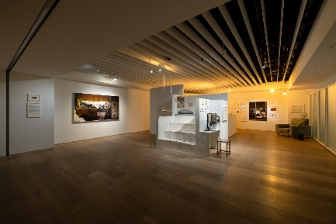  © Jut Art Museum
Jut Art Museum 2nd floor area. | 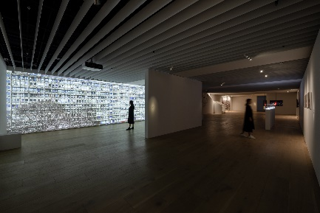  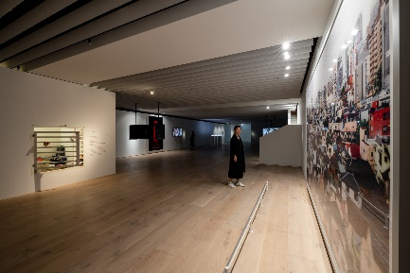  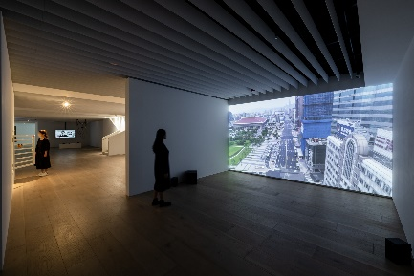  © Jut Art Museum

