Celebrating the 5th Year of Jut Art Museum
Two International Exhibitions
Drawing Ambience: Alvin Boyarsky and the Architectural Association
Kengo Kuma: Place / Inspiration

The year of 2021 witnesses the 5th anniversary of the Jut Art Museum (JAM); we are honored to present two cross-cultural exhibitions—Drawing Ambience: Alvin Boyarsky and the Architectural Association (2021-05-08 to 2021-12-05) and the 2021 Off-Site Project Kengo Kuma: Place / Inspiration (2021-07-24 to 2021-09-12) .

Located in the center of Taipei City, the Jut Art Museum is the first art museum throughout Taiwan that emphasizes the future and cities. Since its establishment in 2016, JAM’s exhibitions and events constantly explore “cities” through introducing architecture and contemporary art of international significance. These exhibitions included Human Nature, Its Generosity and Form—Akihisa Hirata, DIALOGUES: Oyler Wu Collaborative, and SOS Brutalism—Save the Concrete Monsters, among others. The museum provides a platform for the encounter of local and international thoughts from different perspectives on locality in order to stimulate futuristic imagination in the public.

During the pandemic of Covid-19, all visitors are required to make appointments online in advance. For details, please visit JAM’s official website at http://jam.jutfoundation.org.tw/en.

The 2021 Off-Site Project Kengo Kuma: Place / Inspiration kicks off a dialog on places from Japanese architect Kengo Kuma
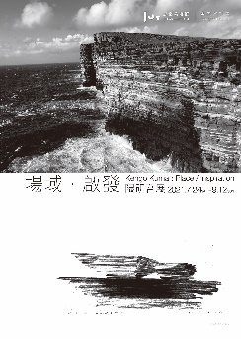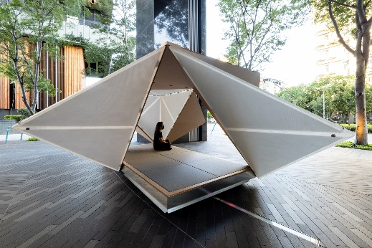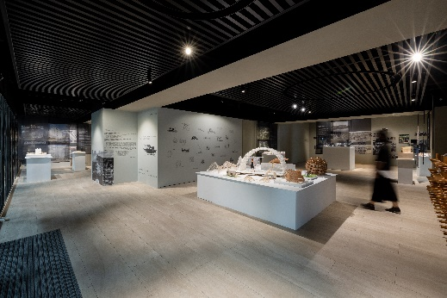
The 2021 Off-Site Project Kengo Kuma: Place / Inspiration is currently open to the public up to the date of September 12nd. It is JAM’s long-term experiment that aims to break away from the limitations of venues, and six works of world acclaimed Japanese architect Kengo Kuma are exhibited. These works are the Waseda International House of Literature (The Haruki Murakami Library), Taki Plaza of the Tokyo Institute of Technology Hisao & Hiroko, GC Prostho Museum Research Center, as well as the Museum of Indigenous Knowledge in the Philippines, V&A Dundee in Scotland, and the H.C. Andersen’s House of Fairy Tales in Odense in Denmark. Models manufactured during the phase of research are shown together with many photos Kengo Kuma had taken, so the audience will have closer observation of the architect’s ideas.

An outdoor installation Oribako has been produced for this exhibition, a structure integrating the traits of Japanese origami and tea culture. In this tranquil tea house which is based on Japanese traditional architecture, the visitors are able to experience the dialogue between the place and the culture.

Date｜2021.07.24 SAT – 09.12 SUN
Venue｜MOT Taipei (No. 9, Ln. 65, Sec. 1, Jianguo S. Rd., Da’an Dist., Taipei City 106 , Taiwan)
Opening Hours｜TUE-SUN 10:00-18:00 (Closed on Mondays)
Organizer｜Jut Art Museum
Curatorial Team｜Kengo Kuma and Associates, Jut Art Museum

Drawing Ambience: Alvin Boyarsky and the Architectural Association exhibits valuable drawings in Asia for the first time to explore experiments and reforms in architectural education
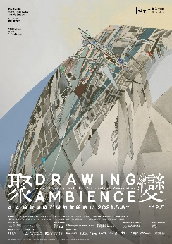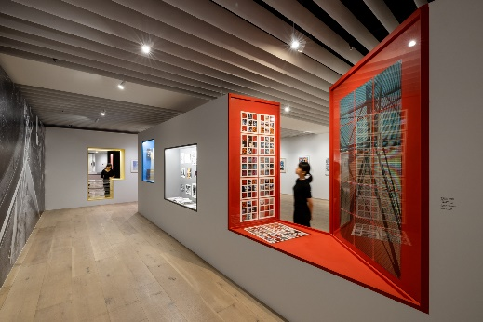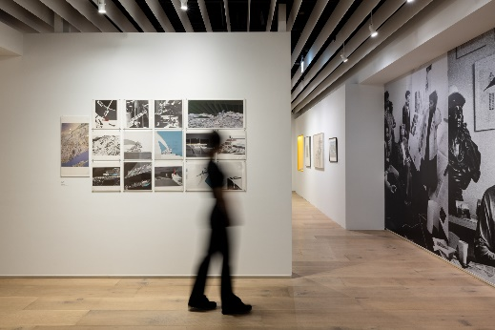
Drawing Ambience: Alvin Boyarsky and the Architectural Association is from now to December 15th. Co-organized with Alvin Boyarsky Archive and coordinated by Mildred Lane Kemper Art Museum at Washington University in St. Louis and RISD Museum of the Rhode Island School of Design in Providence, this exhibition represents the period of Alvin Boyarsky being the chairman of the Architectural Association School of Architecture from 1971 to 1990. Through teaching, exhibitions and publications, his very advanced idealism for architecture education made AA an incubator of architectural stars in the following decades.

Drawing Ambience consists of six themes, namely Summer Sessions, European Radicals, Drawing Ambience, Drawing Practice, Reflection on Modernity, and Reflection on History. Through historical memories, contemporary culture, urbanism, and experiments of new technology and new media, the audience sees the global tides in architecture; meanwhile, in the unique system of AA, how designers formulated their world of imagination with their hand drawings. Close to one hundred objects of Alvin Boyarsky’s personal collection, including his drawings and AA’s out-of-print publications, original diagrams drawn by Rem Koolhaas and Zaha Hadid during their rising period are shown for the first time in Asia, so the audience is able to see the innovativeness and progressiveness of architecture education and design in AA.

Date｜2021.05.08-12.05
Venue｜Jut Art Museum (No.178, Sec. 3, Civic Blvd., Da'an Dist., Taipei City 106, Taiwan)
Opening Hours｜TUE-SUN 10:00-18:00 (Closed on Mondays)
Organizers｜Jut Art Museum, Alvin Boyarsky Archive
Co-organizers｜ RISD Museum, Rhode Island School of Design, Providence, Mildred Lane Kemper Art Museum at Washington University in St. Louis

About Jut Art Museum
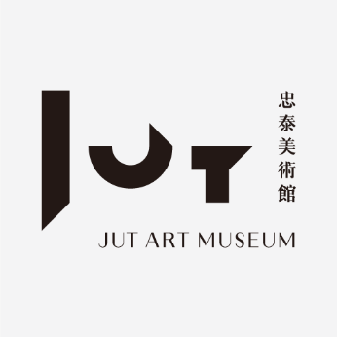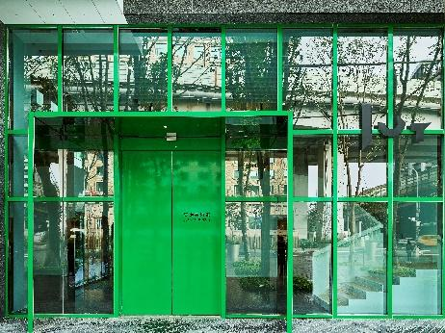
In 2016, the Jut Art Museum was founded by the Jut Foundation for Arts and Architecture, and 2021 is the 5th year of the Museum. Over the past years, the Jut Art Museum never ceases staging events in regard to the three major themes: Issues of the Future, Urban Architecture, and Contemporary Art. The curatorship of the Jut Art Museum gathers thoughts from different places all over the world for the public to gain diverse visions of the future, and the highly accessible educational resources connect the museum with its neighborhoods and the surrounding communities. The abundant aesthetic experience the Museum provides is its best role and greatest function for the society as a whole.

Website: http://jam.jutfoundation.org.tw/en
Facebook: https://www.facebook.com/JUTARTMUSEUM
Instagram: https://www.instagram.com/jutartmuseum/

