Contents

- Curators’ Biography P.2
- Curatorial Advisors’ Biography P.3
- Artists and works’ Introduction P.4~14
- Other photos P.14~17

NOTE
- The press kits and more photos can be downloaded in the link: https://reurl.cc/x9jNo4
- Standard Usage for Images: Photo credit/by must be given where applicable; and please indicate © Jut Art Museum.

【Appendix I. Curators’ Biography】
Curator |  | Biography
Escher Tsai | 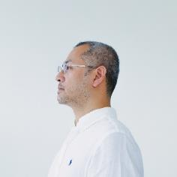  © Escher Tsai | Escher Tsai is a New Media artist, producer and curator. He devotes himself into digital art research, promotion and creation. Now Tsai is the Creative Director of Dimension Plus, and Director of “Arts and Technology: Creative Innovation and Counseling Project”. He was senior consultant of the Preparatory Office of Technology Media Center (Taiwan Contemporary Culture Lab, C-LAB), also served as production supervisor for “3x3x6” Taiwan Exhibition in 58th Venice Biennale. He was worked on the curator of C-LAB Future Media Arts Festival (2021), Taoyuan Art x Technology Festival (2017), Nuit Blanche in Taipei (2016-2017) and Encounter Once in a Lifetime – Toyo Ito Architecture Exhibition (2016). In addition, he was planner of important digital arts creation and center, such as production supervisor for “Lab Kill Lab” and for “Future Vision Lab” at C-LAB. He was also the creative director of Microplayground, the host of Taiwan Digital Art and Information Center, and the planner of “Playaround Workshop”.  Curatorial Discourse  https://issuu.com/jutartmuseum/docs/_0322/8
Amy Cheng | 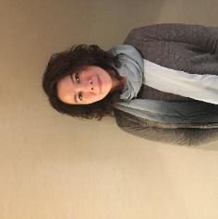  © Amy Cheng | Amy Cheng is a curator and writer based in Taipei. In 2010, she co-founded TheCube Project Space, which serves as an independent art space devoted to the research, production and presentation of contemporary art in Taipei. Her curatorial practices center on the historical and geopolitical relations between Asia and the world in the contemporary scene. With the aim of delving into local culture and establishing long-term relationships with artists and cultural practitioners, Cheng explores the possibility of “expanding curating”. Since 2009, she has carried out several research projects, including sound cultures in Taiwan and Critical Political Art and Curatorial Practice Research, for which she contributed to and edited the publication Art and Society: Introducing Seven Contemporary Artists.  The exhibitions curated by Amy Cheng include: Liquid Love (2020, Taipei, One chapter of The Trilogy of Future Memories), The Ouroboros Screening program (2019, Taipei, Luxembourg), Towards Mysterious Realities (2016 – 2018, Taipei, Kuala Lumpur and Seoul), Taiwan Pavilion at the 54th International Art Exhibition─La Biennale di Venezia: The Heard and the Unheard: Soundscape Taiwan (2011). She also co-curated the exhibitions such as Tell Me a Story: Locality and Narrative (2016, 2018, Shanghai, Torino) and Phantom of Civilization (2015, Luxembourg), The 3rd Taiwan International Video Art Exhibition: Melancholy in Progress (Taipei), The 2004 Taipei Biennial: Do You Believe in Reality? Cheng has been appointed as the nominating member of The Han Nefkens Foundation Video Art Award (2018) and jury member of the 57th International Art Exhibition of La Biennale di Venezia (2017) and of the Hugo Boss Asia Art Award (2015).  Curatorial Discourse  https://issuu.com/jutartmuseum/docs/_0322/12

【Appendix II. Curatorial Advisors’ Biography】
Curatorial Advisors |  | Biography
Ming-Tsung Lee | 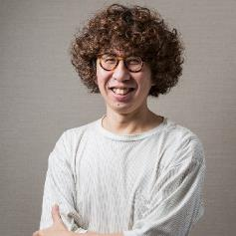  © Ming-Tsung Lee | Sociologist and author Ming-Tsung Lee received his doctorate in Social Anthropology from Kings College at the University of Cambridge, and currently teaches at the Taipei National University of the Arts. He is a producer on the Public Television Service (PTS) program Alone Together, and a participant and host on the PTS program See You at the Market which has received three major Golden Bell Awards in the Non-Drama category, and has been nominated for four Golden Bell Awards in its second season. Currently the CEO of Searchlight Culture Lab, whose work focuses on cultural research; on curating productions with a variety of content; and on executing several widely-acclaimed publications and design projects, including the Golden Tripod-winning regional publication, Very Pingtung. Ming-Tsung Lee has published several books including Thing-ology, and I Read, We Meet. He has twice been named GQ magazine’s “Men of the Year” in 2018 and 2020, and was celebrated as the “Most Creative Influential Person” by La Vie magazine in 2019 for his commitment to the public promotion of sociology, and to cultural education for the masses.
Kuang-Chi Hung | 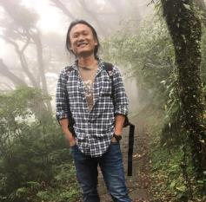  © Kuang-Chi Hung | Kuang-Chi Hung received his PhD in the history of science from Harvard University in 2013, and now he is an associate professor in the Department of Geography, National Taiwan University. Hung’s research concerns the history of biology, the history of forestry, and the geography of scientific knowledge. For the past five years, he has been fortunate to be able to work with artists and curators. He is fascinated by the issues of how artists contemplate and bring their artworks into being, and how curators display artworks to develop and support their arguments. He endeavors to facilitate the interactions between artists and geographers to promote the development of environmental humanities in Taiwan.
Lu-Lin (Jerry) Cheng | 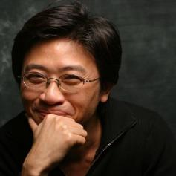  © Lu-Lin (Jerry) Cheng | A former Associate Research Fellow at the Academia Sinica Institute of Sociology, Lu-Lin (Jerry) Cheng received his Ph.D. in Sociology from Duke University in the United States. Currently an associate professor at the Shih Chien University Department of Industrial Design, he has published extensively on research regarding industrial and economic sociology and the sociology of design, in prominent periodicals including the International Journal of Urban and Regional Research, Regional Economies, Regional Studies, the International Journal of Design, the Taiwanese Journal of Sociology, and Taiwanese Sociology. A member of the editorial committee of the International Journal of Design, Cheng has penned numerous columns on design from a sociological perspective for The South Magazine, Business Next, The Affairs, and La Vie magazines.  Since joining the Department of Industrial Design faculty at Shih Chien University 2015, Lu-Lin (Jerry) Cheng has founded the Design x Society Lab (DXS Lab), which aims to distill new sociological perceptions for the design age. By developing various knowledge sets on the cross-fertilization, mutual provocation, and bilateral efforts between design and society, the organization hopes to produce approachable concepts on the ground that give back to society. Cheng served as a consultant on the 2015 Taipei Design City Exhibition, and curated with the team Upsidedn for the 2018 Dao Di Design Exhibition. Subsequent to launching the DxS series with the 2020 publication of “The Marriage of Design and Society,” the next book in the four-volume series, “Folk Art Reimagined,” is slated for publication in 2022, to be followed by “The Theory of Everyday Objects” in 2024.

【Appendix III. Artists and works’ Introduction】
Artist/Group | Biography
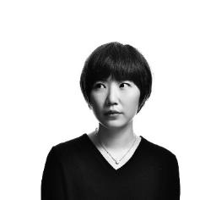  © Joyce Ho | Joyce Ho (Taiwan)  Born in 1983 in Taipei, Taiwan, Joyce Ho currently lives and works in Taipei. Joyce Ho received her M.A. in studio arts from the University of Iowa. She is an interdisciplinary artist, focusing specifically on painting, sculpture, and theater. Ho has worked as a script writer and theater director since 2010.
Introduction
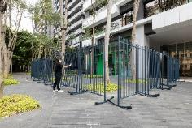  © Jut Art Museum | Balancing Act IV  2022, Painted stainless steel Dimensions variable
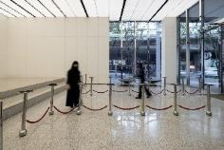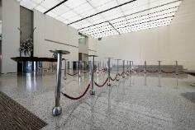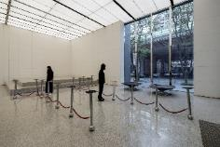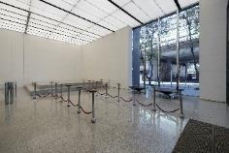  © Jut Art Museum | Heads down  2022, Mixed media Dimensions variable  Joyce Ho works across diverse mediums from painting, video, to installation. By integrating the deconstruction of movements and fragmentation of daily rituals with rich and illusory light and shadow, the artist demonstrates the intimate and isolating tensions between people and reality. The artist’s unique and powerful work simultaneously captivates her viewers while keeping them in a state of confrontation, rendering the quotidian action depicted in her work as a momentary ritual.  This work prompts the viewer to reflect on their location through imagery that evokes the intersection of “cradle” and “fence,” specifically in light of the ways in which “contact/distance” between the self and the other; “openness/shutdown” within a society; and ideas of “connection/distanced” – have been redefined in response to the COVID-19 pandemic. The work ostensibly sets the two extremes apart, but these boundaries are blurred by the work’s interactive and approachable character, which prompts a reexamination of the distance between the two, enabling the viewer to reconsider the formation of various “relationships” in daily life.

Artist/Group | Biography
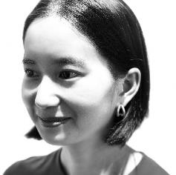  © Sheryl Cheung | Sheryl Cheung (Taiwan)  Sheryl Cheung earned her M.A. from University of Manchester. She currently lives and works in Taipei, Taiwan. Sheryl Cheung experiments with the idea of the body as an instrument that is continually played by affects. Like an open, metabolic body, her sound palette is vulnerable and harsh at the same time. Cheung works between experimental music, abstract scoring and writing to explore a materialist understanding of power, emotion and moral order. Her recent research focuses on sound and medicine through the perspective of Chinese ontology. Cheung is a co-founder of lololol.net, an art collective exploring Taoist-informed mind and body technologies in their ongoing project “Future Tao.”
Introduction
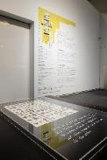  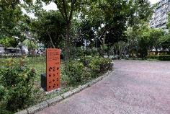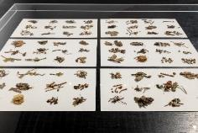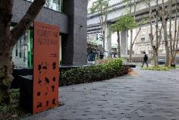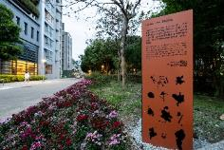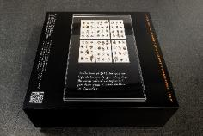  © Jut Art Museum | 1700 Steps  2022, Sound map program, herbal medicine, park plants Dimensions variable  This sound guide is an experimental walk in the neighborhood park, in response to its ecological memory and eventual transformation. Something as valuable as water once determined the fate of this land, from the forests that sprung, to agricultural settlements, to its renaming with a slight phonetic twist to rid its soddy nature. Today, the shaping, channeling, and dividing of energy continue to remain characteristic as the bodily condition of this curious neighborhood.  1700 Steps is designed to attune the relation between human and nature in this age of contagion and climate crisis. Borrowing the concept of the human body as a microcosmic universe in Chinese medicine, the project takes you on an experimental route of augmented reality as you travel on feet. In this pandemic time when movement is precious and isolation is norm, flow is an imaginative realm, in which the project seeks to find new meanings of agility and freedom today.

Artist/Group | Biography
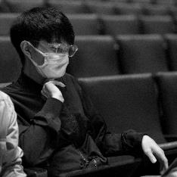  © Tim Wei | Tim Wei (Taiwan)  Tim Wei is a new media artist who graduated from the Department of New Media Arts, Taipei National University of the Arts. His works are mostly real-time computed audio-visual performances and electronic installations which explore social mechanisms, human behavior, and emotions. In recent years, his works focus on penetrating daily life through machine learning and try to disrupt from within as a new creative approach.
Introduction
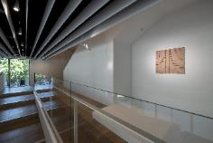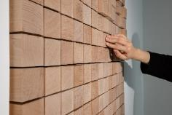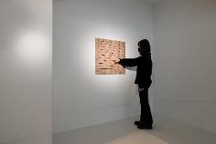  © Jut Art Museum | Game of Life  2022, Wood, pneumatic mechanisms, electronic components, stereophonic speakers, computer 65x65x40cm  Game of Life is an interactive installation where the participant’s touch on a wooden unit cell will initiate the generation of dynamic motion and electronic sounds, calculated using John Conway’s “Game of Life” mathematical model.  John Horton Conway devised an elegant mathematical model of cellular automation called “Game of Life” in March, 1970, where cells on a two dimensional plane simulate life by following a series of simple mathematical calculations, creating a world and community that repeats endlessly and expands infinitely. “In Conway’s Game of Life, the state of each cell depends on the current state of its surrounding cells. A live cell remains alive if two or three of its neighboring cells are alive. A dead cell will remain dead unless it is surrounded by exactly three live neighboring cells.”  With the addition of mechanical dynamism and electronic sound effects, the artist responds to the concept of this zero-player game by creating multiple dimensions of sensory and informational layers. Audience members can create a program, then observe the complex outcome of the resulting calculation. The initial setting of the unit transforms into a musical score of integrated digital aesthetics, producing countless continuous patterns and soundtracks with the passage of time. Our macrocosmic world becomes a microcosmic game of life.

Artist/Group | Biography
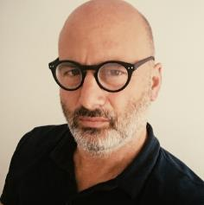  © Peter Sasowsky | Peter Sasowsky（U.S.A）  Peter Sasowsky is the founder and director of Serious Motion Pictures, a script to screen production company that produces documentary and narrative films, corporate communications, and media for foundations and philanthropies. His documentary feature Heaven + Earth + Joe Davis, won top honors at San Francisco Independent Film Festival, and Memphis Independent Film Festival.
Introduction
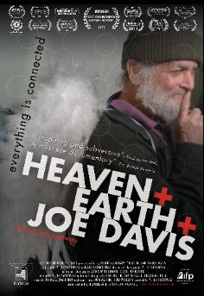  © Peter Sasowsky  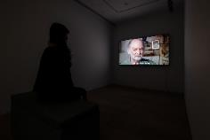  © Jut Art Museum | Heaven + Earth + Joe Davis  2014, Documentary, 1:27'40  This is an award-winning documentary which is filmed by director Peter Sasowsky. This documentary is about the godfather of BioArt, Joe Davis. In 1981, Joe Davis joined MIT Center for Advanced Visual Studies as Research Fellow and Lecturer. Davis’ work has had strong focus in astrobiology and the search for extraterrestrial life. Davis joined Alexander Rich’s laboratory at MIT in 1989 where he is widely regarded to have founded new fields in art and biology. His projects involving “DNA programming languages” have been frequently cited in scientific literature. In 2010, he joined the laboratory of George Church at Harvard as “Artist Scientist.” With “Baitul Ma’mur” (2020) Davis and Pakistani biologist Sarah Khan demonstrated highest density information-keeping in DNA to date. The renowned art critic James Elkins has said of him: “to my mind the most interesting living  artist...”. Enjoy a wild ride from laboratory to bar room and back again in this film that reminds us that anything is possible.  Joe Davis  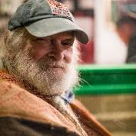  ©Tina Peisser

Artist/Group | Biography
© Lynn Hershman Leeson | Lynn Hershman Leeson（U.S.A）  Hershman Leeson is Professor Emeritus at U.C. Davis, served as Chair of the film Department at San Francisco Art Institute, now she lives and works in San Francisco, CA and NY.
Introduction
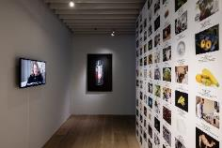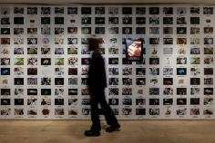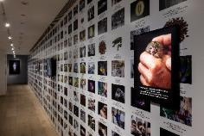  © Jut Art Museum | The Infinity Engine  2014, Installation, Dimensions variable  The Infinity Engine is the installation. It is a space that enacts narratives in which organs can be manufactured and banked, lost limbs can be regenerated from the inside out, skin can be printed on an ink jet printer, and human life can extend to 130 years . . . all of which expose complex physical, psychological, and philosophical possibilities for human evolution and our newly programmable DNA.  Over the last five decades, artist and filmmaker Lynn Hershman Leeson has been internationally acclaimed for her art and films. As one of the most influential media artists, Hershman Leeson is widely recognized for her innovative work investigating issues that are now recognized as key to the workings of society: the relationship between humans and technology, identity, surveillance, and the use of media as a tool of empowerment against censorship and political repression. Over the last fifty years, she has made pioneering contributions to the fields of photography, video, film, performance, installation and interactive as well as net-based media art.  The Infinity Engine is a collaboration with several renowned scientists to conduct genetic research on avant-garde genes, hybrid crops and animals, and artificially try to explore narratives about the evolutionary future of the human species.

Artist/Group | Biography
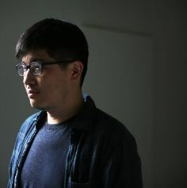  © Kuang-Yi Ku | Kuang-Yi Ku (Taiwan)  Kuang-Yi Ku was born and raised in Taipei, Taiwan, and has been based in the Netherlands since 2016. He is doing his PhD research at Sheffield Hallam University, UK and the research topic is the interdisciplinary practice between art, design and bioscience. Formerly a dentist, Ku is a bio-artist and speculative designer. He co-founded TW BioArt (a Taiwan bioart community) to stimulate the fields of BioArt and Science + Art in Taiwan. His works often deal with the human body, sexuality, interspecies interactions and medical technology, and aim to investigate the relationships among technology, individuals and the environment.
Introduction
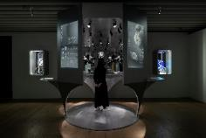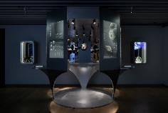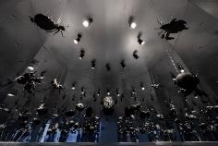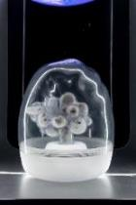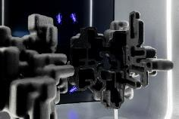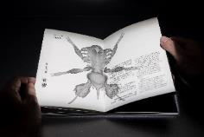  © Jut Art Museum | Queer Termite Project  2022, Mixed media Dimensions variable  Artist Kuang-Yi Ku collaborates with scientists who study the eusocial insect of termites to jointly establish a fictional scenario of an interspecies future. In this futuristic narrative based on a knowledge of termite biology, the artist and scientists have created a fictional social structure for termites where nine social strata have been identified as cornerstones for further classification. From this, more than 1,000 different classes are further derived. In this speculative evolution they have designed, human beings and termites exist in multiple complex relationships of enmity and friendship. At the conclusion in this tale of science fiction, a possible structure of mutually beneficial symbiosis is formed.  The artist hopes to explore new relationships between humans and non-human organisms through this interspecies sci-fi prototype, and aims to evaluate the stigmatization of termites as “pests” from a non-anthropocentric perspective. Additionally, this project will endeavor to contemplate reinterpretations of a termite society where class structures are determined through reproductive abilities and biological sex. By studying new imaginations of gender and the working class among non-human organisms, this project attempts to infer possibilities for a Queer Ecosystem formed by both humans and non-humans.

Artist/Group | Biography
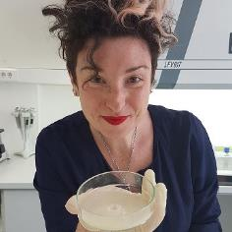  © Charlotte Jarvis | Charlotte Jarvis（UK）  Charlotte Jarvis is an artist working at the intersection of art and science. Charlotte’s practice often utilizes living cells and DNA: she has grown her own tumor, recorded music onto DNA and seen her heart beat outside her body. Charlotte has been resident artist at the European Bioinformatics Institute, The Netherlands Proteomics Center and the Hubrecht Institute. Charlotte is currently a lecturer at the Royal College of Art and resident artist at ABYME supported by seed funding from the British Council.
Introduction
© Charlotte Jarvis  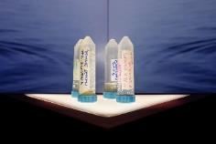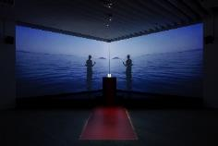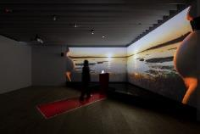  © Jut Art Museum | In Posse  2021, Two channel installation Dimensions variable  Over the past decade artist Charlotte Jarvis has been working on a series of pieces collectively titled Corpus, which aim to find alternative spaces of discourse for the human body, and use stem cell research, genetic engineering and oncological technologies to place the body in between states – disrupting the site, mutating the contents, and confronting im/mortality.  These pieces used Charlotte’s own cells to decontextualize existing scientific processes in order to reveal their social and emotional meaning. In this, the third and final part of Corpus Charlotte is collaborating with Prof Susana Chuva de Sousal Lopes in Leiden, MU Hybrid Art House in Eindhoven, Kapelica Gallery / Kersnikova Institute in Ljubljana and Sheffield Documentary Festival to place her body at the intersection of sex and gender. The piece is called In Posse and they are attempting to make semen from Charlotte’s (“female”) cells. In Posse aims to rewrite this cultural narrative; to use art and science to disrupt the hierarchy.  The project is being developed in three parts – firstly, Charlotte and Susana are on a journey to grow spermatozoa (sperm cells) from Charlotte’s body. At the same time, Charlotte has developed a female form of seminal plasma (the fluid part of semen). Finally, she is re-enacting the ancient Greek festival of Thesmophoria (a creative contextualization of the project). At the same time as Charlotte has been developing these strands of In Posse, she has been pregnant, experienced labor and become a mother. The latest iteration of In Posse is, to some degree, an attempt to reconcile these experiences with the process of making the project. It is also a manifesto of sorts, a kind of theoretical autobiography or map of her thoughts, and a review of where the project stands creatively, scientifically, ethically and personally.

Artist/Group | Biography
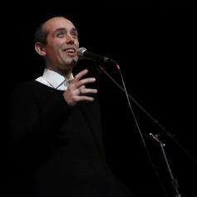  © Paula Court | Ed Atkins（UK）  Ed Atkins lives and works in Copenhagen, Denmark. Atkins’ solo exhibition Get Life / Love’s Work opened at the New Museum in New York at the end of June 2021.
Introduction
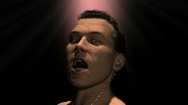  © Ed Atkins  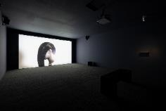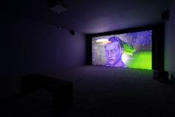  © Jut Art Museum | Warm, Warm, Warm Spring Mouths  2013，Single channel HD video，12'50''  Born in 1982, Ed Atkins is an artist who came of age in an era of accelerated developments in telecommunications and internet technology. As a creator nurtured and inspired by the digital age, he has adeptly used animation as a foundation in his creative journey, using digital media to reflexively contemplate issues of essence and survival such as digital/material, mental/physical, virtual/real. These characteristics are also embodied in his 2013 single-channel work Warm, Warm, Warm Spring Mouths, where Atkins himself serves as a prototype for the creation of a figurative “digital avatar.” Using motion capture devices and facial recognition software, he portrays a man who is seemingly at the bottom of the sea, or in “no-place.” This man’s head is covered with incredibly long, swirling hair that is mysterious, gravity-defying, even disturbing. The movement of his hair indicates that the man is located in a physical world unfamiliar to us. Sitting naked on a chair, he murmurs a repeated refrain of a quote by American poet Gilbert Sorrentino, which begins: “I don’t want to hear any news on the radio about the weather on the weekend.” This ostensibly mundane narrative accompanied by an attitude of refusal, conveys an uncanny sense of alienation, coldness, and death.  Atkins’s images and sound have a seductive and penetrative force beyond what initially meets the eye. Form and consciousness are two sides of the same coin. There is a complex and circular sentiment embodied by the simplicity and fluidity of form that may originate in questions on life and modes of survival as well as an unspeakable despair. However, the visual world presented to the viewer remains smooth, exquisite, and fluid. Located in a century when discussions of an impending metaverse have reached new heights, Atkins’s works have long portended the state of void in the anticipated yet anxiety-inducing “flow of consciousness” that undulates between the finite and infinite. (Text/ Amy Cheng)

Artist/Group | Biography
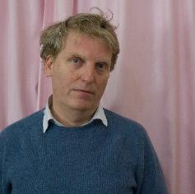  © Lucile Desamory | Nicholas Bussmann（Germany）  Nicholas Bussmann is an artist and musician. With a biographical background in Improvised Music, he creates conceptual frameworks and concrete scenarios for collective performances. At the center of his interest lies the tight and historically rooted connection between music, social practice and socialization. Often he uses game structures to explores matters of community, power and language. Most of his work are therefore collaborative and involve musicians, scientists, artists and also sometimes the audience. He lives and works in Berlin now.
Introduction
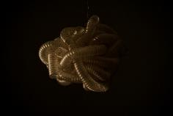  © Nicholas Bussman  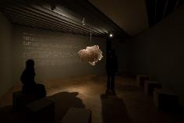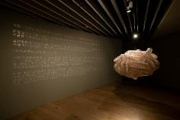  © Jut Art Museum | The Oral Archive of the Future Dead  2022, Sound installation, 140 cm in diameter  To write a text about The Oral Archive of the Future Dead is contradictory – I’d rather talk to you in person as it is about the spoken word.  Writing this I sacrifice all the precision, ambivalence, attitude and accent I have in the way I tell my story with my mouth, my lungs, my teeth, my body.  What you see, when you see this work of art is not “The Oral Archive of the Future Dead“ – What you hear is not “The Oral Archive of the Future Dead“ yet you hear a breathing, breathing with multiple voices (you might hear your own breathing too).  The Oral Archive of the Future Dead does not yet exist.  An oral archive goes from mouth to ear to be remembered to be told again. It is the exhausting process of telling something to be remembered – it is an old technique. The written word is a tool for measurement, it produces distance as its permanent existence gives a point of reference; the written word says: read me again if you don’t understand me! The written word always flirts with the vanity of historic inscription. The spoken word needs to be repeated, appropriated, reinterpreted and reenacted if it wants to become something to be remembered. So why do we need An Oral Archive Of the Future Dead? Why do we have to reintroduce an old, non medial technique? Because we need many little stories to be remembered, we need a heterophonic choir of narratives about why it is worth living. We need a multitude of reason why it is worth to die. The word told to the younger ones to be remembered is the word which makes it easier to die your own death. This Oral Archive of The Future Dead is your story to be shared with the world surviving you. (Text/ Nicholas Bussmann)

Artist/Group | Biography
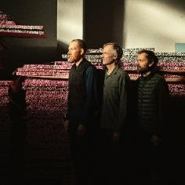  © Ulrik Jantzen/Büro Jantzen | SUPERFLEX（Denmark）  SUPERFLEX was founded in 1993 by Jakob Fenger, Bjørnstjerne Christiansen, and Rasmus Rosengren Nielsen. Conceived as an expanded collective, SUPERFLEX has consistently worked with a wide variety of collaborators, from gardeners to engineers to audience members. Engaging with alternative models for the creation of social and economic organization, works have taken the form of energy systems, beverages, sculptures, copies, hypnosis sessions, infrastructure, paintings, plant nurseries, contracts, and public spaces.  SUPERFLEX has been developing a new kind of urbanism that includes the perspectives of plants and animals, aiming to move society towards interspecies living. For SUPERFLEX, the best idea might come from a fish.
Introduction
©SUPERFLEX  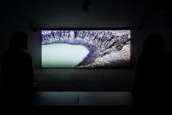  © Jut Art Museum | Hunga Tonga  2019, 2K Cinemascope, stereo sound, color, 21'22''  The film work Hunga Tonga navigates dreamscapes of earth, sea, and space by exploring the connections between humans, microscopic organisms, and the newly-formed volcanic island Hunga Tonga in the South Pacific.  Through a huge volcanic eruption ten years ago, Hunga Tonga emerged from the depths of the ocean. Being a young island, it exists as a porous interface between land and sea, rapidly evolving as it adjusts to its new life above water. Challenging human conceptions of time, narrative, and the boundaries between species, the film visualizes various alien states of embodiment. Hunga Tonga invites the viewer to experience time like a volcanic island, an ancient microscopic organism, and the ocean. As the island will tell you itself, nature is not static: there is no island outside of time.
©SUPERFLEX  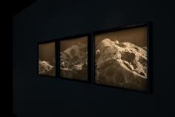  © Jut Art Museum | Every End Is A New Beginning  2020, Photography, 3 pieces, 60x72cm each  The photographic work Every End Is A New Beginning depicts what appears to be a barren landscape; in fact, it is a magnification of a single grain of sand collected on the world's youngest island, Hunga Tonga, in the South Pacific. Devoid of human presence, the image appears like a memory of the early history of our planet, or a glimpse into a future era beyond us.  Humans have roamed this planet for a mere 300,000 years – less than 0.01 % of the Earth’s history. During our relatively short stay, we have managed to create a footprint on the entire ecosystem comparable to that of major natural disasters such as volcanic eruptions, earthquakes and meteor impacts.  A dystopian future seems to approach as the end of the human era draws nearer. But life on Earth has transgressed limits and redefined itself again and again, and will most likely do so in a post-human era, even as large areas of land are submerged by rising seas.  The work is one outcome of SUPERFLEX’s expedition to Hunga Tonga aboard the ship “Dardanella” in 2018 as part of a larger research project, ‘Deep Sea Minding’, commissioned by TBA21-Academy under the program “The Current”.

Artist/Group | Biography
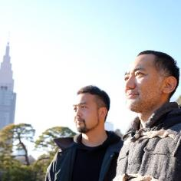  © dividual inc. 2021 | dividual inc. / Dominique Chen （France）、 Takumi Endo （JAPAN）  The startup, dividual inc. was launched in April 2008 by media artist Takumi Endo and information-science researcher Dominique Chen, later joined by creator Yamamoto Koichi in July of the same year. In January 2018, dividual inc. was acquired by SmartNews Inc.; the innovative company continues to operate and manage some of their pre-existing services, and to work on artistic projects.
Introduction
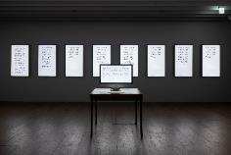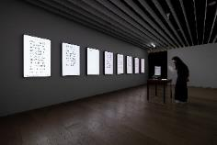  © Jut Art Museum | Last Words / TypeTrace  2019-2022, Installation Dimensions variable  Successively displayed on methodically arranged monitors are “10-minute last words” collected via the Internet, while a keyboard on a table in the center of the exhibition automatically inputs the according text without human involvement. This work is based on the “TypeTrace” software that dividual.inc has been developing since 2006. The software can be used for recording and reproducing entire text input processes via a keyboard, including the timing of typing or erasing letters. The sizes of letters vary depending on the time intervals between the input of single words. Different from the uniformly sized letters one usually encounters in books or on displays, here the writing person's mindset, with aspects of momentum and hesitation, is vividly reflected in the resulting text. Just like authors’ handwritten drafts exhibited at museums for example, or correction marks added in the proofreading process provide information in addition to that of the respective text itself, this work makes the viewer aware of the existence of the writing subjects behind the texts. The experience of writing one’s last words is at once also an opportunity to rearrange one’s thoughts toward loved ones, and about one’s own past and future.

Artist/Group | Biography
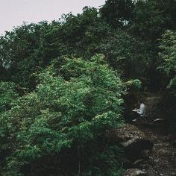  © Bo Zheng | Bo Zheng（CHINA）  Bo Zheng grew up in Beijing and now lives on Lantau Island, Hong Kong. Committed to more-than-human vibrancy, he investigates the past and imagines the future from the perspectives of marginalized communities and marginalized plants. He grows weedy gardens, living slogans, eco-queer films, and “Wanwu workshops” to cultivate ecological wisdom beyond the Anthropocene extinction.  He participated in The 59th Venice Biennale(2022), Liverpool Biennial (2021), Yokohama Triennale (2020), Manifesta (2018), Taipei Biennial (2018), and Shanghai Biennial (2016).
Introduction
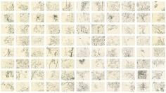  © Zheng Bo & Edouard Malingue Gallery  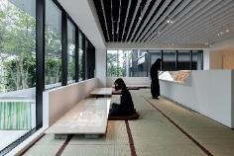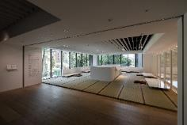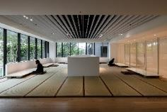  © Jut Art Museum | Drawing Life  2020-2021, Pencil on paper,366 drawings, 21x29.7cm each  This series of 366 daily drawings is called Drawing Life, a title that inverts the artistic practice of life drawing in which people are depicted, signalling instead how Bo Zheng focuses his attention beyond the human. Bo Zheng would initially try to identify the species of each plant that he was drawing using apps, websites and books. However, he subsequently changed his approach to just being with what he describes as “the collective”.  For Bo Zheng, this means having a physical experience opposite to the fast-paced life of constantly moving. The COVID-19 pandemic forced him to spend more time at home. With thousands of plants growing on Lantau Island, he would hike for twenty minutes before leaving the main route for an old trail. Drawing became a way of sitting with multiple species, slowing down, looking carefully and appreciating nature.  The artist has emphasized the sustainability of drawing as a simple practice. He says, “I only need to have a piece of paper and a 6B pencil. For one year, I have used only three pencils, so this practice needs very few resources.” (Excerpted from the introduction text of Gropius Bau solo exhibition)

【Appendix IV. Other photos】
Key Vision
Caption and Copyright | Photo
The 5th Anniversary of Jut Art Museum “LIVES: Life, Survival, Living” key vision (vertical) © Jut Art Museum | 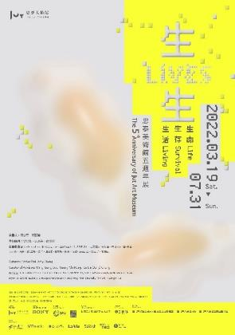

The 5th Anniversary of Jut Art Museum “LIVES: Life, Survival, Living” key vision (horizontal) © Jut Art Museum

Opening Press Conference
Caption and Copyright | Photo
Curator- Escher Tsai © Jut Art Museum | 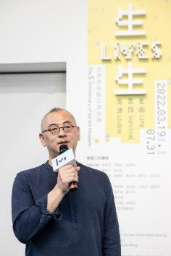
Curator- Amy Cheng © Jut Art Museum | 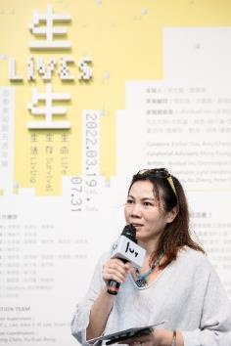
CEO of the Jut Foundation for Arts and Architecture- Aaron Lee © Jut Art Museum | 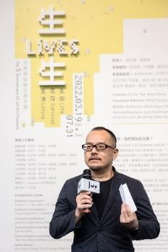
Group photo© Jut Art Museum  (left to right)  - Director of Jut Art Museum- Shan-Shan, Huang  - Artist- Tim Wei  - Artist- Sheryl Chang  - Curatorial Advisor-Lu-Lin(Jerry),Cheng  - Curatorial Advisor- Ming-Tsung, Lee  - Curator- Amy Cheng  - Curator- Escher Tasi  - Educational Program Supervisor of the Goethe-Institut Taipei- Yen-Huei Tsuei  - CEO of Jut Foundation for Arts and Architecture- Aaron Lee  - Artist- Joyce Ho  - Artist- Kuang-Yi, Ku | 