Table of Contents
Download Link：https://reurl.cc/oLEL8q

- Curators’ Biography----- P.2
- Highlighted Case Studies: Introduction and Images ----- P.3~P.12
- Introduction to Exhibition Areas ----- P.13~15

【Appendix I- Curators’ Biography】

Curator |  | Biography
Oliver Elser  Germany | 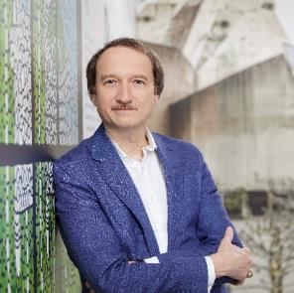  ©Kirsten Bucher | Oliver Elser is a curator at the Deutsches Architekturmuseum (DAM) in Frankfurt am Main and was curator of Making Heimat, the German Pavilion at the 2016 Venice Architecture Biennale. He studied architecture at the Technical University in Berlin. 2012–13 he was guest professor for scenography at the Polytechnic in Mainz. At the DAM, Elser curated exhibitions about Brutalism’s concrete monsters, the DAM’s founding and postmodernism in Frankfurt, architectural models in the 20th century, and the architects Erich Schelling and Simon Ungers. He has worked as an architecture critic for newspapers and magazines and has written numerous articles for catalogs and books. He is co-author of a book on the role of architecture in Tatort, Germany’s most popular crime series. Elser joined forces with the artist Oliver Croy to develop the project “Sondermodelle” that was shown at the Art Biennale in Venice in 2013. In 2019 he was a M+ / Design Trust Research Fellow in Hong Kong.
Chun-Hsiung Wang  Taiwan | 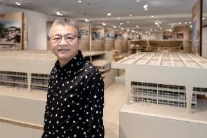  ©Jut Art Museum | Dr. Chun-Hsiung Wang has been Dean of the Department of Architecture at Shih Chien University since 2018. He earned a Master of Architecture from Cornell University and a PhD in Architecture from the National Cheng Kung University, Taiwan. He is the author and editor of several books and articles on architectural and urban history of modern Taiwan and their relationship with neighboring regions with the focus on the development after World War II. He currently also serves as Chief Editor of Architecture + Tectonics Taiwan (a+tec) magazine, and President of the Alliance for Architectural Modernity, Taiwan. Dr. Wang has curated numerous architectural exhibitions, including the Taiwan Pavilion at Venezia Biennale Architettura 2018; the Fieldoffice Touring Exhibition “Making Places” (2016- ); and "Living in Place" Fieldoffice exhibition for Venezia Biennale Architettura 2021.

【Appendix II- Highlighted Case Studies: Introduction and Images】
Standard Usage for Images: Photo credit/by must be given where applicable; and please indicate © Jut Art Museum.

^{C}: begin of design / ^{D}: begin of construction / ^{F}: finished

Taiwan Case-Studies
Case-Study Overview | Caption and Copyright
Jen-Ho Chen: The Wave Tower of San Sin High School of Commerce and Home Economics, Kaohsiung, Taiwan, 1963^{D}, 1963^{C}–1964  The Wave Tower was completed in 1964, designed by architect Jen-Ho Chen (1922-1989) who was trained from the Technical Specialized School of Architecture at Waseda University in Japan (1945). In a post-war social context and transformation of architectural discourse at that time, Chen accordingly developed a distinctive approach to design with unique architectural language in the work. The building was designed as a four-story rectangular volume with an eponymous structure of cantilevered waved corridors on its west side. The wave was the result of an extension of the stepped floors of its classrooms which could provide better sightlines for students. Modular cast-in-place elements reveals an important characteristic of Brutalist architecture. With those practices, the Wave Tower constructed an authentic narrative in Taiwan at that time. | 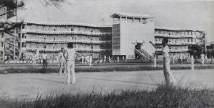  The Wave Tower, historical yearbook photo. ©National Taiwan Museum  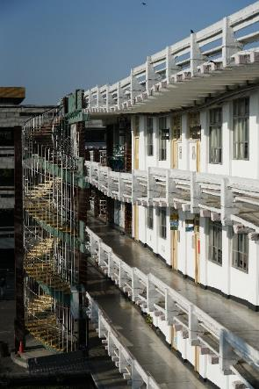  Recent photo of the San Sin High School of Commerce and Home Economics Wave Tower. © Yao-Ting Wu  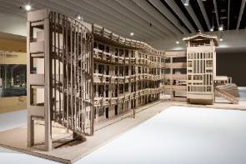  Large-scale exhibition model of the San Sin High School of Commerce and Home Economics Wave Tower. ©Jut Art Museum
Kenzo Tange: Sacred Heart High School for Girls, New Taipei City, Taiwan, 1965^{D}, 1966 ^{C}–1967  Licensing Architect & Site Superintendent: Cho-Cheng Yang & Associates Architects & Engineers  The Sacred Heart High School for Girls (1967, former Taipei University of the Sacred Heart) is the first overseas project completed by Japanese architect Kenzo Tange (1913-2005). The project was generally regarded, on the one hand, as the most representative work of Corbusian brutalism in Taiwan, on the other, as an architectural synthesis of international Modernism and, specifically, Metabolism of Japan. Despite Corbusian details evidently appeared at buildings such as rustic huge spouts made of cast concrete, the roughness of surfaces was finished by various local wash coarse gravel rather than an in-situ reinforced concrete. It technically and elaborately reflected an adaptation to local construction methods. | 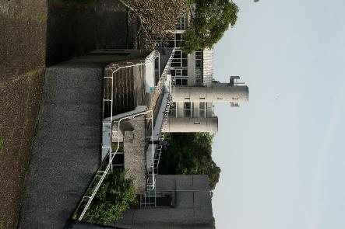  Recent photo of the Sacred Heart High School for Girls. © Yao-Ting Wu  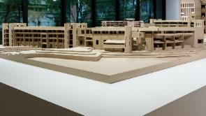  Large-scale exhibition model of the Sacred Heart High School for Girls. ©Jut Art Museum
Chiu-Hwa Wang, Percival Goodman: Former Center for American Studies, Academia Sinica, Taipei, Taiwan, 1970–1971^{D}, 1972^{F}  Licensing Architect & Site Superintendent: T'ang Architects & Engineers  The Center for American Studies is the first project designed by architect Chiu-Hwa Wang (1925- ) in Taiwan. Deeply influenced by the idea of the rationalism and the modernist motto— form follows function, the project not only revealed the reinterpretation of Le Corbusier’s form and language, but more importantly at that time evoked significant concern about modern architecture in Taiwan by responding to the given environment and reclaiming human scale. Moreover, the detail in the building expressed careful selection of commonly-used materials in Taiwan such as red brick. Not least to directly expose structure and material texture, as Wang recounted, is a way to convey the metaphorical sensation and aesthetic characters of architecture. It is her call of rethinking issues emerged from the regional-specific environment that made the Center for American Studies— through the poetics of Brutalism— one of the most outstanding architectural works in Taiwan by the 1970s. | 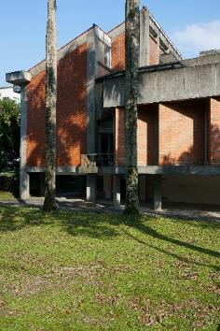  Recent photo of the Former Academia Sinica Center for American Studies building. © Yao-Ting Wu  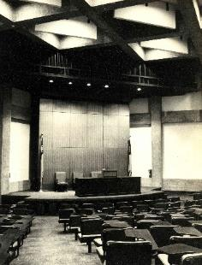  Historical photo of the Former Academia Sinica Center for American Studies building. © National Taiwan Museum  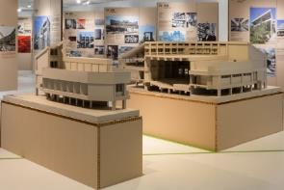  Large-scale exhibition model of the ormer Academia Sinica Center for American Studies building. © Jut Art Museum
Frank M. H. Wu: Taipei Medical University, Taipei, Taiwan, 1961^{C}–1965  Grounded on Taiwan’s architectural training, Architect Frank M. H. Wu was under the tutelage of Kenzo Tange and influenced by the ideas of Le Corbusier. He played a key role in the campus master plan and architectural design for the initial phase of the Taipei Medical University (former Taipei Medical College). Design strategy of the project was employed by responding to the local climate through its construction methods, creating characters with its material selection, and organizing spaces through the details. These principles were clearly demonstrated in three buildings: The Morphology Building (1961-63), the Educational Building (1963–1964), and the Laboratory Building (1964-65). | 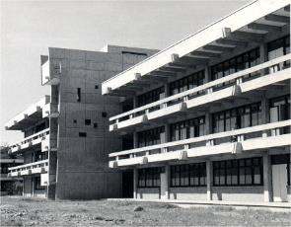  Historical photo of the Taipei Medical University Laboratory Building. © Taipei Medical University
Dr. Justus Dahinden: St. Joseph Kung-Tung Technical High School, Taitung, Taiwan, 1958^{D}, 1959^{C}–1960, heritage protected  Bethlehem missionary Fr. Jakob Hilber, in 1960, inaugurated the St. Joseph Kung-Tung Technical High School, of which the master plan and architectural design was proposed at the same year by Swiss architect Dr. Justus Dahinden. The school’s buildings not only reflected Dahinden’s solid knowledge of Modernist ideas and principles, but manifested an evidence that Le Corbusier’s béton brut techniques had been transformed according to his own design logic. Furthermore, Dahinden utilized slab construction technique rarely seen in Taiwan at that time. That not only provided an appropriate solution to a local difficulty due to limitations in use of small-size rebars for construction, but helped unify various functional spaces, while expressing the Brutalist language by exposed concrete finishing— achieving an ideal of modernist architecture that structure, space, and form are ultimately in harmonious integrated together. | 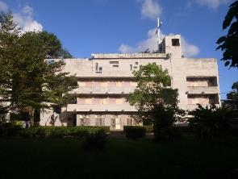  Recent photo of the St. Joseph Kung-Tung Technical High School building. © Kuan-Chih Huang  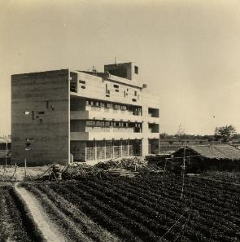  Historical photo of the St. Joseph Kung-Tung Technical High School building. © National Taiwan Museum
Jhao-Fan Wang: Kaohsiung Cultural Center, Kaohsiung, Taiwan, 1975^{D}, 1976^{C}–1981  The Kaohsiung Cultural Center, designed and executed by architect Jhao-Fan Wang, paved the ground work for post-war Taiwanese Brutalism in response to nationalist notions— transforming traditional language of Chinese architecture through modernist abstraction. As for detail in materials, by adjustments of repetition and scaling, the wooden structural language can be observed in architectural finishes of the main structure, where pebbledash supersedes exposed concrete to demonstrate a local expression of the poetic Brutalism, and more significantly, to respond to a call of modernism in a context of East Asian specificity. | 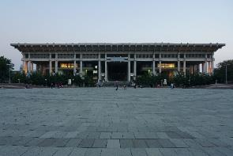  Recent photo of the Kaohsiung Cultural Center. © Yao-Ting Wu

International Case-Studies
Case Study Overview | Caption and Copyright
Kallmann McKinnell & Knowles / Campbell, Aldrich & Nulty: Boston City Hall, Boston, Massachusetts, USA. 1962^{D}–1969  As the keystone of Boston’s ambitious sixty-acre Government Center project, Boston City Hall represents an imaginative synthesis of cultural and political aspirations to renew the city under the mantle of the “New Boston.” Called upon to rejuvenate the urban core, restore confidence in the municipal political system, and kickstart a flagging economy. | 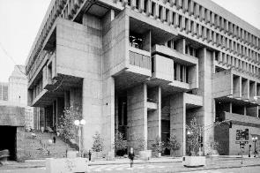  Historical photo of the Boston City Hall. © Bill Lebovic 1981  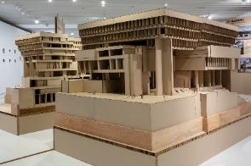  Large-scale exhibition model of the Boston City Hall. © Jut Art Museum
Paul Rudolph: Art & Architecture Building, Yale University, New Haven, Connecticut, USA, 1958^{D}–1963, heritage protected  As Dean of the Faculty of Architecture in Yale, Paul Rudolph was allowed to design his own university building for the growing campus in New Haven. The colossal structure polarized generations of students, confusing them with its complex spaces. Nevertheless, it is considered Rudolph’s masterpiece. The American press praised him for having developed an alternative to the typical glass office boxes. European critics, in contrast, described the building as overdone and individualistic. | 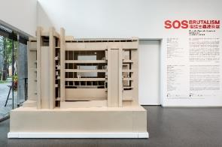  Large-scale exhibition model of the Art and Architecture Building, Yale University. © Jut Art Museum
João Baptista Vilanova Artigas / Carlos Cascaldi: Faculty of Architecture and Urbanism, University of São Paulo (FAU-USP), São Paulo, Brazil, 1961^{D}–1969, heritage protected  The faculty building interior is designed for communication. Meeting points occur in the central hall and on the ramps between the floors, but there are no views from the working spaces towards the outside world. The closed external concrete walls bear the traces of unskilled workers. In the meantime, renovations of the concrete have covered the surfaces with patchwork effects. | 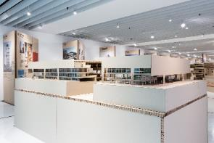  Large-scale exhibition model of the Faculty of Architecture and Urbanism, University of São Paulo. © Jut Art Museum
Youji Watanabe: Dr. Minezaki House (Dragon Fort), Shizuoka, Japan, 1968^{F}  The combination of a private clinic and doctor’s home was ready for demolition. We can thank private initiative for the fact the “dragon’s castle” is once more resplendent in its former glory. The eccentric architect Youji Watanabe gave the building its form of a curled-up dragon, complete with a jaws-shaped terrace and horns. | 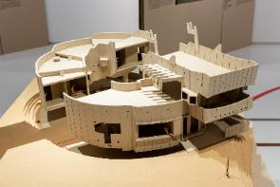  Large-scale exhibition model of Dr. Minezaki House (Dragon Fort). © Jut Art Museum
Graeme Gunn: Plumbers and Gasfitters Employees’ Union Building, Melbourne, Australia, 1968^{D}–1971 | 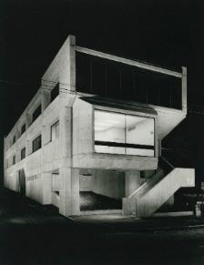  Historical photo of the Plumbers and Gasfitters Employees’ Union Building in Melbourne, Australia. © Graeme Gunn Architect
John Madin: Birmingham Public Library, Birmingham, Great Britain, 1969^{C}–1973 | 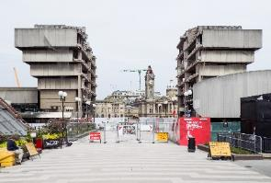  Recent photo of the Birmingham Public Library in the U.K. © Jason Hood 2016

Photos from the Opening Press Conference
Caption and Copyright | Photo
Address by Jut Foundation for Art and Architecture Executive Director, Aaron Y. L. Lee. © Jut Art Museum | 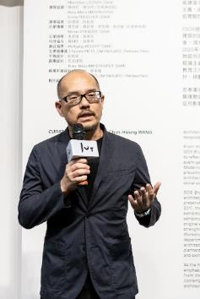
SOS Brutalism—Save the Concrete Monsters! Taiwanese curator, Dr. Chun-Hsiung Wang. © Jut Art Museum | 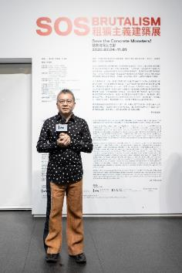
Address by Director Jens Roesler of the Goethe-Institut Taipei © Jut Art Museum | 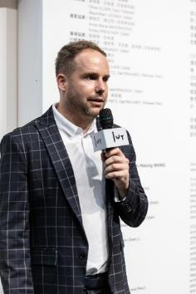
Group photo, from left:  - Director Shan-Shan Huang, Jut Art Museum  - Professor Jeanne Lee, Ming Chuan University, Department of Architecture  - Professor Ching-Chuan Lin, National Taipei University of Technology, Department of Architecture  - Exhibition curator, Professor Chun-Hsiung Wang (Director of the Shih Chien University Department of Architecture)  - Executive Director Aaron Y. L. Lee, Jut Foundation for Art and Architecture Foundation  - Director Jens Roesler, Goethe-Institut Taipei  - Professor Kuang-Tsung Tseng, Chung Yuan Christian University, Department of Architecture  - Professor Chi-Jong Sun, China University of Technology, Department of Architecture  © Jut Art Museum | 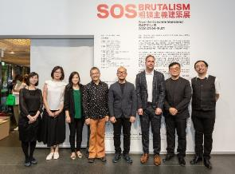

Exhibition Venue Photos
Caption and Copyright | Photo
Key visual for the SOS Brutalism—Save the Concrete Monsters! exhibition © Jut Art Museum | 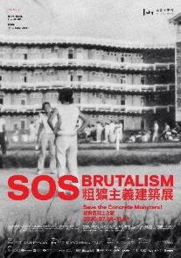
SOS Brutalism exhibition German curatorial discussion and reading area © Jut Art Museum | 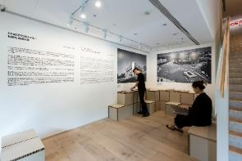
Architectural models of 24 concrete Brutalist structures in the museum’s second floor corridor. © Jut Art Museum | 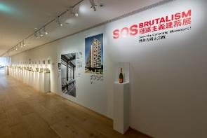  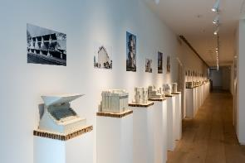
The exploration of 13 regions and five topics begins on the second-floor exhibition area along color-coded pathways. © Jut Art Museum | 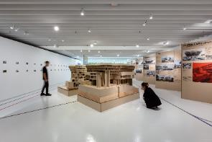  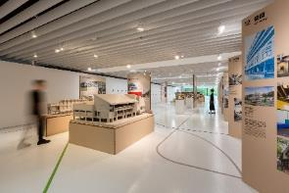  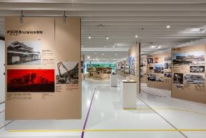
Introduction and curatorial discourse for the Taiwan exhibition area at the SOS Brutalism exhibition. © Jut Art Museum  The special Taiwan exhibition area for the SOS Brutalism Asian premiere. © Jut Art Museum | 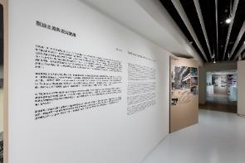  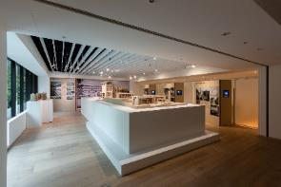

【Appendix III: Description of Exhibition Areas】

13 Regions

NEW. Taiwan
With its global remit, this exhibition highlights a universal issue and, moreover, reflects on the encompassed local perspective. And so, in addition to basing the Taipei exhibition on a foundation of the hundreds of international architectural case studies comprising the original exhibition from Germany, research on a total of six important Brutalist architectural case studies from Taiwan have been added to present a Taiwanese perspective and narrative. These include: the Sacred Heart High School for Girls, the former Center for American Studies at Academia Sinica, the Wave Tower at San Sin High School of Commerce and Home Economics, the Taipei Medical University, the St. Joseph Kung-Tung Technical High School, and the Kaohsiung Cultural Center.

- North America
The architects of the 1950s would build “too many goldfish bowls and too few caves”, as architect Paul Rudolph complained in 1954. His Faculty of Architecture in Yale is the concrete cave-like counter-model to the glass world of anonymous office buildings. Yet American Brutalism was a source of suspicion to many: too monumental, according to Reyner Banham. The student protests of the 1960s were directed not least of all against the university structures cast in concrete, and against an establishment as hard as concrete.

- Latin America
The rapid growth in the economy, cities and population unleashed a construction boom in Latin America in the 1950s. Showing the traces of unskilled workers with coarse concrete surfaces was often seen as a political message. Roughly wrought concrete formwork from wood often contrasted noticeably with the bold, in terms of structural engineering very sophisticated wide-spanning structures.

- Africa
In most countries of Africa, colonial rule ended in the 1950s and 1960s. In many places, a symbolic form of “architecture of independence” was created for important state buildings. These could be as different as universities, parliaments, market halls or even luxury hotels, depending on the political system concerned. The architects often still came from the former colonial states; only rarely did they hail from the country itself. But Israel also played an important role, as did the countries of Northern Europe without any colonial past, and the new communist allies.

- South and Southeast Asia
India won independence in 1947. Le Corbusier was commissioned to plan the city of Chandigarh. “It hits you on the head, and makes you think!” was how Jawaharlal Nehru, the first Prime Minister of India defended the experimental concrete buildings. The young generation of Le Corbusier’s Indian colleagues developed their own, self-confident buildings, including those for a revolutionary milk program. The New Khmer Architecture was another center for experimentation.

- East Asia
China is one of the few countries in which Brutalism never took root. Attempts at sculptural concrete architecture had no chance during the anti-individualistic Cultural Revolution. In Japan, however, concrete architecture was blended with traditional craftsmen’s techniques after the Second World War. Wooden beams became concrete supports. In South Korea, this barely gained currency, as intensely anti-Japanese tendencies dominated architecture due to the war experiences.

- Russia, Central Asia, and Caucasus
The death of Joseph Stalin in 1953 brought with it a change in direction for architecture: under his successor, Nikita Khrushchev, industrial prefabricated programs1 were created, while in those Soviet republics far away from Moscow, there was ever more space for experimentation. Futuristic forms were combined with traditional elements. Yet in Moscow, too, individual and bold constructions were possible.

- Eastern Europe
Regardless of how emphatically East and West cultivated their political differences, in architecture there were remarkable similarities. Major sculptural, monumental buildings were created on both sides of the Iron Curtain. Non-aligned Yugoslavia offered many experiments in particular, in order to reinforce the regional identities of the multi-ethnic state. Regional development also played a large role in Romania.

- Western Europe
The Unité in Marseille and the La Tourette monastery, both works by Le Corbusier, were already known as turning points in architecture even as they were being built: concrete had never been celebrated so roughly before, something that soon afterwards influenced even interior design. At the CIAM congresses, a young generation of architects emerged that attempted to defeat the all-too technical functionalism using new community-based designs.

- Middle East
Oil wealth, strategic position (domination of the Suez Canal) and the conflicts following the founding of Israel provided many crises in the region from 1945 onwards. Architecture played a stabilizing role for many states at this time. Seemingly indestructible concrete buildings built by local architects symbolized a new self-confidence. In Israel, young architects used Brutalism to distinguish their work from the white Bauhaus Modernism of the immigrant generation.

- Great Britain
Was New Brutalism (a phrase invented in 1953) a protest against the too-harmless reconstruction after World War Two, thus a “return” to radical Modernism? Or was New Brutalism set against the patronizing of architects by means of regulations, prefabrication and cost-effective standard solutions? So, did the Brutalists pose as artists? Many buildings in Great Britain are highly individual monsters, always completed with a high degree of craftsmanship.

- Oceania
In the former colonies of New Zealand and Australia, at least one semester in Great Britain was mandatory for all students of architecture. In this way, Brutalism and the organizational form of large, state architectural offices reached the region. The buildings were adapted to the extreme climatic conditions using steep roofs and concrete lamellas. One speciality of the region was the close cooperation with landscape architects.

- Germany
The term Brutalism may have been coined in Great Britain, but the book titled The New Brutalism (1966) by theoretician Reyner Banham was created on the initiative of the Stuttgart-based professor of architecture, Jürgen Joedicke, in the distinguished Karl Krämer Verlag. In it can be found only one project from Germany, the private residence of Oswald Mathias Ungers, twenty years later the architect of the DAM. Yet in Germany, too, countless Brutalist buildings arose, and in the 1970s, even so-called Pop Brutalism.

Five Topics

- Ms. Brutalist
The share of female architects in the exhibition reflects the situation in the architectural profession in those years: only three from 120 selected buildings in the book SOS Brutalism: A Global Survey were planned by independently working women architects, who come from Iceland, Pakistan, and Poland. Women working in leading positions in office partnerships were over-proportionately represented only in Eastern Europe and Israel.

- Le Corbusier’ s La Tourette
There is hardly another building that has so permanently shaped the development of Brutalism worldwide as Le Corbusier’s monastery. The building, subtly composed with its dramatic arrangement of light and color, was often (wrongly) interpreted as a monumental structure in exposed concrete. La Tourette became a cliché and the model for countless other buildings, beginning with the Boston City Hall.

- Concrete Churches
In contrast to the negative reactions triggered by many other Brutalist buildings at the time they were created, churches in those years frequently met with positive reception. Their bleakness is often seen as a commentary on the wave of consumerism that came with the postwar years. Sometimes they also stand in contrast to the less ambitious housing estates in the neighborhood.

- Concrete
When producing concrete, basically three ingredients are required: water, cement and a mix of stones and sand. After mixing, the concrete is poured into formwork. It flows around the reinforcing steel with which it forms one unit after hardening. Thus one speaks of reinforced (or ferro-) concrete. Two types of surface treatment are particularly common in the case of Brutalist buildings: Board-marked concrete, Bush-hammered concrete.

- Campaigns
In recent years campaigns have formed with increasing frequency espousing the preservation of Brutalist buildings. Many campaigns use Twitter, Facebook or Instagram. For this reason, the DAM set up the hashtag #SOSBrutalism. It serves as a symbol of recognition that can be taken up and spread whenever the preservation of Brutalist architecture is at stake.

