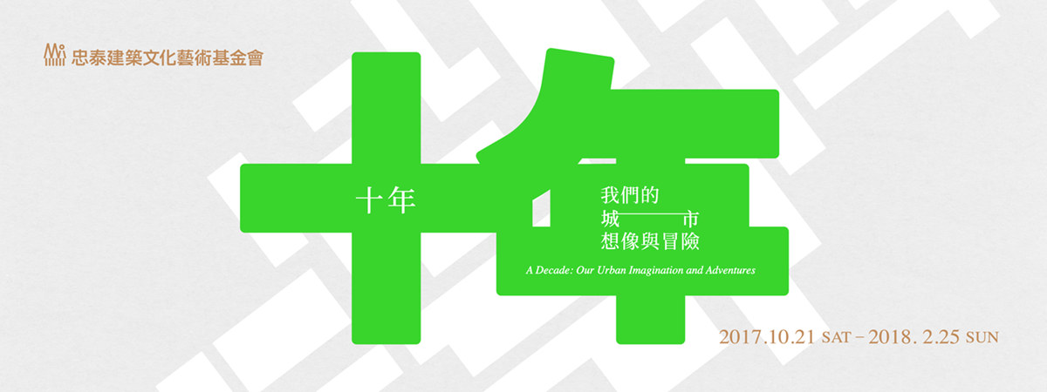
Press Release
It is the 10th anniversary of the Jut Foundation for Arts and Architecture (JFAA). The Jut Art Museum and the U-mkt are pleased to launch the exhibition A Decade: Our Urban Imagination and Adventures, scheduled to be on view from October 21, 2017 through February 25, 2018. Curated by Dr. Su Yaohua, this exhibition features the past decade of JFAA’s treasure hunt throughout Taipei City. A large number of precious behind-the-scenes documents from several interdisciplinary projects launched by JFAA are displayed for the first time. The main exhibition, located in the Jut Art Museum, presenting contemporary artworks, including Japanese artist Susumu Shingu’s Wings of Time and Taiwanese artist Lin Chuan-Chu’s Rice for Thoughts, as well as presenting a rich archive of scale models, publications, and merchandise that document JFAA’s exhibitions, symposiums, events over the years. Through these project documents, it allows the audiences to review numerous creative collaborations among domestic and international architects, artists, designers and interdisciplinary creators from various perspectives. The satellite exhibition, located in the U-mkt, in which chronicles the evolution of the Project UrbanCore, one of JFAA’s four flagship projects, as well as leading visitors to experience the new ideas and impact which the spatial revitalization have brought to the city. Two exhibition areas will hold artist workshops, international forum, Mini Salon talks, guided tours and series of events.

A decade, as a time unit, starts from JFAA’s debut exhibition theFLOWmarket, which was held to open 24 hours to the public. This gradually formed the Foundation’s four flagship projects:

- MUSEUM of TOMORROW
This project is conducted in an itinerant fashion, cruising throughout various corners and landmarks of the city at different times, with an open agenda that focuses on art, architecture and design, inspiring the audience to reconsider their living space, and their future.
- Project Urban Core
The project aims to revitalize idle spaces throughout the city, becoming a biodynamic incubator for aspiring artists and creators of cultural content. The core concept of this project lies in the empowerment of “men.”
- Jut Architecture Academy
The academy encompasses a great array of courses, symposiums, lectures, workshops, and research projects to realize a holistic architecture program that exists the conventional campus setting.
- Jut Art Museum
The museum is a continuation of JFAA’s core ideas, with “future,” “urban architecture,” and “contemporary art” as a three-pronged approach to create a sturdy, open exchange platform.

As a non-profit organization aiming to explore the unlimited possibilities of architecture, culture and art, JFAA pressed on through trial and error to identify a way to engage the city. It is both “unorthodox” and “spontaneous” in its approach to finding change. On one hand, this dialog is independent of outside influences; on the other, it welcomes partnership with the government and other private organizations in hopes of inspiring a symbiotic realm where multilateral interactions are nurtured, and an intersectoral communication channel abled to spark imagination and reflection on a city.

Exhibition Information
- Title: A Decade: Our Urban Imagination and Adventures
- Dates: October 21, 2017 – February 25, 2018
- Curator: Dr. Su Yaohua
- Organizer: Jut Foundation for Arts and Architecture
- Free admission
- Visitor Information:

Venue | Main exhibition:  Jut Art Museum (No.178, Sec. 3, Civic Blvd., Daan Dist., Taipei City 106, Taiwan) | Satellite exhibition:  U-mkt (No. 70, Sanshui Street, Wanhua Dist., Taipei City, 108, Taiwan)
Public Transportation | MRT Zhongxiao Xinsheng Station (Exit No.4) / Zhongxiao Fuxing Station (Exit No.1), 10-minute walk. | MRT Longshan Temple Station (Exit No.3), 2-minute walk
Opening Hours | Tue-Sun 10:00-18:00, closed on Mondays
Website | jam.jutfoundation.org.tw/en | umkt.jutfoundation.org.tw/en

*For detailed information on the exhibition and its associated events, please visit the official website of the Jut Art Museum: jam.jutfoundation.org.tw/en
*Copyrights of the exhibition images are reserved by the Jut Foundation for Arts and Architecture.

