**目次**

1. **忠泰美術館（Jut Art Museum）について------------------------- P.2**
2. **平田晃久 について------------------------------------------------------- P.3**
3. **プレス写真 ----------------------------------------------------------------- P.4~7**

**注意**

* プレスキットおよびその他の写真は、以下のリンクからダウンロードできます：<https://drive.google.com/drive/folders/1sXncVSKNe1B0J-7OrGVkdi6CMsH5Bsem?usp=sharing>
* 画像の標準使用：適用される場合は写真のクレジットを記載し、© Jut Art Museumを明記してください。

**I、 忠泰美術館（Jut Art Museum）について**

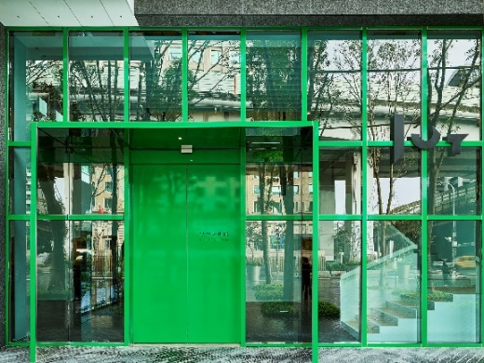 © Jut Art Museum

**Mission**

Jut Land Development’s 30th anniversary, and the Jut Foundation for Arts and Architecture (JFAA)'s 10th birthday, culminates in the establishment of the Jut Art Museum (JAM) in 2016. It is a milestone commemorating the history of Taiwan’s architectural aesthetics.

We anticipate that JAM to act as a new form of platform, catalyst and think tank devoted to corporate social responsibility fulfillment and addressing the societal dynamics of the 21st century. We also anticipate it to carry on the legacy of “A Better Tomorrow” that defines much of JFAA’s work, to become the first museum in Taiwan that is focused on the issues of “future” and “city.”

**Vision**

The Jut Art Museum, located in the heart of Taipei, is also where the Jut Foundation’s debut exhibition of “Museum of Tomorrow” is held. After ten years of circuit shows across the city, the exhibition is now back to where it all started, becoming a “showpiece in the heartland of the city and urban inhabitation.”

As an up-and-coming art establishment, JAM serves to explore what our future might hold, and transdisciplinary issues. The curation process of JAM is three-pronged: “future,” “urban architecture,” and “contemporary art.”

Japanese architect Jun Aoki is tasked with spacing designs of JAM. The identification system is developed by Atsuki Kikuchi. This is their first museum collaboration project in Taiwan. JAM – a statement of both sophistication yet cutting-edge conception – is downtown’s new architectural and art landmark; and it is poised at remaking and bringing new energy into Taipei’s cityscape.

|  |  |
| --- | --- |
|  | Website <https://jam.jutfoundation.org.tw/en>  Facebook <https://www.facebook.com/JUTARTMUSEUM>  Instagram <https://www.instagram.com/jutartmuseum/> |

**II、平田晃久 について**

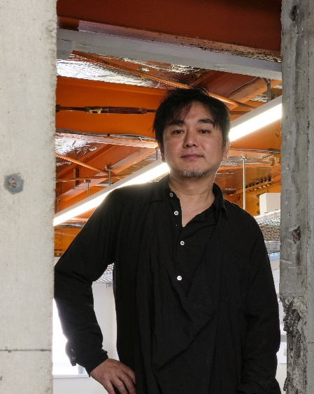 © Marc Goodwin, Archmospheres

1971年大阪府に生まれ。1997年京都大学大学院工学研究科修了、伊東豊雄建築設計事務所勤務の後、2005年平田晃久建築設計事務所を設立。現在、京都大学教授。

SDレビュー朝倉賞（2004年）、第19回JIA新人賞（2008年）、第13回ヴェネチア・ビエンナーレ国際建築展金獅子賞（2012年）、日本建築学会賞（2015年）、村野藤吾賞（2018年）など、数多くの建築賞を受賞。近年では、台湾新竹市図書館新館建設計画公開競圖（2019年）、臺湾大学「藝文大樓」新建工程委託規劃設計監造技術服務公開競圖（2022年）など、台湾の建築設計コンペで数々の賞を受賞。2020年には、台北の忠泰美術館で開催された個展「HUMAN NATURE: Generosity and Its Form」（2019年）で、Golden Pin Design Awardを受賞。

**III、プレス写真**

|  |  |
| --- | --- |
| **Photos** | **Caption** |
|  | 「平田晃久─人間の波打ちぎわ」（台北）キービジュアル (縦) © Jut Art Museum |
|  | 「平田晃久─人間の波打ちぎわ」（台北）キービジュアル (横) © Jut Art Museum |
|  | Tree-ness House ©Vincent HECHT |
|  | Tree-ness House ©Jut Art Museum |
|  | Taipei Roofs ©Dean Cheng |
|  | Taipei Roofs ©Jut Art Museum |
|  | Art Museum & Library, OTA ©Daici Ano |
|  | Museum and Art Gallery of National Taiwan University ©Akihisa Hirata Architecture Office |
|  | Museum and Art Gallery of National Taiwan University ©Jut Art Museum |
|  | HARAKADO ©KENYA CHIBA |
|  | HARAKADO ©Jut Art Museum |
|  | EXPO National Day Hall “Ray Garden” ©Jut Art Museum |
|  | 「平田晃久─人間の波打ちぎわ」（台北）会場の様子©Jut Art Museum |
|  | Jut Art Museum Director, Shan-Shan Huang © Jut Art Museum |
|  | 建築家平田晃久がビデオを通じて展覧会を紹介します © Jut Art Museum |