New Exhibition at the Jut Art Museum Dialogues: Oyler Wu Collaborative on July 20th
American Architects, Dwayne Oyler and Jenny Wu: an evolving conversation on Lines, Surfaces, and Volumes

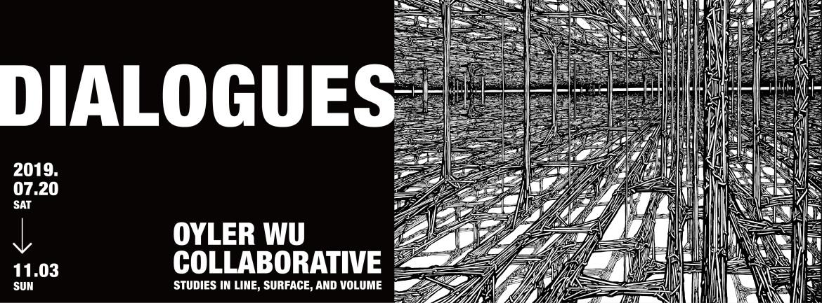

The second exhibition of the Jut Art Museum this year Dialogues: Oyler Wu Collaborative – Studies in Line, Surface, and Volume opens on July 20th (Sat). Oyler Wu Collaborative, a finalist of the first ADA Award for Emerging Architects in 2012, debuts their exhibition for the first time in Taiwan to present the firm’s oeuvre. The exhibition includes over 140 works–from sketches, architectural models, craft artworks and jewelry presented through the organizational lens of Lines, Surfaces and Volumes. Oyler Wu also features two new works: Quicksilver, an installation suspended between the 1st and 2nd floors of the gallery, and Inlay Field, a wall piece that expands upon their Active Inlay series. Dialogues: Oyler Wu Collaborative is exhibited from July 20th to November 3rd.

Formatting Avant-Garde Architectural Art with Dialogues
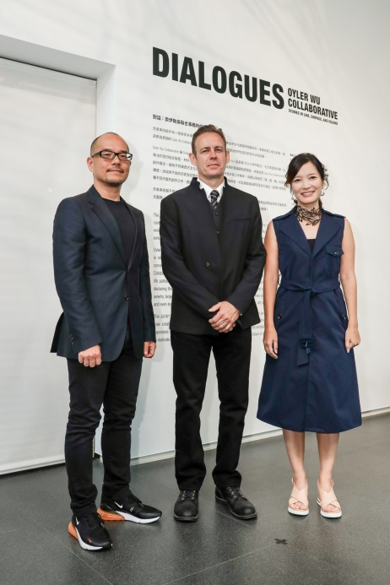
Located in Los Angeles, Oyler Wu Collaborative was founded in 2004 by Dwayne Oyler and Jenny Wu. Within ten years of its establishment, Oyler Wu Collaborative has been internationally recognized, winning significant prizes including the J. Irwin and Xenia S. Miller Prize from Exhibiti Columbus, the ADA Award for Emerging Architects, and Presidential Honor Award for Emerging Practice from AIA LA.

The exhibition title ‘Dialogues’ refers to a multiplicity of different relationships, describing the composite interests of Oyler Wu Collaborative as productive generators for architecture and making. Tracing work constructed from 2008 to today, Oyler Wu uses lines, surfaces and volumes as layered definitions to describe an evolving conversation that weaves the qualities in their work with the trajectories that form it.

The Slash Generation and the Crossover Architecture
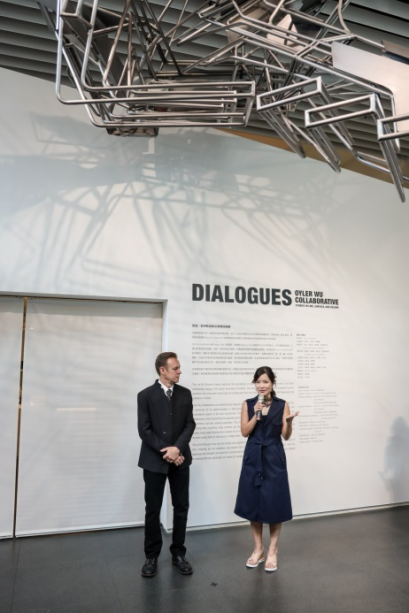
Oyler Wu Collaborative insists a multi-dimensional approach to their architectural pursuits, believing that architecture’s full potential is born out of its ability to operate at all scales- from hand drawing to highly refined jewelry, large-scale architecture to hand-crafted artifacts. Dwayne and Jenny emphasize research and experimentation that highlights new materials and technology, striking a balance that incorporates a more comprehensive spectrum of design ideas.

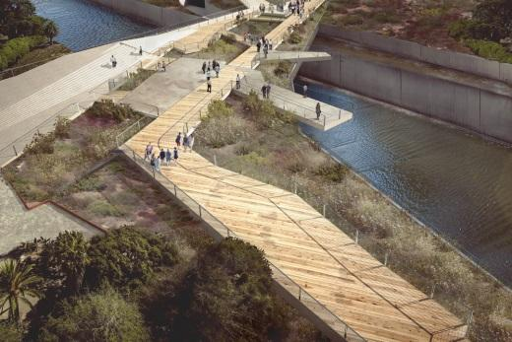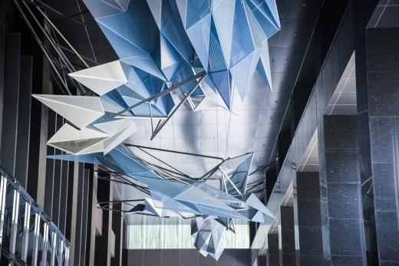
Oyler Wu is invested in cultivating projects that address this way of working, from large urban planning and infrastructural projects to site specific installations. Projects like the Los Angeles Riverway, a revitalization project for the City of Los Angeles to reconnect the public with the infrastructural history of the river. The largest work of the exhibition, Crystal Cloud is a 45m-long installation consisting of 355 faceted metal panels, suspended in the adjacent arcade of the complex of Jut Art Museum.

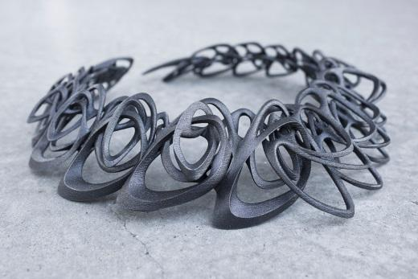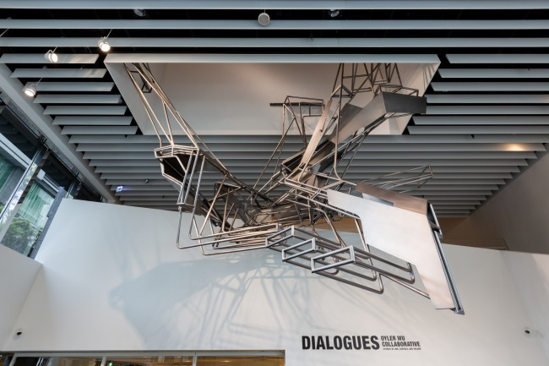
This exhibition is Oyler Wu Collaborative’s most ambitious to date. Oyler Wu showcases 2 commissioned installations Quicksilver and Inlay Field, alongside 17 architectural and urban planning projects, featuring 12 architectural models, and a series of 6 sculptures.

Jenny Wu exhibits pieces from her established 3D-printed jewelry line LACE by Jenny Wu, including the Catena Steel Necklace – a piece in the permanent collection by the Los Angeles County Museum of Art. The exhibition also includes 65 jewelry pieces and drawings from LACE by Jenny Wu, 22 sketchbooks and 3 handmade toys produced by Dwayne Oyler, and a series of project books that document the work of their office.

Continual Events, Jut Art Museum Serves a the Catalyst of Urban Aesthetics
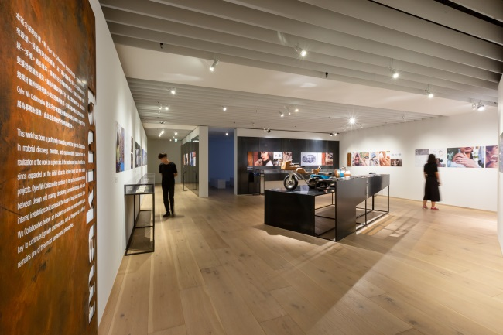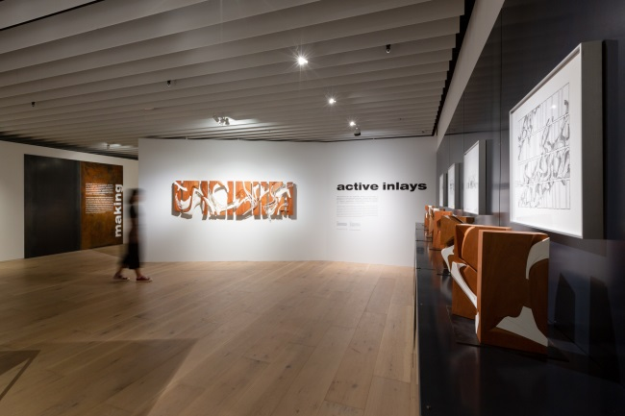
Jut Art Museum explores an interdisciplinary future. Since 2018, Jut Art Museum has focused on architects in mid-career, introducing their practices through new themes and new types of exhibitions. Following architects from Finland and Japan, on July 20th Dialogues: Oyler Wu Collaborative will feature American architects Jenny Wu and Dwayne Oyler. This event seeks to inspire young designers in Taiwan, introducing ideas that come from diverse cultural backgrounds.

Dwayne Oyler and Jenny Wu had given speeches during the unveiling of the exhibition on July 20th, and hosted a guided tour of the exhibition on July 21st. Additionally, guided tours by the museum staff, expert guided tours, workshops, and urban tours will be held throughout the exhibition period. Detailed information of these events can be found on the website and Facebook of Jut Art Museum.

Special Offers from Jut Art Museum
- Student Day on WED – Free admission once upon presentation of valid student ID
- eslite Bookstore Members – Buy-one-ticket-get-one-free on WED for visitors with membership ID
- eslite Forum Members – Free admission once for visitors with membership ID

Visitors staying in HOTEL PROVERBS Taipei, HOTEL QUOTE Taipei, Gloria Residence and Gloria Prince Hotel with room card have one-time free admission. It is a package for art lovers and boutique hotel customers.

More benefits can be found on the official site of Jut Art Museum: http://jam.jutfoundation.org.tw/en

[Reference]
About Oyler Wu Collaborative

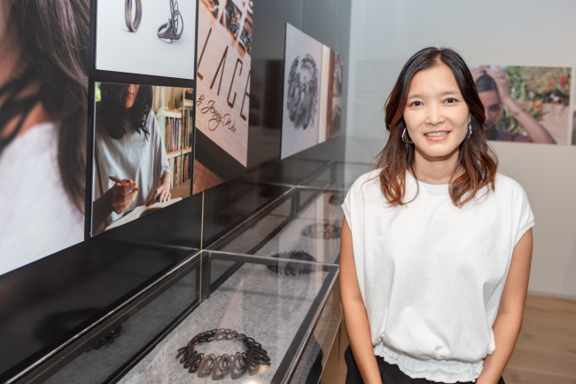
- Jenny Wu
Jenny Wu received her B.A. from Columbia University and M.Arch from Harvard Graduate School of Design. Currently, Jenny Wu is the undergraduate thesis coordinator and a member of the design faculty at the Southern California Institute of Architecture (SCI-Arc). She has previously taught at institutions such as Harvard GSD, Columbia GSAPP, and Syracuse University. In 2014 she founded LACE by Jenny Wu, a jewelry brand manufactured by 3D printing. Jenny was named one of the four design visionaries by Porsche on Dwell Magazine in Powered by Design documentaries.

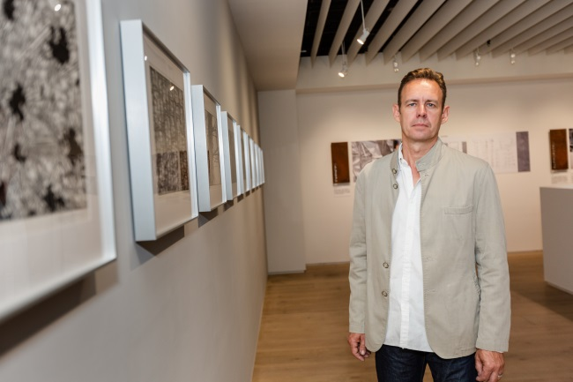
- Dwayne Oyler
Dwayne Oyler received his Bachelor of Architecture from Kansas State University and Master of Architecture from Harvard University Graduate School of Design. Prior to establishing Oyler Wu Collaborative, Dwayne worked for Toshiko Mori Architects and collaborated with Lebbeus Woods on numerous projects. Dwayne Oyler has taught architecture studios at Syracuse University, The Research Institute for Experimental Architecture, the Cooper Union, Columbia University and Harvard GSD. Currently he is currently teaching architecture design studios at the Southern California Institute of Architecture (SCI-Arc).
Dialogues: Oyler Wu Collaborative – Exhibition Information

Exhibiting Architect｜Oyler Wu Collaborative – Dwayne Oyler, Jenny Wu
Venue｜Jut Art Museum (No.178, Sec. 3, Civic Blvd., Da'an Dist., Taipei City 106, Taiwan)
Dates｜2019/7/20 – 2019/11/3
Opening Hours｜TUE-SUN 10:00-18:00 (Closed on Mondays)
Direction｜MRT Zhongxiao Xinsheng Station (Exit 4) or Zhongxiao Fuxing Station (Exit 1) 10-minute walk
Admission｜General TWD 100, Concessions TWD 80 (Students, seniors aged 65 and above, and groups of 10 or more); Free Admission for the disabled and a companion, children aged 12 and under (Concessions or Free Admission upon presentation of valid proof)
Student Day on WED｜Free Admission once on Wednesdays upon presentation of valid student ID
Organizer｜Jut Art Museum
Coordinators｜Oyler Wu Collaborative 、Jut Art Museum
Official Webpage｜http://jam.jutfoundation.org.tw/en/exhibition/107/1489

